REPORT ON STRATEGIC ENVIRONMENTAL ASSESSMENT FOR THE ENERGY SECTOR DEVELOPMENT STRATEGY OF THE REPUBLIC OF SERBIA BY 2025 WITH PROJECTIONS UNTIL 2030, FOR THE PERIOD 2017–2023

C O N T E N T S
4

5

5
5
8
9
12
12
27
27

32
41
49

51
52
53

54

54
54

58
58
83
84

85
86
86

92

94

94
95
100

102

104

105

INTRODUCTORY NOTES..............................................................................................................

- STARTING POINTS FOR STRATEGIC ENVIRONMENTAL ASSESSMENT................
  - Overview of the subject, contents and objectives of the strategy and relationship to other documents.......................................................................................................................................
1.1.1 Subject and contents of the Program………………………………………………………
1.1.2 Objectives of the Program ..................................................................................................
1.1.3 Relationship to other documents ………………………………………………………....
1.2 Overview of environmental quality and the current state of the environment.................................
1.2.1. Quality of basic environmental factors.................................................................................
1.2.2 Elements of the environment that are exposed to impacts...................................................
1.2.2.1. Coal mines..............................................................................................................
1.2.2.2. Thermal power plants (TPP) and combined heat and
power plants (TE-TO)..........................................................................................
1.2.2.3. Hydroelectric power plants....................................................................................
1.2.2.4. Oil and gas deposits..............................................................................................
1.2.3 Considered issues and problems of the nature and environmental protection
in the Program and reasons for omitting certain issues from the SEA………………..……….
1.2.4. Alternative solutions………………………………………………………………….……..
1.2.5 Prior consultations with authorities and organizations concerned...........................................
2. GENERAL AND SPECIAL OBJECTIVES OF THE STRATEGIC
ENVIRONMENTAL ASSESSMENT AND SELECTION OF INDICATORS..........................

2.1 General and special SEA objectives……………………………………………………………….
2.2 Selection of indicators.....................................................................................................................

3. ENVIRONMENTAL IMPACT ASSESSMENT...........................................................................
3.1 Evaluation of characteristics and significance of effects of strategic commitments......................
3.2 Summary of significant strategic impacts........................................................................................
3.3 Cumulative and synergistic environmental effects assessment.......................................................
3.4 Description of guidelines for preventing and mitigating negative impacts and
maximizing positive impacts on the environment..............................................................................
3.4.1 General guidelines..................................................................................................................
3.4.2 Guidelines for important projects envisaged in the Program.................................................
4. GUIDELINES FOR UNDERTAKING THE SEA AT LOWER
HIERARCHICAL LEVELS............................................................................................................

5. PROGRAM FOR ENVIRONMENTAL MONITORING DURING THE
IMPLEMENTATION OF THE PROGRAM................................................................................

5.1. Description of Program objectives.................................................................................................
5.2. Indicators for environmental monitoring.........................................................................................
5.3 Rights and Obligations of Competent Authorities..........................................................................

6. OVERVIEW OF THE USED METHODOLOGY........................................................................

7. OVERVIEW OF DECISION-MAKING METHODS...................................................................

8. OVERVIEW OF CONCLUSIONS OF THE STRATEGIC
ENVIRONMENTAL ASSESSMENT REPORT.............................................................................
INTRODUCTORY NOTES

Strategic Environmental Assessment (SEA) is an assessment of the possible impacts that a proposed project and program may have on the environment, and the specification of measures for prevention, minimization, mitigation, remediation or compensation of adverse effects on the environment and human health. The SEA implementation in planning gives the scope for considering the changes occurring in space, also taking into account the needs of the subject environment п the needs of the subject environment. Within the SEA, all activities envisaged in the plan are critically considered from environmental aspects, after which a decision is made on whether to implement the plan and under which conditions, or whether to abandon the planned activities.

Planning implies development, while a strategy for sustainable development requires environmental protection. In this context, the strategic environmental assessment is an unavoidable instrument for achieving the sustainable development objectives. The SEA integrates socio–economic components with components of biophysical environment, links, analyzes and assesses the activities in different spheres of interest, as well as directs policy, plans or programs towards solutions which are primarily of environmental interest. It is an instrument which helps in integrating the objectives with principles of sustainable development when making decisions about spatial planning, thereby taking into account the need to avoid or limit negative environmental effects on health and socio-economic status of population. The significance of the SEA lies in the fact that it:

- Includes the aspect of sustainable development in addressing the causes of environmental problems in their source,
- Addresses the issues and impacts of wider significance, which do not deal with individual projects, for example – cumulative and synergistic effects,
- Helps in checking the suitability of different alternative development concepts,
- Avoids limitations occurring in carrying out an environmental impact assessment for already defined projects,
- Ensures location compatibility of planned solutions from environmental aspects,
- Establishes an appropriate context for impact analysis of specific projects, including prior identification of problems and impacts for which a more detailed analysis is needed, etc.

In domestic planning practice, the SEA is introduced by the Law on Environmental Protection (“Official Gazette of the Republic of Serbia”, Nos. 135/2004, 36/09, 72/09, 43/11 and 14/16). Pursuant to Article 35 of this Law, Strategic environmental assessment shall be carried out for strategies, plans, programs and principles in the domain of spatial and urban planning or land use, agriculture, forestry, fishing, hunting, energy, industry, transport, waste management, water resources management, telecommunications, tourism, infrastructural systems, protection of natural and cultural resources, flora and fauna and their habitats etc. and shall be an integral part of the plan, program or principle".

The Report on Strategic Environmental Assessment has been prepared based on the Decision on producing the strategic environmental assessment of the Program for implementing the Energy Sector Development Strategy of the Republic of Serbia by 2025 with projections until 2030, for the period 2017–2023 (hereinafter referred to as the “Program”), made by the Ministry of Mining and Energy of the Republic of Serbia (No.: 312-01-00493/2016-06 of 9th June 2016).
1. STARTING POINTS FOR STRATEGIC ENVIRONMENTAL ASSESSMENT

Pursuant to Article 13 of the Law on Strategic Environmental Impact Assessment (“Official Gazette of the Republic of Serbia”, Nos. 135/2004 and 88/2010), the starting points for the SEA include:

- Brief overview of contents and objectives of the Program and relationship of the Strategy to other plans and programs;
- Overview of environmental quality and the current state of the environment in the area encompassed by the Report,
- Characteristics of the environment in the fields in which it can be exposed to significant impacts,
- Consideration of environmental protection problems in the plan and explanation of reasons why certain issues have been left out from the assessment process,
- Overview of alternative solutions relating to the environmental protection in the plan and program, including the alternative solution for non-implementation of the plan , as well as the most favorable solution from the aspect of environmental protection.

This Chapter encompasses all abovementioned points, except for the overview and evaluation of alternative solutions which are given in Chapter 3 of the SEA Report.

  - Overview of the subject, contents and objectives of the Program and relationship to other documents

1.1.1 Subject and contents of the Program

Pursuant to the Energy Law (“Official Gazette of the Republic of Serbia”, No. 145/2014), the energy policy of the Republic of Serbia is established in the Energy Sector Development Strategy of the Republic of Serbia (“Official Gazette of the Republic of Serbia”, No. 101/2015), whereas conditions, manner, dynamics and measures for implementing the Strategy are determined in the Program for implementing the Strategy, while annual needs for energy and/or energy resources, which must be provided with the aim of reliable, safe and high-quality supply of end users, the sources of providing necessary amounts of energy and/or energy resources, as well as the necessary level of supplies and spare capacities of energy facilities for safe supply of buyers with energy and energy resources are determined in the Energy Balance of the Republic of Serbia (hereinafter referred to as the “Energy Balance”). The Energy Sector Development Strategy of the Republic of Serbia by 2025 with projections until 2030 defines strategic priorities for energy sector development in the Republic of Serbia which are established within the Program. Those are:

  - Ensuring energy security by:
    - Reliable, safe, efficient and high-quality supply of energy and energy resources
    - Establishing conditions for reliable and safe functioning of all the systems within the energy sector and for their sustainable development
In order to ensure safe, reliable and high-quality energy supply it is necessary to promote rational energy use, provide appropriate oil and natural gas reserves, provide various supply sources of these energy resources, and then proceed to the construction of new capacities for electric power production (with renewable energy sources, as well as with conventional energy sources, with high energy efficiency) and capacities for transmission and distribution of electric power and energy resources which will ensure safe supply with the lowest total costs.

  - Development of energy market by:
    - Ensuring competitiveness in the energy market with the principles of non-discrimination, public openness and transparency;
    - Protecting consumers of energy and energy resources;
    - Developing the market of electric power and natural gas and their connecting with the uniform energy market of the EU;
    - More connecting more intensively the energy system of the Republic of Serbia with energy systems of other countries, particularly those in the immediate surroundings.
According to the Energy Community Treaty, the Republic of Serbia put the establishment of the regional energy market as one of its priorities. This market should be integrated into the EU energy market and ensure more investments in this sector and contribute to its development.

  - Transition towards sustainable energy system by:
    - Ensuring conditions for improving energy efficiency in performing energy-related activities and energy consumption;
    - Creating economic, commercial and financial conditions for increasing the share of energy from renewable sources, as well as for combined production of electric and heat energy;
    - Creating institutional, financial and technical assumptions for using new energy sources (wind power, solar power, biomass, biogas etc.);
    - Improving the state and system of environment protection in all fields or energy-related activities;
    - Establishing more favorable legal, institutional and logistic conditions for more dynamic investments in the energy sector.
In the Energy Sector Development Strategy (“Official Gazette of the Republic of Serbia”, No. 101/105), the National Action Plan for Energy Efficiency (“Official Gazette of the Republic of Serbia”, No. 1/2017), the National Action Plan for Renewable Energy Sources (“Official Gazette of the Republic of Serbia”, No. 53/2013), the National Plan for Emission Reduction and the National Program for Integration of the Republic of Serbia into the European Union (the document adopted at the session of the Republic of Serbia held on 9th October 2008, http://www.parlament.gov.rs/aktivnosti/evropske-integracije/dokumenta.1015.html), the Republic of Serbia defined objectives, measures and activities which should contribute to increased energy efficiency, increased energy production from renewable sources, reduction in emission of greenhouse gases as well as reorganization and restructuring of enterprises in the energy sector, creating new national regulations and standards and harmonizing already existing ones with the regulations and standards applied in the EU. Individual measurable objectives for each of the energy sectors are shown in the chapter referring to that particular sector.
Note: The National Plan for Emission Reduction was adopted on 15th June 2015. The National Program for Integration of the Republic of Serbia into the European Union is a document containing a precise plan as to how to fulfill all the criteria necessary for becoming a member state of the EU, and it was adopted at the session of the Government of the Republic of Serbia held on 9th October 2008.

Measures, activities and projects contributing to the realization of defined measurable objectives within individual sectors are aimed at overall transition to sustainable energy system in Serbia. Development sustainability derives from the general improvement of energy efficiency, increased use of renewable energy sources and upgraded state of the environment, which partially results from the previous two factors. The field of energy efficiency has been regulated by the Law on Efficient Use of Energy, while both framework laws for the field of energy also regulate the field of renewable energy sources..
Apart from the energy efficiency level (i.e. the indicators showing energy efficiency) and the participation of renewable energy sources in the final energy consumption, the third significant indicator of sustainable development is the level of improvement of the state of the environment in the field of environmental protection in line with relevant legislation and accepted international agreements and treaties (Kyoto Protocol, UN Framework Convention on Climate Change, Parma Declaration on Environment and Health, Paris Agreement. European Convention on Landscape, Podgorica Initiative/a regional approach to environmental and climate change issues in the South East Europe, Protocol on Water and Health to the Convention on the Use of Transboundary Watercourses and International Lakes, the Treaty establishing the Energy Community, Convention on Co-operation for the Protection and Sustainable Use of the River Danube, the Framework Agreement on the Sava River Basin).

The greenhouse gas (GHG) inventory for the period 2010–2013 and projections until 2020, i.e. for the part of the period covered by the Program for implementing the Strategy, are given in the First Biennial Update Report to the UN Framework Convention on Climate Change. The projections about the emission of the greenhouse gases until 2030 and nationally defined contribution to the reduction of the emissions by 9.8% in relation to the emissions in the basic year of 1990, are given in the document “Intended Nationally Determined Contribution of the Republic of Serbia”. Particularly significant to measures, activities and programs mentioned in the Program for implementing the Strategy is the Directive on the limitation of emissions of certain pollutants into the air from large combustion plants (“Official Gazette of the Republic of Serbia”, No. 6/16), which regulates the realization of a whole series of projects in the field of electric energy, in the field of heat energy, in the field of oil and in the field of industry, where there are large combustion plants. Twenty heating plants within the remote heating system, NIS a.d. and Public Enterprise “Elektroprivreda Srbije” (hereinafter: “EPS”) were recognized as operators subject to the Law on Integrated Environmental Pollution and Control (“Official Gazette of the Republic of Serbia”, Nos. 135/2004 and 25/2015) and are obliged to file a request to the relevant ministry for obtaining the integrated permit. Moreover, there is a number of planned measures and activities which should ensure the sustainable energy sector in line with internationally undertaken obligations and positive practice.

The Program includes the following wholes or chapters:

- Manner of defining strategic energy projects and necessary activities in relation to decision-making about a project being strategic, and basic obligations of the Government of the Republic of Serbia, its ministries and the Energy Agency of the Republic of Serbia regarding strategic energy projects;
- Overview of measurable objectives and indicators of their realization which should be achieved through the Program for implementing the Strategy, defining a list of measures, activities and projects by the fields within the Program for accomplishing the set objectives, also taking into account environmental protection and energy efficiency:
  - Sector of electric energy
  - Sector of heat energy
  - Sector of renewable energy sources
  - Sector of oil
  - Sector of natural gas
  - Sector of coal
  - Sector of energy efficiency in the energy consumption sector
- Determination of project priorities.

An integrated and continual planning approach has been applied in developing the Program and the subject SEA an emphasis placed on seeking sustainable measures through integrating the realistic objectives with potentials in the field of energy on the one hand, and objectives with the need for protecting the environment, quality of life of people and socio-economic development, on the other.

1.1.2. Objectives of the Strategy

Main goals of energy sector development in the Republic of Serbia, which are at the same time the goals of the Strategy, include: energy security, establishment of energy market and functioning of energy sector under the principle of sustainable development, while legal and institutional frameworks, as well as potential directions of their development in light of activities of the Energy Community and EU-accession process, should enable the realization of these goals. Strategic objectives for each energy sector are the following:

Electric power system

- Ensuring security of electricity supply in the domestic market;
- Developing electricity market at national and regional levels;
- Expanding electric transmission capacities/corridors through the Republic of Serbia which are of regional and pan-European importance;
- Reducing losses in distribution network;
- Creating possibilities for net electricity export.

District Heating System

- Ensuring security of heat supply for wide and industrial consumption along with strict observance of environmental protection rules;
- Increasing energy efficiency in production, transportation, distribution and consumption of heat;
- Increasing the use of renewable energy sources;
- Sustainable operations of heat producers.

Renewable energy sources

- Increasing the power production from renewable energy sources in order to reduce dependence on energy imports and improve energy security.

Coal

- Ensuring security and reliability of coal supply for thermal power plants;
- Securing the necessary amount of coal for final consumption and heat production.

Oil

- Ensuring security of supply of oil derivatives that would meet the highest EU quality standards on domestic market;
- Reducing import dependence;
- Ensuring new directions for crude oil path.

Natural gas

- Ensuring security of natural gas supply on domestic market;
- Creating domestic and regional natural gas markets.
- Diversification of sources and directions of gas supply

Efficient energy use

- Improving energy efficiency in all end-use sectors.

1.1.3. Relationship to other documents

Spatial Plan of the Republic of Serbia from 2010 to 2020

The strategic priorities of energy sector development regarding renewable energy sources in the Strategy of Energy Sector Development are harmonized with the main objective of the Spatial Plan of the Republic of Serbia in relation to the share of renewable energy sources in the total energy balance of the Republic of Serbia. Energy production will be directed to the use of locally available renewable energy sources, thereby reducing negative effects on the environment. Furthermore, this will also provide greater possibility to employ domestic capital, spur the development of small-size enterprises in the field of renewable energy technologies, as well as to spur greater employment. The Energy Sector Development Strategy envisages the construction of renewable energy power plants with total capacity of 1.112 МW by 2015, and 1.413 МW by 2020. In the district heating systems the target share of renewable energy sources in electricity generation is 11.2% in 2020, and 12.1% in 2025 (the share of RES is currently negligible). The RES usage (except for biomass) is envisaged to be between 270 and 307 thousand toe (tone of oil equivalent) in the total energy consumption by 2025 (currently, 5 thousand toе is used).

The operational objective of the Spatial Plan of the Republic of Serbia aimed at climate protection is neutral to priorities set out in the Energy Sector Development Strategy. The operational objective is defined in the Spatial Plan of Republic of Serbia in terms of introducing the environmentally friendly technologies in energy sector implying greater use of available renewable energy sources, along with active involvement of local self-governments, while in the Energy Sector Development Strategy, it is defined as an activity that includes greater use of RES, whereby the promotion of RES should be included into energy plans for cities and local communities as a part of local energy strategies. For the purpose of achieving the progress in environmental protection, one of the priorities is to reduce pollution originating from energy industry. This implies making of a polluter cadastre with emission balances, as well as construction of desulfurization and denitrification systems of thermal power plants (plants (“TPP Kostolac” and “TPP Nikola Tesla A and B” and ash-handling system of the “TPP Nikola Tesla A”), as well as ash and slag handling systems. There is a good correlation between these priorities and priorities of the Strategy which also refer to a reduction in greenhouse gas emissions associated with electricity generation.

The main objective in the Spatial Plan of Republic of Serbia is to improve energy efficiency in sectors of building industry, industry, transportation and public utility, which is of economic interest for the Republic of Serbia, as well as of importance for environmental protection, and all in the context of sustainable use and preservation of natural resources. In the Strategy, it is defined in the context of sustainable energy sector development, as the creation of conditions for improving energy efficiency.
Taking into account the priorities set in strategic documents regarding the thermal power plants in the Republic of Serbia, the Spatial Plan of the Republic of Serbia envisages the following: to complete the construction of blocks of “TPP Kolubara B” with presumed installed capacity of 700 МW (2x350 МW); the construction of a new modern block “TPP Nikola Tesla B 3” with presumed installed capacity of about 700 MW with ultra-supercritical parameters, reconstruction/construction of a new gas-fired power plant of presumed installed capacity up to 450 МW – combined heat and power plant in Novi Sad, construction of “TPP Kostolac B3” with presumed installed capacity of 700 МW; construction of a separate circulating fluidized bed (CFB) power plant of installed capacity of about 200 MW in the Kolubara Mining Basin. These plans are uncertain to a significant extent as they are conditioned by overall development in the country, thus also energy sector development. This fact has been confirmed in the process of the Spatial Plan implementation so far.

In the field of hydropower, the following is envisaged: increasing the installed capacity for several existing hydroelectric power plants; preparation of the investment and technical documentation and realization of projects by “Elektroprivreda Srbije” at the existing reservoirs and energy facilities, and preparation of investment and technical documentation and realization of projects by “Elektroprivreda Srbije” and “Vodoprivreda Srbije” at the existing multi-purpose reservoirs for water resources management, ; construction of new hydroelectric power plants with the aim to use potentials of cross-border watersheds, construction of reversible hydropower plants “Bistrica” and “Djerdap 3” and other hydroelectric power plants on larger rivers; and the construction of small and medium hydroelectric power plants.

In the field of renewable energy sources, it is envisaged to construct plants for distributed energy generation based on renewable energy: district heating plants and cogeneration power plants fired by biomass, industrial and municipal waste; wind farms; solar power plants; small hydroelectric power plants.

National strategy for sustainable development

Strategic priorities for energy sector development are harmonized with main sectoral objectives of the National Energy Sector Development Strategy related to reduction of air pollution originating from the energy industry, improvement of fuel quality, improvement of the air pollution monitoring system in cities and capacities of air quality test laboratories, as well as improvement of public access to information on air quality and raising public awareness. The objectives of sectors in the National Energy Sector Development Strategy for renewable energy sources are: to intensify the exploration of renewable energy sources for their verification and more realistic balancing; identify technologies for which it is justifiable to introduce incentive measure; perform comparative analysis of possible incentive mechanisms; adopt regulations for stimulating the use of renewable energy sources (tax relief, incentive prices of electricity generated by RES, etc.); increase the use of renewable energy sources; environmental education and public awareness-raising in order to stimulate greater use of renewable energy sources. The goals in the area of energy efficiency are: improving energy efficiency in each stage of goods and service production – from designing, production (particularly in the production of electric and heat energy and generally in industry), via primary and secondary use, to recycling and disposal; rational use of raw materials and reduction of traffic intensity. All abovementioned is harmonized with principles of the Strategy to create economic and financial conditions for increasing the share of energy from renewable sources. Concerning the climate change and ozone layer protection , the Strategy sets out the priority of adaptation of economic entities in the energy, housing and public utility sectors to the climate change policy, as well as fulfillment of international obligations. It is neutral to the strategic priority of careful analysis of climate change impact on the energy sector in the Republic of Serbia and adoption of adequate adaptation plans.

National Strategy for Sustainable Use of Natural Resources and Goods

The National Strategy for Sustainable Use of Natural Resources and Goods (“Official Gazette of the Republic of Serbia”, No. 33/12) is also focused on increasing the efficiency of the use of natural resources thereby reducing the intensity of their use) and reducing the environmental impact of resource use from economic growth. Briefly, it is focused on finding practical policy options for separating the trend of economic development, and even wider, the development in general, from the trend of resource use and environmental impact. The National Strategy establishes a relationship between resource use and negative effects of resource use on the environment, and also identifies where it is necessary to undertake certain actions for overcoming problems. The objective of the National Strategy is to improve sustainable economic development through an efficient use of natural resources along with simultaneously reducing negative environmental impacts.

National Program for Environmental Protection

The National Program for Environmental Protection (“Official Gazette of the Republic of Serbia”, No. 12/10) sets strategic goals for environmental protection, as well as specific goals for air, water and soil protection and protection of the environment from the effects of certain sectors (industrial, energy, agricultural, mining, transportation sectors, etc.). .). It also specifies necessary reforms which include regulatory instruments, economic instruments, institutional framework, monitoring system, financing system in the field of environmental protection, and necessary infrastructure in the field of environmental protection. In order to overcome the existing problems, industrial policy goals have been set, amongst which the improvement of ecological standards for production processes and implementation of the system of integrated permits for plants pursuant to the law. It is also necessary to build institutional capacity for risk management and response to chemical accidents at all levels.

Water Management Strategy in the territory of the Republic of Serbia

The Water Management Strategy in the Republic of Serbia determines a long-term policy of water management in the territory of the state, i.e. directions of sustainable acting in the field of water use, water protection, planning of watercourses and protection from harmful effects of waters. This implies integral water management in the entire territory of the Republic of Serbia, in line with the established main rules and principles, and with the possibility of adaptive manage. Bearing this in mind and starting from the natural characteristics of the Serbian territory, spatial and time distribution of the water resources of Serbia, including the mutual interaction of people and the nature, the basic strategic objective has been defined – achieving integral water management, or harmonized water regime in the entire territory of the country and ensuring such water management as to reach maximum economic and social effects in a fair and sustainable manner while observing international agreements. One of significant strategic solutions of the Water Management Strategy is formulated in sustainable use of hydroenergy potentials.

Strategy for Cleaner Production

The Strategy for Cleaner Production in the Republic of Serbia (“Official Gazette of the Republic of Serbia”, No. 17/09) elaborates a concept of sustainable development through encouraging the implementation of cleaner production, increasing energy efficiency and efficiency of natural resources use, as well as through reducing the amount of waste generation.

Waste Management Strategy

The Waste Management Strategy (“Official Gazette of the Republic of Serbia”, No. 29/10) continues the directions set forth in the 2003 Strategy. The priority is to establish a system for managing hazardous waste generated by industries: development of regional hazardous waste storage facilities and facilities for physical/chemical treatment of hazardous waste.

Effects of International Obligations Undertaken by Serbia

Membership in the Energy Community and the process of joining the EU are of special importance. The Energy Community Treaty is the first agreement between the Republic of Serbia and EU by which the Republic of Serbia has undertaken the obligation to implement regulations of the EU.. It entered into force in 2006. The importance of the Energy Community Treaty was confirmed by ratification of the Stabilization and Accession Agreement in 2008. The Agreement underlines the need for cooperation between the Republic of Serbia and the EU in integrating achievements of the Energy Community and integrating the Republic of Serbia into the European energy market. The Agreement between the Government of the Republic of Serbia and the Government of the Russian Federation on Cooperation in the Field of Oil and Gas Sector from 2008 essentially determined the direction of the development of oil and gas sector because on the basis of this Agreement, the agreements on sale and purchase of majority package of NIS shares and on construction of the part of the South Stream pipeline through the territory of the Republic of Serbia and Banatski Dvor underground natural gas storage were signed. This Agreement provided a more secure supply of natural gas and, to a considerable extent, a secure supply of oil derivatives, but at the same time a foreign partner has been introduced in this process.

1.2 Overview of the current state and quality of the environment

1.2.1. Quality of basic environmental factors

The characteristics of the current state of the environment are a basis for investigating and evaluating environmental problems in an area. Environmental quality is considered one of the basic criteria for a balanced and sustainable development in the Republic of Serbia. For the needs of this investigation, basic characteristics of the current status are defined based upon the existing strategic documents, environment reports, environmental studies, as well as other available professional and scientific literature. Different factors determine the state of the environment in Serbia, out of which the most important include: urban and coal-mining areas where there is heavy traffic and high concentrations of population and industry, which exerts pressure on the environment posing a threat to environmental quality, on the one hand, and to the survival of rural and protected areas with depopulation trend in which the environment is preserved to a greater or smaller extent, on the other hand.

Ambient Air Quality

Ambient air quality is certain areas and cities is dependent on emissions of SO₂, NOx, SO, soot, fine particulate matter and other pollutants generated by different facilities and processes. Major causes of ambient air pollution include: obsolete technologies; lack of flue gas purification devices or poor efficiency of filtration devices; irrational use of raw materials and energy resources; poor maintenance etc. A considerable pollution comes from inappropriate storage and disposal of by-products, such as fly ash from thermal power plants and mine waste rock from open-pit mines. Levels of traffic-generated pollution are raising, including high emissions of benzene, lead and soot, particularly in large cities. Major sources of air pollution include thermal power plants in Kolubara and Kostolac lignite basin and the RTB Bor Mining and Smelting Complex. Lignite has a low caloric value and high moisture content, while large quantities of fly ash, sulfur and nitrogen oxides are emitted from lignite combustion. The most important industrial ambient air polluters include: oil refinery in Pančevo; chemical plants in Pančevo, Šabac and Kruševac; and Smederevo steelworks. The highest levels of pollution come from combustion processes of low quality lignite (thermal power plants in Obrenovac, Lazarevac and Kostolac) and liquid fuels (Belgrade, Niš, Užice, Čačak, etc.). The ambient air pollution also comes from the use of solid fuels (wood and coal) in households, boiler rooms in buildings and solid fuel burners. Certain economic sectors which contribute to emission of SO_{x}, NO_{x} and PM₁₀ classified according to the NFR nomenclature (CLRTAP) are shown in figures for each pollutant separately. The most significant amounts of sulfur dioxide emissions come from thermal power plants, metals production and processing plants, refineries, and chemical industry.

The greatest sources of emissions of this pollutant are considered to be:

- Thermal Power Plant “Nikola Tesla A”;
- Thermal Power Plant “Kostolac B”;
- Thermal Power Plant “Nikola Tesla B”;
- Thermal Power Plant “Kostolac А”;
- RTB Bor, Bor Copper Smelting Plant and Copper Refining;
- Thermal Power Plant “Kolubara”;
- Thermal Power Plant “Morava”;
- NIS, Pančevo Oil Refinery;
- Kolubara Mining Basin, the Processing Unit.
- The Sulfuric Acid Factory.

The greatest amounts of sulfur dioxide in 2015 are emitted from thermal power plants, as well as mineral and food industries. The results of the data analysis have revealed that the total emission of this pollutant from the observed point sources is 320.91 Gg. The share of the sectors in the emission of sulfur oxides is shown in Graph 1.1.
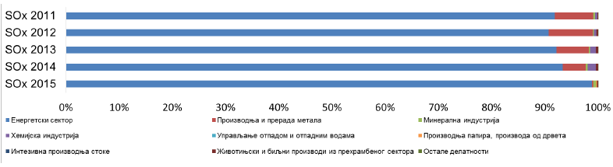
Graph 1.1. SO_{x} emissions by source sectors in the period 2011–2015 (Gg/year)

The spatial distribution of sulfur oxide emissions in 2015, in 25х25 km quadrants and by municipalities, is shown in Figure 1.1.

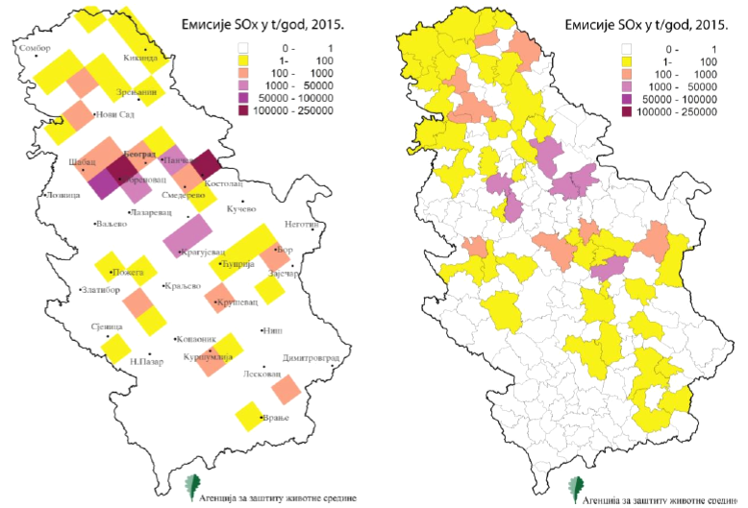

Figure 1.1. The spatial distribution of sulfur oxide emissions in t/year in 2015;
distributions are given in the 25х25 km quadrant grid (left) and by municipalities (right)

The results of the data analysis from the National Registry have revealed that the greatest amounts of nitrogen oxide from point sources in 2015 is 53.50 Gg. The share of sectors in nitrogen oxide emissions is shown in Graph 1.2.
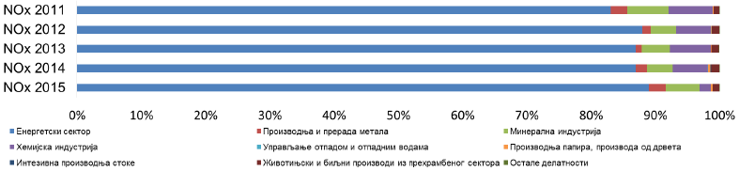

Graph 1.2. NO_{x} emissions by source sectors in the period 2011–2015
The spatial distribution of nitrogen oxide emissions in 2015, in 25х25 km quadrants and by municipalities, is shown in Figure 6.

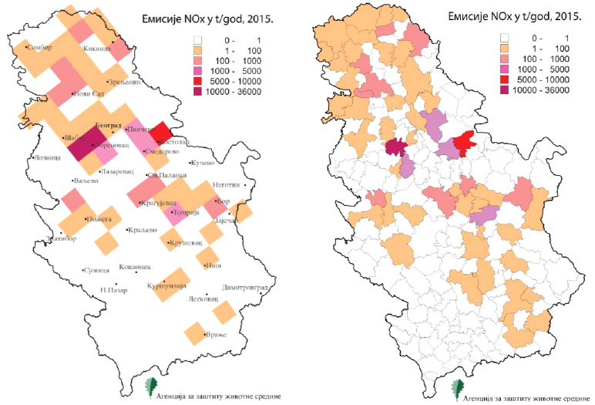

Figure 1.2. The spatial distribution of nitrogen oxide emissions in t/year in 2015; distributions are given in the 25х25 km quadrant grid (left) and by municipalities (right)

The greatest amounts of this pollutant are emitted from thermal power plants, metals production and processing plants, mineral and chemical industries.

- Thermal Power Plant “Nikola Tesla A”;
- Thermal Power Plant “Nikola Tesla B”;
- Thermal Power Plant “Kostolac B”;
- “HIP Azotara” nitrogen plant;
- Thermal Power Plant “Kostolac A”;
- Thermal Power Plant “Kolubara A”
- Cement Plants;
- “Železara Smederevo” Company for the production and processing of steel;
- PD Pannonian TE-TO (Combined Heat and Power Plant), TE-TO Novi Sad;
- NIS, Pančevo Oil Refinery.

The most significant amounts of fine particulate matter in 2015 are emitted from thermal power plants, chemical and mineral industries as well as the production of paper and wood products:

- Thermal Power Plant “Nikola Tesla A”;.
- Thermal Power Plant “Kostolac B1”;
- Thermal Power Plant “Morava”;
- Thermal Power Plant “Nikola Tesla B”;
- Thermal Power Plant “Kolubara”;
- Thermal Power Plant “Kostolac A”;
- RTB Bor, Bor Cooper Smelting Plant and Copper Refining, the Smelting Plant;
- NIS, Pančevo Oil Refinery;
- “HIP Azotara” nitrogen plant;
- Kolubara Mining Basin, the Processing Unit.

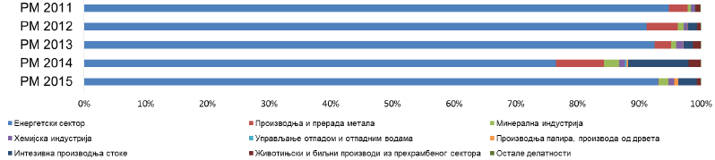

Graph 1.3. Fine particulate matter emissions by source sectors in the period 2011–2015

The total amount of fine particulate matter emitted in 2015 was 14.10 Gg. The spatial distribution of fine particulate matter into air during 2015, in 25х25 km quadrants and by municipalities is shown in Figure 1.3.

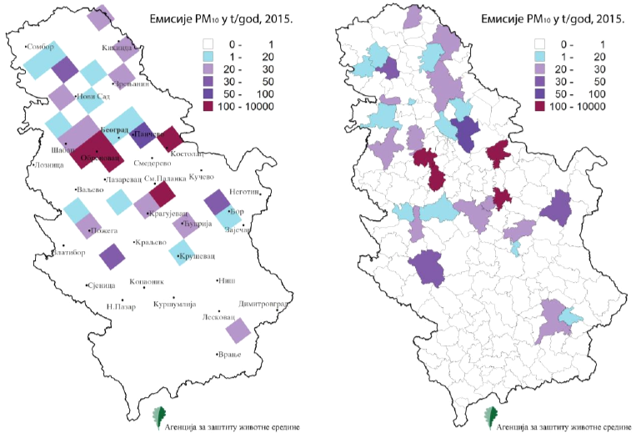

Figure 1.3. The spatial distribution of particulate matter in t/year during 2015: distributions are given in the 25х25km quadrant grid (left) and by municipalities (right)

Climate Change

In the coming years, the accession of Serbia to the European Union and adoption of energy and climate laws of EU will be a major driver for managing greenhouse gas emissions in Serbian energy sector. The current carbon emission intensity and environmental impact of the energy sector in Serbia are high not only compared to EU Member States, but also to the world average. In 2014 the greenhouse gas emissions originating from the Serbian energy sector account for about 80% of the total emissions in Serbia (source: Second report of the Republic of Serbia to the UN Framework Convention on Climate Change: 1.3. Assessment of GHG Emissions), due to which the energy sector has become the most important sector in the future climate-change policy.

Investments in the energy sector, including the increased share of renewable energy in combination with the energy efficiency measures in the final energy use might substantially reduce greenhouse gas emissions. The improvement of energy efficiency is by far the most cost-effective measure given a very low energy efficiency of Serbian economy. It is necessary to carry out a detailed assessment of potentials in different end-use sectors, together with assessment of the most efficient policy and regulations which would enable the use of these potentials. n case of continued lignite dependency in Serbia, a low carbon energy sector can only be achieved by large carbon capture and storage projects. It is difficult to assess when this technology would be commercially available in Serbia. Sectors for electricity production and district heating systems in Serbia are characterized by low energy efficiency and high carbon dioxide emissions Serbia ranks among the 20 most energy intensive and among the 10 most carbon intensive countries in the world in terms of GDP. The simple replacement with new capacities (under assumption that all current capacities will be replaced before 2050) would provide a considerably higher energy efficiency, particularly by using highly energy-efficient technologies. However, this will not be sufficient for achieving a low carbon energy sector.

The National Plan for Emission Reduction is in the process of adoption. The greenhouse gas (GHG) inventory for the period 2010–2013 and projections until 2020, i.e. for the part of the period covered by the Program for implementing the Strategy, are given in the First Biennial Update Report to the UN Framework Convention on Climate Change. The projections about the emission of the greenhouse gases until 2030 and nationally defined contribution to the reduction of the emissions by 9.8% in relation to the emissions in the basic year of 1990, are given in the document “Intended Nationally Determined Contribution of the Republic of Serbia”. Particularly significant to measures, activities and programs mentioned in the Program for implementing the Strategy is the Directive on the limitation of emissions of certain pollutants into the air from large combustion plants, which regulates the realization of a whole series of projects in the field of electric energy, in the field of heat energy, in the field of oil and in the field of industry, where there are large combustion plants. Twenty heating plants within the remote heating system, NIS a.d. and Public Enterprise “Elektroprivreda Srbije” (hereinafter: “EPS”) were recognized as operators subject to the Law on Integrated Environmental Pollution and Control re obliged to file a request to the relevant ministry for obtaining the integrated permit.

Water quality

The quality of surface water is mainly contingent on industrial plants, agricultural production, as well as long dry periods both in the territory of the Republic of Serbia and in neighboring countries and transboundary river basins. Major sources of surface water pollution in Serbia include untreated industrial and municipal wastewater; agricultural drainage water drainage and seepage water from landfills, as well as water pollution caused by pollutants that are spread through rivers, floods and waste materials originating from thermal power plants.

Characteristics (quantitative and qualitative) of surface and groundwater are established on the basis of monitoring relevant parameters. The monitoring results are also used for defining the level of watercourses from the aspect of managing watercourses and protection from harmful effects of waters, including the forecast aimed at defense from floods. For several decades the Republic Hydrometeorological Service (RHMSS) conducted the monitoring of surface and groundwater of the “first” aquifer according to the annual program whose content was stipulated by the law. Starting from 2011 this program has been realized by the Serbian Environmental Protection Agency and RHMSS.

The status of the system for collecting and evacuation (primary and secondary sewage network and main sewage collectors) and purification of wastewaters from settlements (plants for waste water treatment) is at a high level in comparison to European standards. This refers in particular to the development state of the plants so that most wastewaters from settlements are discharged into recipients without necessary purification. In the past few decades more than 50 town plants have been built in Serbian settlements with over 2,000 inhabitants. Thirty two of those plants are in functioning order; a small number of them functions by the project criteria, while others function below the projected efficiency. Effects of the treatment of wastewaters from settlements (for selected parameters) by watersheds are given in the following table.

Table 1.1. Effects of treatment of wastewaters from settlements by watersheds

Watershed | Number of resident users | Effective treatment |  |  | Number of plants
Watershed | Number of resident users | BOC₅, ЕС | Total N, ЕС | total P, ЕС | Number of plants
South Morava | 40,766 | 23,903 | 10,054 | 9,325 | 5
West Morava | 22,988 | 13,793 | 4,598 | 4,598 | 1
Great Morava | 242,178 | 151,114 | 73,379 | 39,684 | 8
Tisa | 124,547 | 90,130 | 59,422 | 61,577 | 6
Sava | 82,967 | 44,886 | 32,582 | 16,479 | 3
Danube | 90,814 | 61,236 | 26,547 | 17,922 | 9
TOTAL | 604,260 | 385,061 | 206,582 | 149,584 | 32
Source: Republican Statistical Office

The existing plants for waste water purification which function serve about 600,000 inhabitants, while their total effective treatment is reduced to about 385,000 EС. The general conclusion is that less than 10% of the population is included in the wastewater purification to a certain extent. Overall effects of the treatment of removing the organic load are below 65%, in nitrogen compounds they are below 35%, while in phosphorous compounds they are below 25%. Moreover, the spatial distribution of built plants in the territory of Serbia is not uniform. Concentrated pollution sources from settlements with more than 2,000 inhabitants account for about 80% of the total pressure by the phosphorus parameter and about 70% by the nitrogen parameter produced by the population.

Additionally, the existing industrial capacities within settlements are most frequently connected to the public sewers of settlements. However, there are no sufficient reliable data about the type and amounts of industrial wastewaters from existing industrial facilities so that meritorious conclusions can be made. Having in mind the decrease in the country’s production, the share of industrial wastewaters within settlements has substantially dropped and is estimated to less than 20% (compared to 45% in the 1980s).
Figure 1.4. Plants for wastewater treatment in Serbia with the estimated treatment effect on BOD5

In industry it is evident that most frequently there are no built plants for pre-treatment of industrial wastewaters before their discharge into the town sewers, i.e. into recipients, or that their functioning is inefficient, which may affect the functioning of the existing plants for wastewater treatment from settlements, as well as the living organisms in water and on the banks. The records about industrial water pollution for large polluters are kept within the National Registry of Pollution Sources (Serbian Environmental Protection Agency) and at the level of local self-government for smaller polluters. Practice has shown that the majority of polluters do not submit regular and timely reports and those who do usually submit incomplete data, which results in the inability of making reliable quantification of industrial pressures. In the absence of relevant data, the locations of wastewater discharges from larger industrial facilities are shown below.

Figure 1.5. Industrial pollution – industrial discharges of waste water
,

The Serbian Environmental Protection Agency has established an environmental indicator called Serbian Water Quality Index (SWQI) which is based on the method of aggregating ten parameters of physical-chemical and microbiological quality (oxygen saturation, BOD5, ammonium ion, the pH value, total nitrogen, orthophosphates, suspended matter, temperature, electrical conductivity, and coliform bacteria) into a composite indicator of surface waters quality. The analysis of water quality by applying the SWQI indicator has been performed for the watersheds of the watercourses in the Republic of Serbia including:

- Waters of Vojvodina, watercourses and Danube-Tisa-Danube canals on the Danube left bank;
- The Danube River from Bezdan station to Radujevac;
- The Sava watershed with the watersheds of the Drina and Kolubara rivers;
- Tributaries of Djerdap Lake, the Danube right-hand tributaries downstream from the mouth of the Great Morava;
- The Great Morava watershed with the watersheds of South Morava and West Morava.

The SWQI analysis encompasses the period 1998–2013 with the total of 21,819 samples of physical-chemical indicators taken on average once a month. The monitoring program for 2013 included 91 measuring points for the control of surface waters quality, where 1,056 samples were taken for the laboratory analysis. The quality percentage of all water samples by year (1998–2013) as determined by SWQI method is given in Graph 1.4.
Graph 1.4. Percentage of all water samples by year (1998–2013) as determined by SWQI method

Source: Serbian Environmental Protection Agency, 2013 State of the Environment Report (pp 52–56). http://www.sepa.gov.rs/download/Izvestaj2013.pdf

The quality analysis of all water samples based on SWQI method for 2013 in comparison to the previous year of 2012 indicates an increasing percentage share of the samples in the category of very poor, which may be the indicator of effects of polluters. However, by checking the results from the measuring stations from the Monitoring program for 2012 it was established that the Monitoring program for 2013 introduced new stations of Slatina (the Bor River) and Slatina (the Krivelj River). Out of the total of 22 samples in these stations, 15 were in the category of very poor and 7 in the category of poor, which changed the picture about the water quality by watersheds in the multi-year average and deteriorated the average quality of Djerdap lake tributaries.

Below is shown the percentage of all water samples by watershed (for the adequate number of samples) for the period 1998–2013 as determined by SWQI method.

Graph 1.5. Percentage of all water samples by watershed (for the adequate number of samples) for the period 1998–2013 as determined by SWQI method
Source: Serbian Environmental Protection Agency, 2013 State of the Environment Report (pp 52–56). http://www.sepa.gov.rs/download/Izvestaj2013.pdf

When the analysis is made in relation to the total number of samples from all watershed regions, the category of very poor includes as many as 79% samples from the Autonomous Province of Vojvodina. The poor water quality of the canals and rivers in AP Vojvodina is proved by the fact that as many as 59% samples in this watershed region falls within the categories of very poor and poor. It is especially concerning that the canals and watercourses incorporated in the hydro-engineering system Danube-Tisa-Danube are in a very poor state. The reason for it is that this system is inadequately used for the evacuation of wastewaters from large settlements and industries, while its performances (flow) is not intended for that purpose. The consequences are extremely grave but not spoken of: the state of water quality in that hydro-system (HS), designed as a typical melioration system (drainage, irrigation, flood protection) is currently such that the water from many HS segments should not be used for irrigation because there is a risk of polluting crops and the soil. The maintenance of the system is poor or almost non-existent, which has substantially reduced the dimensions and the flow of the canals and regulated watercourses due to sediment deposition. However, the problem is that the deposited sediments also contain a large number of pollutants (heavy metals etc.) from discharged wastewaters which are still discharged into the canal network. That is why the problem of cleaning the canal system is rather complex because permanent degradation of soil quality must not be allowed in the dump zones.

The insight into the table of the 10 worst watercourses in 2013 shows that two measuring points had the SWQI mean annual value of “very poor”: Slatina (the Bor River) with SWQI of 29 and Slatina (the Krivelj River) with SWQI of 38 index points.

State of the quality of surface waters

The quality of surface waters was evaluated by looking into the average state of their quality and observed long-term trends, primarily by the parameters which have the character of indicators of pollution input into surface waters coming from various polluter groups. Based on the available data the classification was made of 103 water bodies included in the network of stations monitored for the quality of surface waters.

Figure 1.6. Water bodies according to the Decree on limit values of pollutants in surface and ground waters and sediments, and the deadlines for their achievement

The largest number of water bodies (over 80% of monitored water bodies) is in the 2nd and 3rd quality class, while less than 20% of water bodies is in the 4th and 5th quality class. It should be emphasized that the water bodies in large watercourses, primarily the Danube, Tisa, Sava and Drina rivers, as a rule meet the criteria for the 2nd quality class, except when it comes to the orthophosphates content at the exit section of the Danube, which belongs to the 3rd class. The increased orthophosphates content in this section of the Danube is probably the consequence of the applied sampling methodology. The deteriorated state of certain water bodies has been recorded mostly in smaller watercourses and canals in Vojvodina, as well as in the surroundings of larger settlements. The general conclusion is that the state of quality of surface waters is relatively good having in mind the fact that less than 10% of wastewaters is purified in an adequate manner. It is particularly significant that the water quality of the Danube at its exit from Serbia is much better than at the entrance, i.e. that the quality is improved along its entire flow through our country. That precise and easily provable fact is not used sufficiently in the presentation of Serbia before international bodies in order to show the important role of Serbia in the protection of the Black Sea, which is one of important objectives in the protection of the Danube.

According to the parameters of ecological and chemical status the classification was made of surface waters in the territory of Serbia excluding Kosovo and Metohija, for the following groups of types:

- large lowland rivers with the dominant fine layers (the Danube, Sava, Great Morava, Tisa, Tamiš, Begej and Old Begej rivers) – type 1;
- large rivers with the dominant medium layers, except for the rivers in the Pannonian Plain – type 2;
- small and medium watercourses up to 500 meters above the sea level, with the dominant large lining – type 3
- small and medium watercourses over 500 meters above the sea level, with the dominant large lining – type 4;
- watercourses of the Pannonian Plain (outside type 1 watercourses) – type 5;
- small watercourses outside the Pannonian Plain not included in other types, and watercourses not included in the rule book regulating this field – type 6.

Poor quality of the watercourses by biological parameters was established in about 25% of water bodies, including parts of the watercourses of the South Morava, Rasina, Kubršnica, Nišava, Begej, Zlatica, Turija and Ljig rivers, then the accumulations of Potpeć, Sjenica, Bovan, Gruža etc. The most endangered water bodies – with the poor quality by ecological and chemical parameters – are: Canal Vrbas-Bezdan in the Danube-Tisa-Danube system, from the mouth of the DTD canal to the Zobnatica dam, and Pek-Kaon Gorge, from the mouth of the Ljesnica to the mouth of Kučaj River.

State of the quality of groundwaters

The natural quality of groundwaters in the territory of Serbia is rather uneven, which is the consequence of different mineralogical-petrographic composition of the waterbearing environments, the genesis of groundwaters and aquifers, age of the water, different intensity of water exchange etc. It ranges from exceptional quality which does not require any treatment to waters which require very complex conditioning procedures prior to their use for public water supply.

The chemical composition of groundwaters from the “first” aquifer in the region of West and South Bačka is characterized by mineralization of 250–500 mg/L near the banks of the Sava and the Danube, to 400–800 mg/l in the region of “Varoška” terrace, while in some parts of Bačka the value of this parameter is above 2.000 mg/L. The content of iron and manganese is increased. In the northeast of Bačka the basic aquifer is characterized by the mineralization of 240–480 mg/L, while in the south this value is 350–635 mg/L.

In the Banat region it is possible to distinguish 3 regions by the first aquifer quality: the region north of the Begej and Plovni Begej, the region of central Banat (Zrenjanin–Žitište) and the region of south Banat. The quality of the “first” and basic aquifer in the Srem region is similar to that of Banat, having in mind the hydraulic connection of these two aquifers. Mineralization ranges from 600 to 850 mg/L, water hardness is over 20ºdH, consumption of KМnO₄ is low (3–7 mg/L), while iron is regularly higher (0,5–3,5 mg/L). One of important characteristics of groundwaters of the basic aquifer in Vojvodina region is increased arsenic concentration. Increased concentrations are present in central and north Banat (10–50 μg/L and over 50 μg/ L), in central and north Bačka (10–50 μg/L, even over 50 μg/L) and west Srem (10–50 μg/L).

Water quality of deep aquifers in the region of Bačka and Banat is not satisfactory (due to increased mineralization, iron, organic matter, muddiness), while the quality is much better in Srem. Specially observed negative effects have been registered in the old and damaged industrial facilities of oil industry (Novi Sad, Pančevo), in the area of certain watercourses (Great Bačka Canal etc.), in the zones of numerous settlements without sewer systems, in the zones of farms and industrial-processing facilities.

In other parts of the territory of the Republic of Serbia (south of the Sava and the Danube) there is a variety in the chemical composition of groundwaters, so the overview will be given generally by types of the waterbearing environments. The general characteristic of aquifers in the alluviums of large rivers in central Serbia is relatively low mineralization with the variable content of iron and manganese depending on the area. Increased values of electrical conductivity above 1,000 μS/cm may be considered as indicators of anthropogenic effects and they usually appear in combination with the increased content of nitrates, chlorides and occasionally sulfates. In the Great Morava alluvium increased nitrate concentrations are quite frequent while sporadically there are nitrate concentrations above maximum allowed concentration. This affects the quality of the water used in the public water supply systems, which is poor in the majority of settlements using individual shallow wells, as well as at Garevina, Žabari, Livade, Meminac and Ključ sources.

Soil Quality

The soil quality, i.e. degree of soil degradation, in Serbia is affected by numerous natural processes (erosion, landslides, surface runoff). However, anthropogenic phenomena and processes have significant effect on the soil quality, amongst which the most significant include: soil pollution caused by chemical substances (mineral fertilizers, pesticides) and organic fertilizers (solid and liquid manure) used for agricultural purposes; industrial processes; mining works; inappropriate waste disposal, existence of septic tanks that receive non-sanitary wastes (form households, livestock farms); pollution of soil along the roads due to unsolved water drainage; changes in land use (illegal construction); etc. Soil pollution is also affected by inappropriate agricultural practices, including uncontrolled and improper use of artificial fertilizers and pesticides, as well as absence of irrigation water quality control. Sporadic presence of heavy metals in soil is a result of untreated drainage waters from landfills, as well as from mining facilities and power plants. oil is polluted in areas of intensive industrial activities, inappropriate waste disposal sites, mining areas, as well in places where different accidents occur.

An important source of soil pollution causing high degree of soil degradation include exploitation of mineral raw materials, particularly in Kolubara-Kostolac and in Bor-Majdanpek mining basins, as well as the uncontrolled and inappropriate disposal of industrial waste, particularly nearby large industrial centers (Bor, Pančevo, Novi Sad, Smederevo, Belgrade, Kragujevac). However, although soil degradation as a consequence of exploitation of mineral raw materials is inevitable, such degraded soil is used for an adequate purpose through the technological procedure of recultivation, so negative impacts on the soil are relativized in that context. Another source of soil pollution is deposition of air pollutants contained in the exhaust gases from vehicles along roads, in particular along main roads. Based upon analyses carried out by the Serbian Environmental Protection Agency, 332 locations were identified at which soil pollution was confirmed by the results of laboratory tests of soil and underground water in immediate vicinity of localized sources of pollution, where soil pollutants have been present over a longer period of time.

Agricultural soil analysis was carried out near the three most significant coal mining and electric power industrial complexes: Kostolac basin, TPP „Nikola Tesla“ Obrenovac, and Kolubara mining basin, where lignite is extracted and burned. The total number of 344 soil samples have been taken from the three mentioned locations. The soil test results of samples taken in surrounding area of mining and thermal power plants revealed that limit values of certain parameters, out of which Cd, Co, Cu and Ni stand out, were exceeded.

Graph 1.6. Value percentage in excess of allowable concentrations of heavy metals in soil in surrounding areas of significant coal mine industrial complexes

The land in the Kostolac Mining Basin is mechanically damaged and degraded by open-pit mines and mine rock waste, coal waste and ash dumps. The open-pit mine together with waste rock dumps covers an area of 2,085 ha and extends up to three separate locations. The village of Ćirikovac together with the Mlava-Mogila waste dump which is outside the area of the village covers an area of 525ha, the village of Klenovnik together with the waste dump covers an area of 380ha, open-pit mines in the area of the village of Drmna cover an area of 170ha, while the total area is 1,010 ha together with waste dumps within the areas of villages. In addition to open-pit mines, there are also two thermal power plants (A and B) with total installed capacity of 310MW. Fly ash and slag produced by burning lignite in boilers of thermal power plants is transported by hydraulic removal systems and disposed of in three cassettes of the total area of 264ha. Effects of TPP “Kostolac”, open-pit mines and mine waste rock dumps on soil properties have been monitored in an area of about 49,000ha, where 90 surface soil samples were taken. Fly ash from dumps, gases and particulates from TPP chimneys and coal dust from open-pit mines are principal sources of ambient air and soil pollution.

Thermal power plants „Nikola Tesla“ A and B are located in the Sava River valley near Obrenovac. The fly ash dump covers an area of 407.94 ha. The total area of ash dump of the TPP „Nikola Tesla B“ is 727.68 ha. Effects of pollution originating from TPPs and dumps have been monitored in an area of approximately 46,000 ha, where 206 surface soil samples have been tested.

The Kolubara basin covers an area of approximately 48,000 ha, within which the coal exploitation is envisaged at an area of 13,400ha, out of which 7,038 ha has already been reserved for surface coal mining. Chemically damaged soil has been monitored at an area of 51,000 ha, in a wider area of coal overburden layers, dumps and recultivated areas, where 48 soil samples were taken.

Areas most threatened by pollution

Areas in which the environment is polluted and degraded (locations where concentrations of pollutants exceed limit values, urban areas, areas of lignite open-pit mines, waste rock dumps, fly ash and slag dumps, thermal power plants, expressway corridors, watercourses whose water was classified into the fourth class and “below” class of quality, have negative effects on people, flora and fauna and quality of life of people. For this category, it is necessary to provide such solutions in which further degradation will be relativized by optimal dynamics of the recultivation process. For the purpose of achieving better environmental quality, it is also necessary to carry out the restoration of threatened ecosystems, as well as the remediation of consequences of pollution. The hot spots belonging to this category include: Pančevo, Bor, Majdanpek, Obrenovac, Smederevo, Belgrade, Novi Sad, Subotica, Loznica, Kostolac, Čačak, Lučani (within the company “Milan Blagojević-Namenska”, the reconstruction of the power plant – emitter and electrostatic filter, was carried out in 2012), Kruševac, Šabac, Kikinda, Prahovo, settlements in Kolubara mining basin, expressway corridors Belgrade-Novi Sad, Belgrade-Šid and Belgrade-Niš-Leskovac. The greatest emissions of SO₂, NO_{x} and suspended particles are found in the area of the City of Belgrade, then in Braničevo district, Bor and South Banat districts. Big dumps for fly ash produced during coal combustion in thermal power plants are located in Obrenovac, Lazarevac and Kostolac. Urban areas in this category include: Zrenjanin, Ruma, Valjevo, Kosjerić, Novi Popovac, Kraljevo, Niš, Vranje, Zaječar, Majdanpek, Vrbas, Mladenovac, Smederevska Palanka, Požarevac, Sremska Mitrovica, Kragujevac, Gornji Milanovac, Užice, Priboj, Trstenik, Prokuplje, Pirot, Novi Pazar, Leskovac, Jagodina, Paraćin; as well as watercourses whose water was classified into the fourth class and “below” class of quality.

If the broader context exceeding the frame of the Program is examined for the purpose of a general analysis of the state of the environment in the Republic of Serbia, it may be stated that the hotspots in the Republic of Serbia include Bor (RTB - smelting and mining complex, flotation tailing dump in Veliki Krivelj), Pančevo (chemical and petrochemical industry, refinery), Obrenovac (thermal power plant “Nikola Tesla”, fly ash dump), Lazarevac (open-pit mines, thermal power plant, fly ash and slag dump, Vreoci), Kostolac (thermal power plant, open-pit mines, fly ash and slag dump), Šabac (industry, sludge dump), Belgrade (industry, traffic, landfill sites), Kruševac (chemical industry, landfills), Smederevo (steelworks, raw mineral dump), Loznica (industry, Zajača), Novi Sad (oil refinery, unremedied consequences of the NATO bombardment), and the Great Bačka canal (on the Crvenka-Kula-Vrbas section).

Based upon the Preliminary IPPC List for plants for which an integrated permit is issued in the Republic of Serbia, there are 161 of such plants, out of which 29 in the energy sector. The environmental issue is also important in the context of achieving regional cooperation and cooperation in the Danube and the Sava River basins, as well as in establishing an integrated regional energy market and regional transport network, the Black Sea economic cooperation, transboundary cooperation of regions, etc.

Transboundary impacts

The Republic of Serbia cooperates with the countries in the region on issues of water quality control and transboundary water pollution. International cooperation primarily refers to water quality of the Danube, Sava, Tisa, Tamiš and Drina rivers. The Danube river water is of particular interest for the Republic of Serbia primarily because of public water supply, i.e. the protection of groundwater in the South Bačka and the South Banat against the pollution. The pollution of the Danube river water also affects water quality of the Djerdap Lake. Furthermore, developing the regional cooperation in the field of water resources management is also of great importance. To this end, the sustainable water management, regulation of the use and protection of water and aquatic ecosystem, as well as protection of water against negative impacts, have been carried out based on the ratification of the Convention on Co-operation for the Protection and Sustainable Use of the River Danube and signing of the Framework Agreement on the Sava River Basin.

1.2.2 Elements of the environment that are exposed to impacts

1.2.2.1. Coal mines

Large area occupied by open-pit mines, ecosystem degradation and out-migration of population, i.e. changes in settlements network, are amongst the most significant aspects of structural changes caused by open-pit coal mining. In addition, high levels of harmful emissions from energy-generating complexes cause pollution (air, water, soil and flora). Coal deposits and zones in which raw minerals are extracted are numerous. From the aspect of land use and degradation, the surface deposits and open-pit mines are of special importance. The greatest areas of surface mining include Kolubara Mining Basin, Kostolac-Kovin coal basin and Bor-Majdanpek mining basin.

Kolubara Mining Basin

Coal in the Kolubara surface mining basin is extracted from four open-pit mines: Coal Field “B/C”, Coal Field „D” and “Tamnava – Western Coal Field”. These four coal fields covering an area of approximately 80 square kilometers which are located in Lazarevac, Lajkovac and Ub municipalities make up a technological and production whole. Approximately 30 million tons of coal per year is produced in the “Kolubara” Mining Basin.

Location: 50 km southwest of Belgrade. The Kolubara basin extends along the lower course of the Kolubara river from Lajkovac to its confluence with the Sava river. It encompasses an area of almost 600 square kilometers. The seat of the „Kolubara” Mining Basin is in Lazarevac.
Climate: Moderate-continental climate. Special attention should be paid to winds, because direction in which they blow is an important factor of potential pollution and environmental endangerment in this area. The climate is favorable for agricultural production.

Relief: The area is composed of a lowland to the northwest and a hilly-mountain terrain to the southeast. The Kolubara, as the strongest river in the area, has cut a large valley. The surface mining has completely changed the relief of this area. The broken hilly terrain subsidence in the eastern part of the basin has been caused by coal mining, while a flat terrain surface has been formed by deposited substrates.

Geological properties: Paleozoic crystalline schist, Triassic chalk and limestone, sandstone and marl, mass of extrusive igneous rocks of andesitic and dacitic composition. The economically most important raw mineral in this area include coal, lignite, infusorial earth, quartz-sandstone, etc.

Soil: According to the represented land categories, the most part of the area within the Kolubara mining basin falls into the category of arable land, considering that over 80 % of arable land falls into I-IV worthiness class.

Hydrological characteristics: Several larger and smaller rivers, such as the Kolubara, Onjeg, Ljig, Peštan, Turija, Beljanica, and Lukavica rivers, are in immediate surrounding area.

Ambient air quality: Zones of open-pit mines are sources of high level of dust emissions, but the emissions originating from mining equipment and transport means containing harmful gases such as nitrogen oxides, carbon monoxide, sulfur dioxide and volatile organic matters, are not negligible. The latest systematic monitoring of ambient air quality in the immediate vicinity of the open-pit mines the Mining Basin “Kolubara” branch was initiated in March 2016 at seven measuring points: three in the surroundings of eastern pits and three in the surroundings of western pits (total settleable particles are measured in 4 places). In order to get the best possible picture during the year, measuring at each measuring point was performed continually for ten days every two months (measurements of total settleable particles lasted 30 days respectively). Measurements made in September in the settlement of Baroševac, instead of Kalenić water supply system, were made upon the order of the management of the Mining Basin “Kolubara” branch. The control of the following parameters was carried out: SO₂, NO₂, NO, NOx, CO, RM₁₀ and RM _{2,5}.

The analysis of the mean values of RM10 concentration indicates that in all 20 samples mean values of RM10 concentration were above the limit for the calendar year, i.e. 40 µg/m³.

The analysis of the values of RM2,5 concentration indicates that during the measurement period from 15th January 2016 to 14th April 2016 (20 samplings), all mean values, i.e. 20 out of 20, were above the limit of 20 µg/m³. Only 3 out of 20 minimum values in the series were lower than the limit, while 17 out of 20 (85%) were higher than 20 µg/m³. All individual maximum values were above the limit for that calendar year.

During the measurement period for CO concentration in all three categories of individual values (mean, minimum and maximum) of CO concentration, there were no numerical values above the limit for the annual averaging of 3,0 mg/m³.

No values of NO2 and NO concentrations did not exceed the limit as set out in the applicable regulations. Since the measurement cycle includes a large number of winter days, the findings of increased mean values of RM10 and RM2,5 concentrations may confirm that individual combustion plants contribute to the air pollution in the settlement Baroševac. Having in mind the increased concentrations of fine suspended particles in the ambient air, it is likely that the inhabitants of the settlement Baroševac are exposed to this pollutant inside their households as well.

Water quality: In cooperation with “Tamnava” laboratory which is authorized by the Ministry in charge of environmental matters, including the analysis of surface, ground and waste waters, as well as drinking water, since 2016 systematic monitoring has been performed at 75 measuring points within the Mining Basin “Kolubara” in relation to all waters at the frequency higher than prescribed in the Law. The information about measurements is available to the employees of “Kolubara” on the portal through GIS data base about the environment. A smaller number of parameters for which “Tamnava” laboratory is not accredited are examined by an externally authorized laboratory.

The waters from the pre-drainage and drainage system represent the technological part of the coal exploitation system. The waters pumped from these systems (mining waste waters) are discharged without purification via the sedimentation basins into nearby recipients as follows:

- Open-pit mine “Veliki Crljeni” and open-pit mine “Tamnava East Field” into the Kolubara river;
- Open-pit mine “Field B/C”', Baroševac into the Peštan and Turija rivers;
- Open-pit mine “Field D”, Medoševac into the Peštan river;
- Open-pit mine “Tamnava West Field” into the Kolubara river.

Quality control of the recipients (50 m upstream and downstream from the waste water discharge, as well as at the very place of discharge) is performed by an accredited laboratory four times a year. During 2016, quality control of waste waters at the open-pit mines of the Mining Basin “Kolubara” was performed by the City Institute of Public Health Belgrade, which was in charge of microbiological analyses, and by the laboratory of the Organizational Unit “Treatment”, which was in charge of physical-chemical analyses.

The technological process of treatment and upgrading of Kolubara lignite produces waste waters of Wet separation, Dryer and Heating plant – chemical preparation of boiler water and sanitary water which are purified in the facility for waste water purification. The purified water from the waste water purification facility is discharged via the water-measuring station, into the canal and is transported into the Kolubara river along the 7km-long canal. The discharge of purified water from the waste water purification facility does not affect negatively the quality of the recipient, i.e. the Kolubara river, while there are no significant changes in the water quality of the Kolubara River.

Noise: Noise sources in the "Kolubara-Prerada” include: District Heating Plant, Drier Facility, Dry Separation Facility, Wet Separation Facility, as well as the noise originating from industrial railway traffic, heavy vehicle traffic and cableway. Noise is generated both by processing plants and by transportation of processed coal and coal from open-pit mines. The "Kolubara-Prerada" plants are sources of noise generating different noise levels. Measurements in “Kolubara-Prerada” plants and reload stations in Baroševac have shown that noise exceeds the permitted level. In Vreoci, noise is generated by intensive heavy vehicle traffic. The thermal power plant in Veliki Crnjeni The is also one of the noise sources.

Soil Quality: The degradation of humic soils is caused by surface mining technology used in the Kolubara open-pit mines. The soil degradation typical for this area is a result of intensive coal excavations which have led to the formation of soil of lower worthiness class, as well as formation of deosole and technogenic soils. These are anthropogenic soils derived from disposal of mine waste rock and fly ash, as well as from open-pit mines at which coal is excavated. Higher levels of arsenic (above the permitted 20 mg/kg) have been detected in a greater number of soil samples taken from the most threatened villages (Vreoci, V. Crljeni), while the content of other metals (Cu, Zn, Cr, Pb, Ni, Hg) has shown only an increasing tendency. According to values of parameters tested in soil samples, the most polluted location is the one situated within the area of the Coal Upgrading Facility. On other locations, the values in soil samples have shown that intervention measures are not needed, in accordance with the Regulation.

Other impacts: landscape devastation, degradation of natural cover, degradation of agricultural land cover, erosion, mining equipment noise, change in land use, impacts on biodiversity, habitat loss for certain flora and fauna species, adverse human health impacts.

Kostolac-Kovin mining basin

Over the past four decades, the effects of surface coal mining in the Kostolac basin on all elements of the environment have been numerous. Lignite surface mining in “Drmno”, “Ćirikovac” and “Klenovnik” mines has caused a degradation of geomorphologic and pedologic structure of the terrain and entire ecosystem, negative effects on water natural regime, function of settlements, infrastructure systems, etc.

Location: The Kostolac coal mining basin is located about 90 km east of Belgrade, in a western part of the territory of the town of Požarevac. Other potential deposits of energy resources – zone of oil and gas exploration, are located in the western part of the Veliko Gradište municipality and northern and western parts of the town of Požarevac.

Climate: Moderate-continental climate in which effects of steppe climate of neighboring Banat are noticeable. A relative vicinity of the entrance into the Djerdap Gorge, as well as exit from the Gorge, affects the speed of košava (southeast wind) which blows at over 90km/h and thus significantly affects this region. The entire region is under the influence of this wind about hundred days a year. Characteristics of the climate include dry winters with small amount of snow falls.

Landscape (type of landscape): natural and rural landscape – pastures and meadows with smaller anthropogenic impacts.

Hydrological characteristics: The Danube and its tributaries, the Great Morava and Mlava rivers, with a backwater called “Dunavac” and the Canal make up specific hydrographic features of the region.

Vegetation: Vegetation in areas surrounding open-pit mines is degraded – dust clumps onto the leaves and reduce the effectiveness of photosynthesis, thus affecting the plant's growth rate.
Noise: Excessive noise levels are possible in all phases of lignite surface mining. Noise sources include: machines for lignite excavation and transportation, as well as ancillary machinery, with the following noise emissions: rotor dredges (92–94 dB), dragline excavators (82dB), disposal machines (85–89 dB), conveyor belt transporters (96–102 dB), bulldozers (115 dB), and diesel trucks (110 dB).

Ambient air quality: Excavation, transport and reloading of coal, as well as waste rock, generate the highest level of pollutants in open-pit mines. Waste rock dumps are the largest sources of ambient air pollution considering that they contain large amounts of sand or other loose material, which is particularly pronounced when strong winds blow. Dust emissions form surface mining operations and coal and overburden transported by conveyor belts, as well as harmful vehicle exhaust and diesel emissions from mining equipment (carbon monoxide CO, carbon dioxide CO₂, nitrogen oxides NOx, sulfur oxides SO₂, methane (CH₄) and volatile organic compounds /VOC/, etc.) occur in all phases of technological process in lignite surface mining. Primary pollutants include: point sources (dredgers, loaders), line sources (roads in open-pit mines, conveyor belt transporters for coal and overburden) and surface sources of pollution (active surfaces in open-pit mines and dumps). Occasionally, secondary pollutants are emitted due to greater wind speed causing the dust to rise and disperse within the air. The air quality in the vicinity of the mines and TPP Kostolac A and TPP Kostolac B is examined within a unique network of measuring points.

Water quality: The water from the drainage system of the open-pit mine Drmno is mostly taken to the cooling water basin TPP Kostolac B, while smaller part goes into the Mlava river. The water from the drainage system of the open-pit mine Ćirikovac is accumulated near the mine. The amount of water for the open-pit mine ПК Klenovnik is small and that is why it is not measured. In 2016 quality control of the drainage waters from the system of the open-pit mine Drmno was performed by the accredited laboratory “Institute Jaroslav Černi” at two measurement points. Physical-chemical analyses of drain overflow of water from “Drmno” open-pit mine have shown that mineral oils, phenols and biological oxygen consumption are the main parameters which do not satisfy the water quality in the Mlava river. The water which is used for drinking and sanitary needs at the open-pit mine Drmno comes from its own sources. Quality control of the drinking water is performed by the Institute for Health Protection from Požarevac. The amount of water is not recorded. Sanitary waste waters are purified through the separators and discharged into the internal sewage system. The water which is used for drinking and sanitary needs at the open-pit mines Ćirikovac and Klenovnik comes from the town water supply. Quality control is performed by the Institute for Health Protection from Požarevac. The amount of water is not recorded. Sanitary waste waters are not purified and they are discharged into the internal sewage system.

Soil Quality: TPP-KO Kostolac Branch monitors the emission of pollutants in the soil every two years. According to the Regulation on systematic soil quality monitoring programme, indicators for assessment of risk of soil degradation, and methodology for preparation of remediation programmes (“Official Gazette of the Republic of Serbia” No. 88/2010), soil quality is monitored during the vegetation and non-vegetation periods. Accordingly, soil monitoring and sampling in the vegetation period was performed in summer 2014, while sampling and monitoring in the non-vegetation period was performed in winter 2015. The study results from 2015 indicate that the average value of the total content of heavy metals in the soil of the explored region was usual for agricultural land. The total content of most heavy metals such as zinc (Zn), mercury (Hg), lead (Pb), cadmium (Cd), copper (Cu) or, chromium (Cr) did not exceed the maximum permitted concentration in any samples. The total content of arsenic (As) was above the maximum in one sample, while nickel (Ni) was above the maximum in 40% samples. The values are by far below the remediation value when rehabilitation measures are necessary, except one sample with the concentration of arsenic was at the remediation value level. Taking into account all the results of soil exploration it may be concluded that the explored region is not polluted by most heavy metals. One of the predominant pollutants is nickel (Ni), whose high content is largely caused by the geochemical composition of the parent substrate. Moreover, the difference in average metal values by zones does not clearly point to the impact of distance from the pollutant on the pollutant content, particularly because of large variations of the values within the same zone. The measurements results do not differ substantially from the results from 2012. Note: The Environment monitoring plan and program for TPP-KO Kostolac Branch stipulates that monitoring of impacts of the work of TPP-KO Kostolac Branch should be performed every second year.

Other impacts: higher level of noise and vibrations, accident risk, agricultural land degradation, threat to construction and housing, negative effects on human health, irrational land use, negative effects of pollution on agricultural crops, erosion, landslides, negative effects on natural resources.

1.2.2.2. Thermal power plants (TPP) and combined heat and power plants (TE-TO)

Thermal power plants “Nikola Tesla” (in Serbian: TENT) include:

- TPP “Nikola Tesla A” (with the total of 6 blocks);
- TPP “Nikola Tesla B” (with the total of 2 blocks);
- TPP „Kolubara“ (with the total of 5 blocks);
- TPP „Morava“ (with one block).

“Kostolac” thermal power plants and open-pit mines include:

- TPP „Kostolac A“ (with the total of 2 blocks);
- TPP „Kostolac B“ (with the total of 2 blocks).

“Pannonian” Combined Heat and Power Plant (TE-TO) includes:

- TE-TO Novi Sad.
- TE-TO Zrenjanin.
- TE-TO Sremska Mitrovica.

Thermal power plant "“Nikola Tesla A"

TPP "“Nikola Tesla A" (Serbian: TENT A) uses approximately 56,000 tons of Kolubara lignite per day, while its blocks are combined heat and power plants.

Location: on the right bank of the Sava river, about 40 km upstream of Belgrade between settlements of Krtinska and Urovci, about 3 km west of Obrenovac.

Relief: Most of the region is a noticeable low-lying area, while some parts are low mountain and hilly area. The Bukvik mountain top dominates in a low mountain part of the area.

Geological features: Paleozoic crystalline schist, Triassic chalk and limestone, sandstone and marl, mass of extrusive igneous rocks of andesitic and dacitic composition. The economically most important raw mineral in this area include coal, lignite, infusorial earth, quartz-sandstone, etc.

Hydrological characteristics: The Sava and Kolubara rivers, as well as the Tamnava river which is the third-largest river in this area, actually a canal which remained from the previous course of the river.

Soil: The following types of soil are found in the area: euthric combisols, black soil, strongly acidic euthric combisols, alluvium, sandy soils.

Climate: The area is in the center of moderate-warm belt. The low moderate-warm belt, high relative humidity, fog and atmospheric temperature inversion result in smaller dispersion of flue gases both in vertical and horizontal directions, so that pollutants stay near the ground, near sources of pollution.

Climate change: Coal-fired thermal power plants are a significant source of CO₂ emissions.

Ambient air quality: Flue gases from large combustion plants, after giving up a part of their heat to pre-heaters and intermediate pre-heaters, move through air heaters where they heat fresh air, and then move through electric filters where fly ash particles are separated, and further through fans for flue gases where they are pushed up the chimney into the atmosphere. Flue gases contain pollutants, out of which SO₂, NOx, CO,CO₂ and fine particulate matter (fly ash) are the most significant ones. Fly ash dumps of TENT A contribute to cumulative air pollution. The air quality control near TENT A includes the total settleable particles and sulfur oxide (ЅO₂) in the air. Emissions of the total settleable particles are monitored at 18 measuring points, while ЅO₂ emissions at 4 measuring points at different distances from TENT A and TENT B. These parameters (sulfur dioxide and total settleable particles) are measured for the needs of air quality monitoring within the TENT measurement network, since air quality is also monitored in the vicinity of TENT A and TENT B within the city's and republic measurement network.

In the analysis of results obtained in 2016 the assessment was made of compliance with the legal regulations by comparing measured values of harmful substances emission into the air with the limit emission values as stipulated in the Directive on the limitation of emissions of certain pollutants into the air from combustion plants (“Official Gazette of the Republic of Serbia” No. 6/2016), the Directive on measurements of emissions of pollutants into the air from stationary pollution sources (“Official Gazette of the Republic of Serbia” No. 5/2016) and the EU Directive 2001/80/EC referring to large combustion plants. The deviation in the emission of fine particulate matter from the limit in Blocks А1 and А2 in TENT A, where the EF reconstruction was performed, is connected with increased amounts and temperatures of smoke gas in comparison to the projected values. During 2016 there were guarantee measurements of the emission of fine particulate matter of reconstructed electric filters in Block A3 – Тest B. The resutls of Test B confirmed the output concentratin of fine particulate matter below 50 mg/Nm³. In Blocks A3 and A5 the burners were reconstructed with the aim of reducint the emission of nitrogen oxides and increasing the power of the block (Block А3). During 2016 EF reconstruction was performed in Block М1 in TPPM. The guarantee measurements of fine particulate matter were performed in the reconstructed electric filter.

Water quality: During 2016 quality control of ground waters was performed in the vicinity of landfills: TENT A – 10 piezometers and 5 village wells, TENT B - 9 piezometers and 9 village wells, TPP Kolubara А – 1 piezometer and 4 village wells and TPP Morava 1 piezometer and 5 village wells. Since the manganese concentration in overflowing and drainage waters of the fly ash dump is low, the increased manganese concentration in the water of certain village wells is probably the consequence of the high presence of this element in the soil. The high zinc concentration measured in the piezometers in TENT A and TENT B is contributed to the dissolution of metals from galvanized pipes the piezometers are made of. The bacteriological analysis of the water in village wells indicates the presence of coliform bacteria. Increased concentrations of ammonia, nitrites and nitrates are of sewage origin due to the vicinity of septic tanks and stables. Increased concentrations of manganese and nitrates in the water of village wells as well as unsatisfactory bacteriological quality in the vicinity of the fly ash dump TENT B were established by “zero state” exploration. Therefore, it can be definitely concluded that they are the consequence of high presence of these pollutants in the soil (manganese) or the effect of septic tanks and stables located near village wells (ammonia, nitrates, unsatisfactory bacteriological quality).

Fly ash disposal: The cassette 1 of the ash dump of the TENT A in Obrenovac is covered with earth. The cassette 2 is active and the ash dumped into this cassette is mixed with water, while the cassette 3 is passive and recultivated, with planted grass.

Noise: In 2016, environmental noise measurements in the vicinity of the TENT A showed higher nighttime noise levels in some measuring points, while permitted noise levels were not exceeded in the daytime.

Other impacts: accident risk, negative effects on health of people, problem in waste management, negative effects of pollution on agricultural crops, degradation of agricultural land, greenhouse gas emissions, negative effects on natural resources.

Thermal power plant “Nikola Tesla B”

Location: on the right bank of the Sava river, 50 km upstream from Belgrade, between settlements of Skela and Ušće, in the area called Vorbis.

Relief: The most of the region is a noticeable low-lying area, while some parts are low mountain and hilly areas.

Geological features: Paleozoic crystalline schist, Triassic chalk and limestone, sandstone and marl, d mass of extrusive igneous rocks of andesitic and dacitic composition. The economically most important raw mineral in this area include coal, lignite, infusorial earth, quartz-sandstone, etc.

Hydrological characteristics: the Kolubara, Sava and Tamnava rivers.

Climate: In the center of moderate-warm belt. The low moderate-warm belt, high relative humidity, fog and atmospheric temperature inversion result in smaller dispersion of flue gases both in vertical and horizontal directions, so that pollutants stay near the ground, near sources of pollution.

Climate change: Coal-fired power plants are a significant source of CO₂ emissions.

Ambient air quality: Flue gases from boiler furnaces, after giving up a portion of their heat to pre-heaters and intermediate pre-heaters, move through air heaters where they heat fresh air, and then move through electric filter where fly ash particles are separated, and further through fans for flue gases where they are pushed up the chimney into the atmosphere. Flue gases contain pollutants, out of which SO₂, NOx, CO,CO₂ and fine particulate matter (fly ash) are the most significant ones. In 2016, in the vicinity of TENT A and TENT B measurements were performed of the content of total settleable particles, sulfur dioxidee concentration and soot concentration. The measurement of the content of total settleable particles was performed at 18 measurement points, while SО₂ and soot concentrations were monitored at 4 measurement points. Due to periodical breakdowns of the air samples, the availability of the data for SО₂ and soot is 87.8%. During 2016 there were no stormy winds which could have caused substantial fly ash from the dumps and citizens did not complain aboug air pollution. All the existing protection systems in active cassettes at the ash dumps of TENT A and TENT B were in operation, while the water mirror had the optimal surface area in line with the technical conditions. Moreover, dry surfaces were soaked. Based on the long-term monitoring of air quality in the surroundings it may be concluded that SО₂ are below the prescribed mean daily ad mean annual limit values and tolerable values and that they do not constitute a local but a global problem; air pollution caused by ash particles is of local importance, whereas the consequences are mainly eolic erosions of the ash from the dumps during wind storms.

Water quality: The situation is the same as in the case of Thermal power plant “Nikola Tesla A”.

Fly ash disposal: New technology for reducing the ash dispersion level is used by mixing fly ash with water in the ratio 1:1 (previously, this ratio was 1:10).

Noise: In 2016, environmental noise measurements in the vicinity of the TENT B showed that permitted levels for the nighttime and daytime noise were not exceeded in none of the measuring points.

Other impacts: landscape degradation, degradation of agricultural land cover, change in land use, impacts on biodiversity, habitat loss for certain flora and fauna species, adverse human heath impacts.

“Kolubara” Thermal power plant

Location: "Kolubara" thermal power plant is located at the edge of the Kolubara mining basin, in Veliki Crljeni, 15km north of the center of Lazarevac.

Climate: Moderate-continental climate. North, southeast and west winds are most frequent winds in this region. Wind speed ranges from 0.1 to 6.5 m/s.

Relief: The terrain is inclined towards the Kolubara river which forms a western boundary of the region. The northwestern part of the region is a low-lying land, while the southeastern part is a hilly area.

Vegetation: This is a forest-rich region. Oaks trees grow in the low-lying area, while elms trees grow in the hilly part of the area. Climatic and soil conditions are very favorable for growing all main agricultural crops: maize, vegetable, fruit, beet, sunflower, etc.

Geological features: The region is composed of different rocks, both in terms of their geological age and way of their formation, as well as in terms of their petrographic and chemical properties. The geologically oldest rocks include Paleozoic crystalline schist, Triassic chalk and limestone, sandstone and marl. The lower, hilly part of the terrain and low-lying terrain is composed of Tertiary and Quaternary sediments composed of sand, clay, sandstone, limestone, loam, gravel, infusorial earth, and coal. A large mass of extrusive igneous rocks of andesitic and dacitic composition bears witness of turbulent geological past of this region.

Hydrological characteristics: The Kolubara, Beljanica, Seona and Turija rivers.

Ambient air quality: Sources of air pollution in the TPP “Kolubara“ include: two chimneys (105m and 130m high), ash and slag dump – coal dump, coal transportation system. Principal air pollutants emitted from the TPP "Kolubara" include: sulfur, nitrogen and carbon oxide, solid particles of fly ash and slag, and coal particles. The results of analysis of harmful emission measurements revealed that:
- Measured values of solid particle measurements most frequently exceeded the GVI values;
- Measured values of nitrogen oxide concentration were most frequently within the GVI values;
- Measured values of sulfur oxide concentrations frequently exceeded the GVI values for such boiler furnaces.
Considering the content of sulfur in the fuel (0.5% in average), as well as the fact that de-sulfuring plant has not been built, such values are expected. The results of the analysis of measurements of emissions of harmful ambient air pollutants revealed that:
- Measured values of median daily SO₂ concentration were bellow the prescribed GVI values;
- Measured values of median daily soot concentration were season depended.

In the summer, they are within the permitted limit value, while in the winter they exceed the permitted limit value. However, due to simultaneous effects of local household solid-burning stoves, the overall results cannot be fully accepted as they refer only to operation of thermal power plant. The analysis of the obtained results of ambient air quality revealed that direct effects of thermal power plant are felt in the northwestern – southeastern zone due to circulation of winds. This zone along the mentioned longitudinal axis extends from northwest of the Ibar's main road to southeast of Sokolovo junction (Local Ecological Action Plan of the City Municipality of Lazarevac). The problem of ambient air pollution originating from fly ash dump has been solved through recultivation of passive cassettes and maintenance of water body in the active cassette, i.e. through a careful monitoring of activities at ash and slag dumps. The “Kolubara” thermal power plant has permanently recultivated cassettes 1 and 2 in the area of about 32 hectares by applying 30 cm thick humus layer, as well as by afforestation of the plateau and edge slopes of cassettes. Cassettes “A” and “B” were superelevated up to maximum ground level of 116 m above sea level. The cassette “A” is active, where, by unloading hydromixture, a water mirror is formed which is not less than 60% of the dump surface. By frequently changing the unloading spots, dry beaches are sprayed with water. The cassette “B” is passive, namely, the humus layer has been applied on cassette slopes and plateau. A transport of hydromixture is used in block A5 at ash-water ratio 1:3.

Water quality: In cooperation with “Tamnava” laboratory which is authorized by the Ministry in charge of environmental matters, including the analysis of surface, ground and waste waters, as well as drinking water, since 2016 systematic monitoring has been performed at 75 measuring points within the Mining Basin “Kolubara” in relation to all waters at the frequency higher than prescribed in the Law. The information about measurements is available to the employees of “Kolubara” on the portal through GIS data base about the environment. A smaller number of parameters for which “Tamnava” laboratory is not accredited are examined by an externally authorized laboratory. The amount of water taken from the Kolubara river for the needs of technological processes is estimated at about 5.5 million m³/year. TPP Kolubara has seven discharge outlets as follows: one for discharge of waste water from the slag and fly ash disposal site into the Turija river, and five discharge outlets for the discharge of waste water via the Bare canal into the Turija river. Technical water used for fly ash and slag transport from excavator stations is discharged through two pipelines into the dump where there are several unloading spots on the active cassette which operate alternately. In TPP Kolubara, there is a system of recirculating water from the fly ash dump.

Oil separators are installed in two discharge outlets into the Bare canal, thus preventing discharge of oily water. The other three discharge outlets into the Bare canal include two discharge outlets from coal dump and one for cooling water. Sanitary wastewater is discharged into the Kolubara river. Water from chemical preparation of water is transported to the ash and slag dump via a special pipeline.

Noise: Thermal power plant is a source of noise of different strengths and frequencies. Specific technological operations and large-scale mining equipment can generate high noise levels. Occasionally, the level of noise originating from the TPP “Kolubara” exceeds the permitted values.

Soil quality: The highest soil pollution levels occur near sources of soil pollution. Secondary contamination occurs under the influence of unfavorable weather conditions when gases and fly-ash particles settle down on the ground. Soil acidity varies, which can be associated with different acid-gas sediments at different distances from their sources. The soil acidity in soil samples tested ranges from 6.32 to 7.15 pH units, which varies from year to year. Soil reaction in 25% samples was slightly acid (pH 6.32-6.50), while in 75% samples the soil reaction was neutral.

Other impacts: landscape devastation, degradation of forest and agricultural land cover, problems with waste disposal, adverse human heath impacts, impacts on biodiversity.

Thermal power plant “Morava”

Location: on the right bank of the Great Morava river, 2,8km from Svilajnac. This location has been selected because of its position which is the most favorable for waste coal transportation from surrounding mines, as well as vicinity of the river whose water is used for cooling systems.

Climate: Moderate-continental climate. Vicinity of high mountain massive to the east of the area, wide openness towards the west, towards the Great Morava river valley, affects microclimates. The southeast wind known as “košava“ prevails in periods of cool weather, while northwest wind is typical for the periods of warm weather.

Relief: Low-lying land of the Great Morava river valley.

Geological feature: The area is composed of sedimentary rocks, neogenic lake sediments in the hilly part of the area, and alluvial plain in the valley formed by the Great Morava river depositing the sediments on its flood plain. Neogenic sediments are mainly composed of sand and clay, while Tertiary limestone is also found in places.

Hydrological characteristics: The Great Morava and Resava rivers.

Air quality: Flue gases containing sulfur dioxide, nitrogen oxide, carbon dioxide and fine particulate matter are discharged through the 105m high chimney after the purification and separation of fine particulate matters in electro-fillers. The analysis of results of measurements of specific target air pollutants which was carried out in 2016 revealed that values for fine particulate matter, SО₂ and NOx exceeded GVI values.

Water quality: Drain wastewater that overflows during ash and slag hydraulic transport is directly or indirectly discharged into the water recipient due to obsolete hydraulic transport of “rare” ash-water suspension (1:10). Wastewater originating from washing the steep-angle conveyors is directly discharged into river after the mechanical sedimentation of coal particles in sedimentation chambers. Sanitary wastewater are not purified but directly discharged into city’s sewage network. Water which contains oil and/or mazut (fuel oil), after undergoing the process of separation of oil or mazut through absorbing membranes, is indirectly discharged into the water recipient through rain drain pipes or through recirculating cooling water tunnel. The analysis of data obtained in recipients revealed that there was no significant change in water quality in the Great Morava river downstream from the TPP “Morava”. There was no significant change in water quality of the Great Morava river downstream from TPP Morava, while rise in water temperature downstream from the thermal power station was less than 3°C.

Noise: Noise occasionally exceeds the permitted level. According to the latest measurements carried out in 2016, permitted noise levels were exceeded in the nightime.

Other impacts: adverse human health impact, impact on flora and fauna, problems in waste management.

Thermal power plant “Kostolac”

The "TPP - KO Kostolac" uses lignite from "Ćirikovac" and "Drmno" open-pit mines to generate electricity.

Location: in the peri-Pannonian part of the northeastern Serbia, nearby the town of Kostolac and archeological site of Viminacium.

Relief: The relief of the Kostolac basin terrain is characterized by sediment accumulation and soil erosion. Morphologically, the area covered by the Plan is characterized by two ridges (Požarevačka greda and Boževačka greda ridges), with Stig valley in-between. Ridges extend from north to south and are almost parallel. Topographically, the tertian of the Pannonian region slopes downward towards large rivers.

Climate: Moderate-continental climate. The effects of the steppe climate of neighboring Banat are noticeable. The region is highly affected by “košava”, strong southeast wind.

Hydrological characteristics: The Danube and its tributaries, the Great Morava and the Mlava, with a backwater called “Dunavac” and the Canal make up a specific hydrographic features of the region.

Type of land use: Most of the land is arable land, due to which the interest in preserving agricultural land is significant. Mostly arable land is used primarily for the production of wheat, vegetable and stone fruit, while soil fertility can be improved by deep plowing, the use of fertilizers and erosion protection in inclined terrains.

Vegetation: Conditions for vegetation to grow are very favorable, both in low-lying areas and valley and hilly areas. Vegetation types include forest and steppe vegetation in low-lying areas, while hilly areas in the east were once covered by sweet oak and bitter oak trees. Due to high soil moisture, the areas around watercourses (marshy land, marsh vegetation) are natural forest complexes (poplar, willow, common oak, hornbeam, alder, ash-tree etc.), which are autochthonous plant species. So far, insufficient attention has been given to the vegetation preservation so that many habitats have been degraded.

Ambient air quality: During 2016 air quality control near the open-pit mines of the Mining Basin “Kolubara” was performed by the City Institute of Public Health Belgrade (from January to April) and by the by the Institute for Health Protection from Požarevac (from April to December). The measurement was made of the content of total settleable particles, sulfur oxides (SO₂), suspended particles (PM10), soot and heavy metals (Pb, Cd, As and Ni), by processing samples collected in the one-month period for total settleable particles, while SО_{2 c} concentrations were measured by processing 24-hour air samples. “Kostolac A” and “Kostolac B” thermal power plants emit different harmful pollutants that cause ambient air pollution. Harmful pollutants emitted by thermal power plants in the atmosphere include SO₂, NO_{x}, CO₂, CO and fly ash particles. The closer and wider surrounding areas are directly polluted during the transportation and storage of fuel (lignite). The sulfur dioxide which, together with nitrogen oxide, causes acid rains, has the greatest negative effects on human health, flora and fauna, as well as on materials (accelerated corrosion). In addition, a certain amount of particles are emitted from coal dumps, as well as from ash and slag dumps. While ambient air pollution occurs in the immediate vicinity, the ash discharged from chimneys can be dispersed over long distances in dependence of chimney height and weather conditions. The “Middle Kostolac Island” ash and slag dump is a secondary source of pollution because strong winds often disperse the fly ash particles causing excessive ambient air and soil pollution in the vicinity. Based upon comparison of results of emission measurements with the maximum values of the emission (GVI) prescribed by domestic law and EU regulations, in can be concluded that emissions of SO₂, NOx, CO and fine particulate matter occasionally exceed the permitted levels.

Water quality: The used cooling water from the TPP „Kostolac B” is discharged into the Mlava and Danube rivers, but they do not cause significant temperature rise. Hydraulic transport of fly ash and slag provides a necessary level of surface and groundwater protection: overflowing water that leaves the dumps reaches surface water which infiltrates into groundwater. Groundwater in the surrounding area of fly ash dumps is characterized by increased mineralization (increased water hardness, higher content of sulfates, etc.) and higher content of solid substances, lubricants, oil or β radioactive emitters. Wastewater from dumps increases concentration of SO₄, calcium, magnesium, iron, zinc, mineral oils and arsenic in groundwater. Bacteriologically, aerobic mesophilic bacteria, as well as coliform bacteria, have been detected in groundwater, but their number meets the prescribed norms.

Soil Quality: The content of natural radionuclide in coal combustion fly ash and slag is increased relative to its content in a common soil, but does not lead to a significant increase in internal and external radiation exposure.

Location of ash: The “Middle Kostolac Island” ash and slag dump is used for disposal of fly ash and slag from TPP “Kostolac A” and TPP “Kostolac B”.

Noise: The results of noise measurements revealed that in all measurement points the permitted ambient noise levels for both daytime and nighttime period were exceeded.

Other impacts: greenhouse gas emission, adverse human health impacts, impacts on biodiversity, landscape devastation, change in land use, degradation of forest and agricultural cover, problems with waste disposal.

Combined Heat and Power Plant Novi Sad

Location: in northern, industrial area, on the river bank of the Danube, only 5 km from the city of Novi Sad. Combined Heat and Power Plant Novi Sad is the largest of the three Pannonian combined heat and power plants.

Relief: The city of Novi Sad lies on the river banks of the Danube. The lowland area is located on the left river bank of the Danube (Bačka), while on the right river bank, the hilly part of the area lies on the Fruška gora slopes (Srem). Elevation from the Bačka side ranges from 72 meters to 80 meters above the sea level, while from the Srem side, the elevation ranges from 250 meters to 350 meters above the sea level.

Climate: Climate of the area transforms from moderate-continental to continental. The dominant wind is „košava“ – a southeast wind.

Hydrological characteristics: The Mali Bački canal flows into the Danube near Novi Sad. It is a part of the Danube-Tisa-Danube canal and smaller irrigation canal.

Geological features: The area is characterized by two different geomorphologic entities: Fruška Gora, an isolated, narrow mountain, and the flat alluvial plain of the Pannonian basin. The southernmost part of the alluvial plain of the Pannonian basin which has a uniform geological composition and slightly emphasized relief belongs to the surrounding area of Novi Sad. The dominating fluvial erosion limited by meander cutting into the Danube river bed, as well as aeolian and fluvial sediment accumulation, is a factor of relief pollution.

Ambient air quality: Flue gases containing sulfur dioxide, nitrogen oxide and fine particulate matter are discharged through 160m high chimney into the atmosphere. Emissions of pollutants in atmosphere in 2016 were below GVI, while emissions of NOx (NO₂) were sometimes above GVI.

Water quality: The largest amount of water in the TE-TO Novi Sad is used for the water cooled surface condensers and recirculating cooling water system, while water is supplied from the Danube river. The return cooling water, as well as all other wastewaters, after the purification are discharged into the Danube. The Danube river is classified as 2nd class watercourse. In 2016 the Danube river, upstream and downstream, did not meet the MDK for the 2nd watercourses, as well as that concentrations of ammonia, inorganic nitrogen and suspended particulate matter in sewage water.
Noise: Noise measured in the surrounding area of the Combined Heat and Power Plant Novi Sad, near the “Šangaj” settlement showed that the noise levels were within the permitted outdoor ambient noise level in the residential area for both daytime and nighttime period.

Other impacts: waste disposal, adverse human health impacts.

1.2.2.3. Hydroelectric power plants

Hydroelectric power plants (HEPS) inevitably cause environmental impacts. This primarily includes changes in aquatic ecosystem of reservoirs and riparian ecosystem. These changes are of permanent character and require continuous monitoring and protection measures. Different processes take place in HEPS accumulation reservoirs causing a significant water quality degradation due to organic matters and waste which are brought in the accumulation reservoirs.

Hydroelectric power plants (HPPs) within the HPP “Djerdap” include: HPP “Djerdap 1”, HPP “Djerdap 2”, HPP “Pirot” and “Vlasinske” HPPs

Hydroelectric power plant “Djerdap 1”

Location: It is located 10km downstream from Kladovo, 943 kilometers from the Danube mouth at the Black Sea. The hydropower and navigation system "Djerdap 1" is a complex multi-purpose facility. It is currently the largest hydroelectric facility on the Danube. It is completely symmetrical and designed so that each country (Serbia and Romania) has equal parts of the main facility available, which they maintain and use according to the agreement and conventions on construction and exploitation. It is a run-of-the river hydropower station.

Relief: Relief of the terrain is complex and very diverse, composed of tectonic forms (mountains and valleys) formed through exogenic processes – paleo-abrasion relief, fluvial- denudation plateau, karsts both on the surface and beneath surface, aeolian forms.

Geological features: Almost all rocks were formed during all geologic periods: Paleozoic crystalline schist, Permian red sandstones, Mesozoic sandstones and dolomites, Paleocene-Neogene sediments, Quaternary deposits of marl and quicksand and plutonic and volcanic rocks.

Morphological aspects: Main morphological elements include the Djerdap Gorge and lower and medium-high mountains with valleys between them. The gorge is 100 km long and connects the Pannonian basin with the Pontic basin, intersecting the Carpathian mountains.

Climate: A climate boundary zone between steppe climate of Pannonian plain, moderate-continental climate of south edge of Pannonian basin (Šumadija) and continental climate of lowland of Vlaška.

Hydrological characteristics: The Danube river, identified as the Pan European Transport Corridor 7 is a vital connection between the Western Europe and countries of the Central and Eastern Europe. The Djerdap Lake was formed after the construction of a 54 m high and 760 m wide dam. The Lake is 140 km long and 130m deep. It extends between Sip and Ram.

Soil and groundwater: The Danube slow-down caused by building the hydroelectric power plant resulted in changes in groundwater regime in the riparian area. Groundwater level is higher, but oscillations in groundwater levels have been mitigated. Drainage systems have been built to protect land from ground water discharges.

Water quality: According to basic physical-chemical and biological water quality indicators, the water quality in the accumulation reservoirs meets the prescribed quality for the 2nd class watercourses. Out of hazardous matters, the higher concentrations of phenol matters and mineral oil in water have been occasionally registered, which can be associated with the fact that the Danube is one of the largest transportation routes. The content of other hazardous substances and materials in water is within the permitted limit for the 2nd class watercourses (heavy metals, polychlorinated biphenyls, polynuclear aromatic hydrocarbons, radionuclide).

Floating debris: The existing level of urbanization and the development of industry and utility infrastructure resulted in occurrence of a great number of different concentrated and dispersed pollutants upstream from the hydroelectric power plant. Solid wastes from a great number of illegal dumps located at banks of accumulation reservoir, as well as non-purified wastes and used water ,generate a large amounts of floating solid waste upstream from the hydropower plant causing problems in its operation, as well as in operation of its ancillary facilities.

Noise: So far, noise measurements have not been carried out in the surrounding area of “HPPs Djerdap” (Power Plants Djerdap Limited Liability Company) because hydroelectric power plants are dislocated from settlements and, as such, they are not factors of environmental risk from this aspect.

Waste: Municipal solid and floating wastes collected from water surface and waste trap grilles in front of hydro-aggregates at the entrance of facilities of hydroelectric power plants is transported to the landfill built near Davidovac on regular basis. The landfill was built in accordance with current regulations.

Wastewater: Approximately 100 million m³ of technical water and 20.000 m³ of wastewater is discharged from HPP “Djerdap 1” per year. Technical water mostly includes a cooling water used for turbine cooling and, as such, it is discharged in the Danube. The cooling water contains small amounts of oil.

Hazardous matters: In the HPP “Djerdap 1”, there are 12 transformers filled with transformer oil which contains PCBs. Other hazardous matters include turbine and hydraulic oils which are stored in central storage facility. The oil service unit contains 16 reservoirs per 30m³ of oil. The HPP “Djerdap 1” uses a relatively small number of chemicals which may be considered dangerous.

Other impacts: geological stability, impact on flora and fauna due to changes in water level, impact of locally higher relative humidity of the air, impacts on water quality (depending on how long harmful substances stay in water, as well as on their quantity), erosion downstream along river banks due to fluctuations in river water level.

Hydroelectric power plant “Djerdap 2”

Location: A developed area which extends 80 kilometers downstream from HPP “Djerdap 1”. The HPP “Djerdap 1” is the second joint venture between Serbia and Romania on the Danube. It was built at river km 863 upstream from the Danube river mouth at the Black Sea, at Kusjak-Ostrovul Mare profile. This system is a complex and multipurpose hydro-technical facility. It consists of a main hydroelectric power plant, two additional hydroelectric power plants, two spillway dams, two water locks, and two switchgears. One of each two mentioned hydropower plants belongs to Serbia and Romania respectively. Considering that Serbian-Romanian border is between the two hydroelectric power plants, each side maintains and exploits its part of the system without being disturbed. These are run-of-the river hydroelectric power plants.

Relief: The relief is complex and very diverse, represented by tectonic forms (mountains and valleys). The relief was formed through exogenic processes - paleo-abrasion relief, fluvial- denudation plateau, karsts found both on the surface and beneath it, aeolian forms.

Geological features: Almost all rocks were formed during all geologic periods: Paleozoic crystalline schist, Permian red sandstones, Mesozoic sandstones and dolomites, Paleocene-Neogene sediments, Quaternary deposits of marl and quicksand and plutonic and volcanic rocks.

Morphological relief forms: The main morphological elements of the relief include the Djerdap Gorge and low and medium-high mountains with valleys between them. The gorge connects Pannonian basin with the Pontic basin, intersecting the Carpathian mountains.

Climate: A climate boundary zone between steppe climate of Pannonian plain, moderate continental climate of south edge of Pannonian basin (Šumadija region) and continental climate of lowland of Vlaška.

Hydrological characteristics: The Danube river as Pan European Transport Corridor 7 is a vital connection between Western Europe and countries of Central and Eastern Europe. The Djerdap Lake was formed after the construction of a dam 54 m high and 760 m wide. The Lake is 140 km long and 130 m deep. It extends between Sip and Ram.

Suspended debris: At all measured profiles, the content of suspended particulate matters in the accumulation reservoir of the HPP “Djerdap 2” was less than 10 mg/l. A decrease in concentrations of suspended particulate matters was recorded along the watercourse during April, while values measured in June and September were low and uniform along the entire watercourse.

Floating debris: Problem of floating debris is particularly pronounced in the period of high water levels when a great amount of wood waste, plastic package waste, and other floating wastes originating from different sources of pollution upstream of hydroelectric power plant accumulate on water trap grilles in front of aggregates. These wastes are collected by special lifting equipment – the so-called “sweepers”, and transported to industrial landfill of the HPP “Djerdap 2”.

Water quality: According to all basic physical-chemical and biological indicators of water quality, water in the accumulation reservoir of the HPP “Djerdap 2” belongs to prescribed water quality for the 2nd class. The water quality in the accumulation reservoir is a direct result of the quality of water which inflows in the reservoir.

Wastewater: Sources of wastewater from the main hydroelectric power plant and HPP “Djerdap 2” include water from sanitary blocks and cooling systems of aggregates and block-transformers. The quality of wastewater from HPP “Djerdap 2” is monitored on quarterly basis. All prescribed water quality indicators are monitored according the Regulation of Water Classification (“Official Gazette of the Republic of Serbia”, No. 50/2012). С Considering that all technical and sanitary waters are discharged into the Danube in the same place, cumulative impact of wastewater and technical water is monitored.

Hazardous matters: In the HPP “Djerdap 2”, hydraulic and technical oils are used for auxiliary technological equipment of aggregates, while spare amounts of these oils, as well as transformer oil, are stored in the central storage facility. Oils used in the HPP “Djerdap 2” are PCB free.

Waste: Wastes are collected in places at which they are generated and then transported to the plateau in front of the central storage facility in Kursjak, which is located within the HPP “Djerdap 2”. Hazardous waste is stored in the storage facility for hazardous waste matters in Kusjak. The storage facility and its surrounding area is arranged in accordance with current regulations. In the HPPs “Djerdap”, there is an ongoing process of introducing the waste management (sorting, classification in places of waste generation and processing for further treatment). Oil purification is carried out in purification facility within the main hydroelectric power plant. The purified oil is reused so long as it has satisfactory characteristics, while oil sludge is collected and disposed of in storage facility for hazardous waste from which it is delivered to institutions which are authorized for further waste treatment.

Noise: So far, noise measurements in surrounding areas of electric power plants within the „HPPs Djerdap“ have not been carried because hydroelectric power plants are dislocated from settlements and, as such they are not factors of environmental risk.

Other impacts:
- Microclimate change in the accumulation reservoir area within the HPP “Djerdap 2” due to large amount of water;
- Difficult recreational use of reservoir banks due to water-level fluctuations of reservoir;
- Disturbed regimes of surface waters;
- Groundwater level rise in the entire stretch;
- Potential landslides;
- Great daily water-level oscillations of the Danube river;
- Fish migration.

Hydroelectric power plant “Pirot”

Location: It is located in the territory of southeastern Serbia, between the town of Pirot and Serbian-Bulgarian border. The hydroelectric power plant uses water from the Visočka river at the profile of the “Zavoj” dam. It is a hydroelectric power plant with accumulation reservoir.

Relief: The mountains were formed during the Alpine orogeny. They constitute the western part of the Balkanides directed parallel to the Earth’s axis confronting the Meridian Carpathians and create an arch-shape mountain belt. The mountains include the Suva Planina mountain, Svrljiške Planine mountains, and mountains of Ozren, Devica, Tupižnica, Tresibaba, and Belava. The Pirot valley is a part of a composite valley of the Nišava river.

Geological features: Mesozoic rocks. The type of rocks include different colors sandstones and conglomerate. Limestone and Dolomite limestone cover a very large area, while alevrolites and sandstone shale are imbedded in carbonate rocks. The belt close to the river is composed of eluvial-delluvial materials. Concerning the geological rock formation, the terrain is composed of almost always mixed rocks, so that they often form a flysch.

Climate: Climate of valleys and mountain climate, more continental than moderate-continental climate. Small amounts of precipitation.

Hydrological characteristics: Due to scarce precipitation, mountains are often dry, without water sources and streams of greater importance. The Nišava, Timok, Moravica, and Visočica river are major rivers in the region in which there is also the „Zavoj“ artificial lake. Water sources and powerful water sources (Čitlučko vrelo Moravice – powerful water source of the Moravica) are found at foothills (a water source just below the Vražja glava peak of the Stara Planina mountain).

Vegetation: Considering that it is a mountain area, forest cover is insufficient from the aspect of soil protection against erosion. A great part of the land area is covered by forests which are degraded and with underbush which do not offer sufficient soil protection against erosion.

Waste: In the HPP “Pirot”', according to amounts of waste, only some types of waste are separated in an organized way, while other types of waste, non-hazardous waste, are disposed of on municipal solid waste landfill. The waste is, depending on its type, collected at three locations. Waste oils and liquids are collected and stored in the storage facility for oil and mazut before being delivered to companies which are authorized for waste treatment.

Wastewater: The HPP “Pirot” discharges approximately 200 m³ of sanitary wastewater per year into the Pirot sewerage system. Depending on duration of hydro-aggregate operation, an average of approximately 330,000 m³ of technical water is discharged per year. Technical water mostly includes a cooling water which is used for cooling the generators and hydro-aggregate bearings and, as such, it is discharged into a drainage canal. Due to higher pressure in the cooling water system, it is not very likely that more significant amounts of oil will get into water. Smaller amounts of technical water, approximately 10,000 m³, is actually a drainage water which is collected on the hydroelectric power plant and pumped into the drainage canal.

Hazardous matters: There are 2 larger transformers (45 MVA) and 6 smaller ones (100 – 1000 kVA) in the hydropower plant. Transformer oil is PCB free. Other hazardous matters include hydraulic and turbine oils which are stored in the storage facility. The oil is tested on regular basis, while the turbine oil is dried and filtered every year during the overhaul of the hydropower plant.

Other impacts:

- Changes in flow regime (reduction) of the Visočica and Temštica rivers in the section downstream from the dam to the confluence with the Nišava river;
- Changes in flow regime (increase) of the Nišava river in the section downstream from the location where wastewater from drainage canal of hydropower plant is discharged into the river;
- Micro-climate change in the zone of “Zavoj” accumulation reservoir;
- Difficult recreational use of reservoir banks due to water-level fluctuations of reservoir.

Hydroelectric power plant “Vlasina”

Location: Four accumulation hydroelectric power plants are gradually positioned from the Vlasina river to the town of Vladičin Han. The system includes HPP “Vrla 1”, “Vrla 2”, “Vrla 3”, “Vrla 4” and PAP “Lisina” (Pump Accumulation Plant). Water from the Vlasina Lake which was created as a result of building an earth dam on the Vlasina river, as well as water from the Bitvrđe village watershed and the Romanovska and the Masurička river basin flows through tunnels to these hydroelectric power plants. Within the Vlasina HPPs system, consisting of mountain rivers of the Božica and Lisina, a large pump accumulation plant (PAP) “Lisina” was built to pump, when necessary, the water from the Lisin Lake into the Vlasina Lake (which is a main accumulation reservoir for the “Vlasina HPPs” system). It belongs to the type of hydroelectric power plants with accumulation reservoir.

Relief: The relief is composed of deep narrow valleys with steep sides and old mountain rocks with erosion surfaces. The relief is also made up of numerous low and medium-high mountains.

Geological features: The old rocks (gneiss, granite), extrusive igneous rocks (andesite) are frequently found, while limestone is rarely found in the area.

Climate: Climate is of sub-mountain type with cool summers and cold winters. In spite of the great height of the area, precipitation amounts are low.

Hydrological characteristics: Vlasina Lake, the Vlasina, Vrla and Lužnica rivers are in the north, while the Pčinja and Božićka reka rivers are in the south.

Waste: Temporary, partially arranged waste dump is near the central workshop on the HPP “Vrlo 3”. Hazardous waste and transformer and turbine oils are stored in the storage unit which meets legal requirements.

Waste water: An average amount of 6.5x106 m³ of wastewater originating from cooling systems, as well as approximately 60x10³ m³ of sanitary wastewater per year is discharged from the “Vlasina HPPs”. This wastewater is discharged from hydroelectric power plants without prior treatment.

Waste matters: In the “Vlasina HPPs”, there are 18 transformers containing 7–25 t of transformer oil each and 15 smaller transformers containing 0,4–0,8 t of transformer oil each. In the HPP “Vrlo 3”, there is a central storage facility where all types of oil used in the system are stored. Within all HPPs, there are auxiliary storage units for storing certain amounts of technical oil. Technical oil regeneration is carried out occasionally, while a certain amount of waste oil is later sold to authorized companies.

Groundwater: Six accumulation reservoirs are conceived so as to prevent adverse environmental impact of groundwater occurring under the influence of reservoirs, except in case of landslides which occur on accumulation reservoirs of Lisina and HPP “Vrlo 2”.

Other impacts: The very concept of the Vlasina system, implying the use of water from natural waterways, redistribution of water from river basins and, above all else, the building of 6 accumulation reservoirs, 4 hydroelectric power plants and 1 pumping plant with all associated infrastructure in an area of 520 km², involves significant effects of the system on the environment.

Hydroelectric power plant on the Drina river

Location of the HPP “Bajina Bašta”: The “Bajina Bašta” run-of-the-river hydroelectric power plant in Perućac is the larges hydropower plant built on the Drina river. A concrete dam 90 meters high and 460 meters long was built across the Drina river. The lake (reservoir) extends to a length of 52 kilometers towards the town of Višegrad.

Location RHPP “Bajina Bašta”: The reversible hydropower plant RHPP “Bajina Bašta” is a hydropower plant with accumulation reservoir. The upper part of the reservoir is located in the valley of the Beli Rzav river, while the lower part of the reservoir includes a lake of the existing HPP “Bajina Bašta”. It is a reversible hydropower plant.

Location HPP Zvornik: It was built at river km 93 from confluence of the rivers Drina and Sava. It is a run-off-the-river hydropower plant.

Relief: The relief is composed of narrow valleys with steep sides and old mountain rocks with erosion surfaces, as well as numerous low and medium-high mountains. Almost all genetic relief types (except for aeolian) are represented: tectonic, fluvio-denudation, paleo-abrasive, paleo-volcanic, karsts, rarely glacial type. Mountainous relief dominates.

Geological features: Slate, serpentinites, limestone, igneous rocks (more extrusive than intrusive rocks), lake sediments. Impermeable rocks dominate, but there is also limestone.

Climate: Moderate-continental climate, with higher relative humidity of the air after the creation of artificial lakes in Perućac and Zaovina

Hydrological characteristics: The Drina river with tributaries, the small Pilica river, the Rača, and the Rogačič rivers. An artificial reservoir, the Perućac Lake, was built on the Drina river.

Other impacts: geological stability, impacts on flora and fauna due to changes in water level, local increase in relative humidity, impacts on water quality, downstream changes in bank erosion rates due to fluctuations in water level.

Hydroelectric power plants on the Lim river

Location of the HPP “Bistrica”: Located on the Lim river between the towns of Prijepolje and Priboj. It is a hydroelectric power plant with accumulation reservoir.

Location of HPP “Potpeć”: it is located on the Lim river near Pribojska Banja spa. It is a run-of-the-river hydroelectric power plant.

Location of the HPP “Kokin Brod”: The dam and hydroelectric power plant "Kokin Brod" were built on the Uvac river. After the construction of the dam, the 28 km long Zlatar Lake was created containing 250 million cubic meters of water. It is a hydroelectric power plant with accumulation reservoir.

Location the HPP “Uvac”: The Uvac river was dammed for the needs of building a hydroelectric power plant, thus creating the Uvac (Sjenica) Lake. It is a hydroelectric power plant with accumulation reservoir.

Relief: The relief is dissected by narrow valleys with steep sides, as well as by gorges. Medium-high and high mountain area with valleys. All genetic relief types, except for Aeolian, are found in the region:
- tectonic – mountains (Tara, Zlatibor, Golija and Rogozna), valleys (Novopazar and Sjenica valleys and secondary valleys: Ivanjica, Arilje, Tutin, Priboj and Prijepolje valleys);
- fluvial-denudation – composite valleys of the Lim and the Golijska Moravica, as well as narrow valleys with steep sides of the rivers Mileševica and Uvac;
- karsts – Pešter Field, Koštam Field, Ušac glacial system, the Tubić’s Potpećka and Stopić’s caves;
- glacial relief – on Golija mountain.

Geological features: The terrain is of different composition, from Paleozoic shale to lake and Quaternary sediments. There are slate, limestone, serpentine minerals, igneous rocks and sediments.

Climate: More sub-alpine than moderate-continental (in the north) climate.

Hydrological characteristics: The Lim river is the most water-rich tributary of the Drina river. The Lim formed a composite valley. Upstream of the Lim, there is an artificial lake (Potpeć Lake) 10km far from the town of Priboj. The valley of the Uvac river was dammed, thus creating the Zlatar Lake. The Uvac river is the greatest tributary of the Lim flowing from the eastern part of the Drina river basin. Many mountain streams that flow down the southeastern slopes of the Ozren mountain join and form the Lim river. The total area to the Uvac river basin is 1,344 km², while median elevation is 1,300 meters above seal level. The river is 115 km long with height difference of 657 meters. The Uvac river has a large hydropower potential. The most significant hydrographic objects in the region also include: river Raška (60km), Golijska Moravica and Rzav.

Other impacts: disturbed natural regime of surface water, potential landslides, geological stability, impacts on flora and fauna due to changes in water level, local increase in relative humidity of the air, impacts on water quality (depending on how long the harmful substances stay in water and on their quantity), fish migration.

Hydroelectric power plant “Elektromorava”
Location of HPP “Ovčar”: Located on the West Morava river at the entrance to the Ovčar-Kablar Gorge near Ovčar Banja spa. It is a run-of-the-river hydroelectric power plant.
Location of HPP “Međuvršje”: Located at the Ovčarsko-Kablar Gorge exit.
It is a run-of-the-river hydroelectric power plant.

Relief: Noticeable missives of Ovčar and Kablar mountains. The West Morava river that flows between these two mountains has cut a huge gorge.

Geological features: Kablar mountain is composed of serpentine minerals, limestone, diabase and hornstone, while Neogene sediments are found in valleys.

Hydrological characteristics: The Morava together with the West Morava river is the largest river in Serbia. The Great Morava river is 185 km long, while together with the West Morava, it is 493 km long. The Great Morava river flows through the most fertile agricultural and most densely populated region of Central Serbia called Pomoravlje (the Morava River Valley). The West Morava flows in direction parallel to the Earth’s axis from the west to the east, separating Šumadija region from southern parts of the country. The first Serbian hydroelectric power plants – “Međuvršje” and “Ovčar banja”, were built in one of the most beautiful parts of Central Serbia where the river that flows between Ovčar and Kablar mountains has cut a huge gorge.

Climate: Moderate-continental climate. There are great microclimate differences between towns and surrounding mountains, while moving west, the climate becomes colder.

Other impacts: impacts on infrastructure, disturbed natural regime of surface water, potential landslides, geological stability, impacts on flora and fauna, local increase in relative humidity of the air, impacts on water quality, fish migration.

1.2.2.4. Oil and gas deposits

Large oil and gas deposits have been discovered in the territory of Autonomous Province of Vojvodina within the Pannonian basin. Altogether 222 hydrocarbon deposits in 88 fields were found at the depths ranging from 300 to 3600 meters. The larger deposits are found in Banat region: Mokrin, Kikinda, Elemir, Boka, Janošik, Jermenovci, and Lokve, while in Bačka region, in Kelebija, Velebit, and Palić.

Underground natural gas deposits include: Mokrin, Kikinda, Elemir, Torda, Međa, Begejci, Plandište, Velika Greda, Tilva (Banat), and Srbobran (Bačka) deposits.

Potential oil and natural gas deposits have been located in the West Morava river valley between the towns of Čačak and Kraljevo, then in the Kosovo valley and, in the east, in the surrounding area of the Timok river (Vlaška-Pontic basin), in the Getska depression. According to the volume of technically recoverable oil and on the basis of the world classification of reserves, the greatest number of discovered deposits belong to the group of marginal deposits, while there is also a smaller number of small and medium deposits. According to available data from 2010, the remaining balance reserves of crude oil in the Republic of Serbia were 10.14 million tons, and 4.23 billion m³ of natural gas.

The most significant environmental impacts of exploitation of oil and natural gas resources are associated with oil drilling (drilling fluid from oil and gas drilling operations), crude oil storage and transportation. The issue of bentonite drilling fluid has been regulated by the Law on Mining and Geological Explorations (“Official Gazette of the Republic of Serbia” No. 101/15).

Water pollution: The formation water occupies a dominant position in the process of exploration and production of oil and natural gas by its quantity, as a waste which always accompanies oil and natural gas production processes. Based on the latest available data from 2004, 1,473,000 m³ of formation water in the oil and natural gas production was produced. The produced formation water is reinjected through 55 boreholes into the formations from which it was withdrawn. The water in refineries is used for steam generation, cooling systems, fire protection systems, etc. The water taken out of watercourses is used and processed in water treatment plants where untreated water is chemically treated. All atmospheric wastewater in Pančevo refinery passes though primary treatment units and, as such, it is discharged into the water recipient, while oily water, after primary treatment, is transported to secondary water processing unit for chemical and biological treatment in the HIP “Petrohemija” and then discharged into the water recipient.

Concentration of hydrocarbon in hit water bearing layers: During the exploration and borehole drilling, casting (steels pipes) is inserted into boreholes to provide their technical safety and prevent communication between the hit layers. In this way, the contamination of water bearing layers saturated with oil or hydrocarbons is prevented.

Concentration of hydrocarbons in hit surface water basins: The groundwater is protected by technically equipping a borehole. Considering that operations to extract oil and natural gas involve drilling boreholes, as well as the collecting systems, the accident situations causing the pollution of surface water may occur. Over the past fifty years of oil and gas production in AP Vojvodina, there has been sporadic water pollution cases, but the effects on the environment have not been great.

Drilling waste management: Temporary disposal techniques are currently used for disposing of drilling wastes generated in the process of drilling for oil and gas, but technical documentation is under preparation which will ensure that drilling waste, in accordance with principles of waste management, will be permanently disposed of by injecting the drilling waste deep underground into a geological formation. So far, the amount of disposed drilling wastes, i.e. temporarily disposed drilling wastes, is estimated at approximately 600,000 m³ with a prediction that, in future, another extra 7,000 m³ of drilling wastes will be disposed of per year. Refineries are also generators of waste. Waste comes from technological processes used in the production, as well as from other activities carried out within refineries. In Pančevo refinery, a certain amount of waste matters, both the secondary materials and hazardous waste, are temporarily stored in boxes that are classified according to the type of waste matter which is stored in them. Hazardous waste which is sorted and designated is stored in a separate box. Oil-based mud from api mud separators, tanks and pipelines, is disposed of in two sedimentation basins (the old and new one) in the refinery and continually processed until the state of inertia is reached using the method of sodification by authorized organization.

The total amount of the generated and disposed wastes (drilling fluid wastes in particular): Approximately 7,000 m³ of drilling fluids are used per year. Drilling fluids are also temporarily stored in fluid tanks for temporary use.

Air quality: The flare stack system in the refinery is, in normal conditions of plant operation, intended to maintain operating pressure in processing equipment by letting hydrocarbon gases through pressure regulators, while under accident conditions, its role is to protect pressure vessels and columns against too high pressures through safety valves and provide safe removal of hydrocarbon gases. Furthermore, the flare stack system also serves for occasional draining of processing equipment for the purpose of repairing the equipment under pressure and for partially or completely stopping the operation. All gas which gets into this unit is burned with flare stacks. After the gas recovery unit in which gases are compressed and washed out is put in operation, the recovered gasses return into fuel gas system, thus providing the minimum amount of gas burned on flare stack. Waste flow from the flare stack system include combustion byproducts: CO, SOx, NOx; unburned hydrocarbons, and solid particles.

Loss of agricultural/forest land: Exploration and production of oil and natural gas are for the most part carried out in AP Vojvodina which is a lowland agricultural land, so that in the phase of exploration and drilling the exploration boreholes, three hectares of agricultural land are occupied. If the results are negative, the borehole is liquidated and land prepared for crops. If results are positive, the area of min. 10 m x 10 m is used for drilling the boreholes. Considering that exploration is carried out in AP Vojvodina where forests do not occupy significant area, forests are not endangered in the phase of exploration and drilling of exploration boreholes. Concerning canals and watercourses, which are plenty in AP Vojvodina, locations for boreholes and collection systems are dislocated to prevent water pollution.

Impacts on protected areas and flora species: Explorations for oil and natural gas have been carried out in a part of Deliblatska peščara (Deliblato Sands), which is a protected area. The exploration for natural gas, which is about to be completed, is carried out in the Tilva field where there are still two boreholes, while other boreholes have been preserved. In the protection of strictly protected areas and species, a great problem lies in the existence of reserve pits in vicinity of oil well boreholes. In most cases, the works on borehole construction and exploitation occur prior to the remediation of sites (temporary drilling-fluid and solid waste disposal sites) after the completion of exploitation of the existing boreholes. Scattered drilling fluids remain in depressions nearby arable fields posing a threat to people and animals (wild animals in such areas suffer the most). The groundwater and soil quality of surrounding land is threatened the most, which directly contaminates the existing vegetations. Example: “Melenci Duboko” gas-condensate deposit which lies in the vicinity of the Banja Rusanda spa.

1.2.3. Considered issues and problems of the nature and environmental protection in the Plan and reasons for omitting certain issues from the SEA

Criteria for the identification of possible significant effects of plans and programs on the environment are contained in Annex I of the Law on Strategic Environmental Impact Assessment. These criteria are based on: characteristics of the plan/program and characteristics of environmental impact. In this specific case, in addition to the mentioned criteria, the identification of problems in environmental protection in the area under direct influence of energy facilities and activities is of special importance, as well as the analysis of possible effects of the mentioned activities on environmental quality, and in particular on:

- Quality of basic environmental factors: air, water, soil;
- Natural values (particularly the protected natural resources);
- Cultural and historic heritage;
- Waste generation and treatment;
- Human health;
- Social development;
- Economic development;
- Natural resources.

Based on the analysis of the Draft Program, the possible environmental implications of mining sector, thermal power plants and hydroelectric power plants have been considered because the mentioned activities imply dominant environmental impact of energy sector. Although the focus will be placed on these activities and facilities, all strategic guidelines set forth in the Strategy have been analyzed from environmental and socio-economic aspects, also including (positive and adverse) impacts of the so-called “green” or renewable energy (wind farms, small hydropower plants, etc.).

The Strategic Environmental Assessment Report can explain why certain issues related to environmental protection have not been appropriate for consideration. In this specific case, this refers to the absence of a more detailed environmental impact assessment for individual projects and activities in the energy sector at the level of technical and technological analysis, taking into account that an appropriate level of detail of such analysis has not been reached in the Program. However, it will be possible to reach the required level of detail in developing projects at the level of making the planning, project and technical documentation for each planned energy facility. In this context, the strategic assessment will be predominantly based on the assessment of trends in the environment resulting from individual activities in the field of energy and listed priority activities or from interactions with several activities in the field of energy (cumulative and synergistic impacts).

1.2.4. Alternative solutions

The Draft Program did not consider alternative solutions for each field. That is why there is no basis for evaluating alternative solutions within the SEA. On the other hand, the Program represents the elaboration of the Energy Sector Development Strategy for which the Report on Strategic Environmental Assessment was made, encompassing the following alternatives:

- Alternative A – reference scenario (“business as usual” – “BaU”), which by no means represents the BaU scenario of the Strategy itself, but the process which, apart from being opposed to the previous Strategy, is also opposed to the regulations in the area of environmental protection and internationally undertaken obligations, which makes unsustainable); and
- Alternative B – scenario with the implementation of energy-efficiency measures (hereinafter referred to as “ЕЕ”).

Summarizing the assessment of effects of alternative solutions within the SEA, the following was concluded:

- Alternative A – reference scenario (“business as usual” – BaU) is based upon the continuation of the current practice in energy consumption, which also implies an increased need for energy resources, i.e. an increased production for the same amount of required energy. This leads to more serious implications for basic environmental factors, but also for socio-economic development in the Republic of Serbia. The alternative does not exclude the realization of sectoral priorities (significant projects) which have significant positive effects on environmental quality, but certainly diminishes their importance, which directly affects dynamics of positive trends in the area, the environment and socio-economic aspect of development in the Republic of Serbia;
- Alternative B – scenario with the implementation of energy-efficiency measures has been corrected in relation to the alternative A, because it implies the implementation of a series of measures aimed at reducing the final energy consumption in accordance with obligations under the Energy Community Treaty the Directive 2006/32/EC on energy end-use efficiency and energy services. These measures will inevitably lead to a reduction in electricity consumption and positive effects on environmental quality and socio-economic development in the Republic of Serbia.

Based on the above, it can be easily concluded that Alternative B of the Strategy is much more favorable than Alternative A from the aspect of sustainability.

1.2.5. Prior consultations with authorities and organizations concerned

In the preparatory phase for the proposed Program and the SEA, consultations were conducted with relevant sectors within the Ministry of Mining and Energy of the Republic of Serbia, as well as with other relevant enterprises operating in the energy sector: Public Enterprise EPS, EMS a.d., NIS a.d., Public Enterprise Srbijagas, Public Enterprise Transnafta and AERS.

These consultations, opinions and harmonizations were taken into consideration when formulating the final text of the Program.
2. GENERAL and SPECIAL OBJECTIVES OF THE strategic
ENVIRONMENTAL ASSESSMENT and SELECTIOn OF INDICATORS

2.1 General and special objectives

Pursuant to Article 14 of the Law on Strategic Environmental Impact Assessment, general and special objectives of the strategic environmental assessment have been set based on requirements and objectives related to environmental protection in other plans and programs, environmental protection objectives set at national and international levels, collected data on the state of the environment and significant issues, problems and proposals related to environmental protection in plans or programs.

The general SEA objectives have been set based on requirements and objectives related to environmental protection in other plans and programs, environmental protection objectives set at the national level and objectives of relevant sectoral documents related to environmental protection. Based on requirements and objectives related to environmental protection set in plans and strategies, the general SEA objectives have been set, and they predominantly relate to the following fields of the environment: protection of basic environmental factors and sustainable use of natural resources, as well as improvement in waste management and rational use of mineral and energy resources aimed at reducing the pollution and pressure caused by human activities in threatened areas, then biodiversity conservation, landscape enhancement and protection of cultural and historic heritage, as well as population, human health and socio-economic development and strengthening of institutional capacities for environmental protection.

Specific SEA objectives have been set in certain fields of environmental protection in order to achieve general objectives. Special SEA objectives are concrete, partially qualified statements in form of guidelines and actions for the implementation of changes. Specific SEA objectives are primarily a methodological measure through which the effects of the Program on the environment are identified and checked. They have to provide a clear picture on important effects of plans/programs on the environment to decision-making authorities, on the basis of which it is possible to make decisions which associated with environmental protection and achievement of basic objectives of sustainable development. Specific SEA objectives are the basis for evaluating strategic environmental impacts of the Program (Table 2.1.).

2.2. Selection of indicators

The indicators within the SEA have been selected from the set of UN indicators of sustainable development in accordance with the Instruction issued by the Ministry of Science and Environmental Protection in February 2007 and the Regulation on the National List of Environmental Indicators (“Official Gazette of the Republic of Serbia”, No. 37/2011 This set of indicators is based upon the concept of cause-effect-response. Indicators of cause denote human activities, processes and relationships affecting the environment, indicators of effects denote the state of the environment, while indicators of response define strategic options and other responses aimed at changing “consequences” for the environment. This set of indicators fully reflects the principles and objectives of sustainable development. The selection of indicators listed in Table 2.1. is in accordance with the planned activities in the field of the Program realization and will serve for evaluating the planning solutions.
Table 2.1. Selection of general and specific SEA objectives and selection of relevant indicators for environmental receptors

SEA field | General SEA objectives | Specific SEA objectives | Indicators
AIR AND CLIMATE CHANGE | Reducing air pollution levels | - Reducing air pollutant emissions | - Particle emissions, and SO₂ and NOx emissions  - Frequency of exceeding the daily limit values for soot, SO₂ and NO₂  - Changes in greenhouse gas emissions, primarily in CO_{2,} N₂O, CH₄, SF₆, HFC, PFC (%)  - Projection of greenhouse gas emissions  - Increase of RES share in energy balance (%)
WATER | Protection and conservation of surface and groundwater quality | (1) Reducing surface and groundwater pollution to the level that will not affect their quality  (2) Mitigating negative effects of energy facilities on hydrological regimes | - BOC and COC in watercourses affected by energy facilities and activities  - Temperature changes in watercourses  - Changes in water regimes  - Changes in water quality class (%)  - Reused and recycled water as a result of energy sector activities (m³)
SOIL | Protection and sustainable use of forest and agricultural land | - Protection of agricultural and forestry land  - Reducing soil degradation and erosion | - Changes in forest cover (%)  - Changes in agricultural land area (%)  - Share of degraded areas and landslides as a result of activities in the field of energy (%)  - Land area threatened by soil erosion processes (ha)
NATURAL VALUES | Landscape, natural values, biodiversity and geodiversity protection, conservation and enhancements | - Landscape protection  - Protection of natural values and areas  - Biodiversity and geodiversity conservation – avoid irreversible losses | - Share of re-cultivated areas in the overall area of degraded regions (%)  - Number of energy facilities that may cause landscape changes  - The surface area of all protected natural areas  that may be affected by energy sector activities  - Number of endangered flora and fauna species  that may be affected by energy sector activities
CULTURAL AND HISTORIC HERITAGE | Preservation of protected cultural heritage | - Cultural properties protection, preservation of historic properties and archeological sites | - Number and importance of protected immoveable cultural properties that may be affected by energy sector development activities
WASTE | Sustainable waste management | - Improving waste utilization, treatment and disposal | - Total annual amount of waste generated in energy sector (t)  - % of total amount of waste subject to re-use, recycling and treatment
POPULATION  HEALTH | Population health improvement | - Reducing negative effects of energy industry on human health | - Frequency of respiratory diseases (%) close to energy facilities (thermal power plants and open-pit mines)  - Frequency of diseases which can be associated with activities in the field of energy  - Number of people affected by noise generated by energy facilities
SOCIAL  DEVELOPMENT | Social cohesion | - Better quality of life  - Preservation of population density in rural  areas | - Improvement of energy efficiency in residential buildings (%)  - Number of rural inhabitants employed in enegy projects  - Number of households displaced as a result of activities in the energy sector
INSTITUTIONAL DEVELOPMENT | Strengthening institutional capacity for environmental protection | Improve environmental protection and management and control services | - Number of measuring points in monitoring  system
ECONOMIC  DEVELOPMENT | Encouraging economic development | - Encouraging economic development  - Promote local employment  - Reducing dependency on sources of imported energy  - Reducing transboundary negative environmental impacts caused by energy facilities | - % of people employed in the energy sector with salary above the average salary in the Republic of Serbia  - Reduction in number of unemployed people as a result of growth in the energy sector employment (%)  - Number of environmental protection programs for energy sector development  - Amounts of emitted pollutants in the air (t/year)
NATURAL RESOURCES | Rational use of nonrenewable resources | - Rational use of nonrenewable energy sources and increasing the use of renewable energy sources  - Improving energy efficiency  - Introducing cleaner technologies | - Final energy consumption per capita  - Share of renewable energy sources in total energy use  - Improvements in energy efficiency  (% of reduction in energy use)

Table 2.2. Designation of SEA special objectives

No. | SEA Objectives
1. | Reducing harmful air emissions to prescribed values
2. | Reducing surface and groundwater pollution to the level that will not effect their quality
3. | Mitigating negative effects of energy facilities on hydrological regime
4. | Protection of forest and agricultural land
5. | Reducing soil degradation and erosion
6. | Landscape protection
7. | Protection of natural vales and areas
8. | Biodiversity conservation – avoid irreversible losses
9. | Cultural heritage protection, preservation of historic properties and archeological sites
10. | Improving waste utilization, treatment and disposal
11. | Reducing negative effects of energy industry on human health
12. | Better quality of life of people
13. | Preservation of population density in rural areas
14. | Improvements in the organizational unit for environmental protection, monitoring and control
15. | Encouraging economic development
16. | Promoting local employment
17. | Reducing dependency on sources of imported energy
18. | Reducing transboundary negative environmental impacts caused by energy facilities
19. | Rational use of nonrenewable energy sources and increasing the use of renewable energy sources
20. | Improving energy efficiency
21. | Introducing cleaner technologies

The evaluation was carried out for each individual sector of the Program for each field of the Program (in multi-criteria evaluation and identification of strategically significant impacts) in relation to specific SEA objectives shown in Table 2.2.
3. ENVIRONMENTAL IMPACT ASSESSMENT

Pursuant to Art.15 of the Law on Strategic Environmental Impact Assessment, the assessment of possible effects of plans and programs on the environment shall contain the following elements:

- Overview of the assessed impacts of alternative solutions of plans and programs that are favorable from the aspect of environmental protection, with the description of measures aimed at preventing and limiting the adverse effects or increasing the positive effects on the environment;
- The comparison of alternative solutions and an overview of reasons for selection of the most favorable alternative solution (as set forth in Item 1.2.4. of the SEA);
- The overview of the assessed impacts of plans and programs on the environment with the description of measures aimed at preventing and limiting the adverse or increasing the positive effects on the environment;
- The way in which the environmental factors have been taken into consideration in the environmental impact assessment, including the data on: air; water; soil; climate; ionizing and non-ionizing radiation; noise and vibrations; flora and fauna; habitats and biodiversity; protected natural resources; population; human health; cities and other settlements; cultural and historic heritage; infrastructure, industrial and other structures; or other man-made values;
- The ways in which the following impact characteristics have been taken into account: probability, intensity, complexity/reversibility, time dimension (duration, frequency, reversibility), spatial dimension (location, geographical area, size of the exposed population, transboundary nature of impact), as well as cumulative and synergistic nature of impact.

3.1. Evaluation of characteristics and significance of effects of planning solutions

In continuation of the SEA, an evaluation of significance, spatial extent and probability of impact of the activities defined in the Program on the environment has been carried out. The impact significance is assessed in relation to impact magnitude (intensity) and spatial extent of potential impact. . Impacts, i.e. effects of planning solutions, are evaluated according to the magnitude of change by assigning scores from -3 to +3, where minus sign is used to denote a negative change, while sign plus to denote a positive change.

Table 3.2. Criteria for evaluating the impact magnitude

Impact magnitude | Designation | Description
Critical | - 3 | Significant environmental overload
Greater | - 2 | Environmental disturbance of great extent
Smaller | - 1 | Environmental disturbance of smaller extent
No impact | 0 | No direct and/or unclear environmental impact
Positive | +1 | Smaller positive environmental changes
Favorable | +2 | Favorable environmental changes
Very favorable | +3 | Changes that significantly improve the quality of life

Criteria for evaluating the spatial extent of impacts are shown in Table 3.3.
Table 3.3. Criteria for evaluating the spatial extent of impacts

Impact significance | Designation | Description
International | I | Possible transboundary impact
National | N | Possible impact at the national level
Regional | R | Possible impact at the regional level
Local | L | Possible impact of local character

Criteria for assessing the probability of impact occurrence are shown in Table 3.4.

Table 3.4. Scale for assessing the impact probability

Probability | Designation | Description
100% | S | Impact will definitely occur
More than 50% | L | Likely impact
Less then 50% | P | Possible impact

Additional criteria can be derived according to impact duration, i.e. duration of consequences. In this context, temporary/occasional (TO) and long-term (LT) impacts can also be defined, as well as direct (Di) or indirect (Id) impacts. Based upon all abovementioned criteria, the importance of identified impacts for the realization of SEA objectives has been evaluated.

It is adopted that: Impacts of importance for the subject Program are those which have strong or greater (positive or negative) effects in the entire territory of the Republic of Serbia or at the regional level, or which imply transboundary impacts, according to criteria shown in Table 3.5.

Table 3.5. Criteria for evaluating strategically important impacts

Level | Impact magnitude |  | Designation of significant impacts
International level:  I | Strong positive impact | +3 | I+3
International level:  I | Greater positive impact | +2 | I+2
International level:  I | Strong negative impact | - 3 | I-3
International level:  I | Greater negative impact | - 2 | I-2
National level:  N | Strong positive impact | +3 | N+3
National level:  N | Greater positive impact | +2 | N+2
National level:  N | Strong negative impact | - 3 | N-3
National level:  N | Greater negative impact | - 2 | N-2
Regional level:  R | Strong positive impact | +3 | R+3
Regional level:  R | Greater positive impact | +2 | R+2
Regional level:  R | Strong negative impact | - 3 | R-3
Regional level:  R | Greater negative impact | - 2 | R-2

Table 3.6. Program fields with priority activities encompassed by SEA
PROJECT NAME | BASIC PROJECT INFORMATION
Sector of electric power
Project “Improvement of metering infrastructure” | - Project description: The objective of the project is the replacement of worn-out measuring infrastructure and implementation of modern systems for remote reading and load management, and information systems that allow the use of the collected data. The project is being implemented in phases, through the replacement of electric meters and implementing the system in areas where prior preparation and recording of the existing situation were carried out.  - Strategic relevance: The project contributes to ensuring security of electricity and the development of the electricity market.
Transbalkan corridor - phase 1 | - Project description: The project consisting of two phases and including the implementation of several subprojects of building new 400 kV power lines (in the 1st stage four sections are carried out) and connecting and switching substations, enables an increase in transmission capacity of the transmission network of Serbia, the replacement of worn-out 220 kV network, easier connection of production and storage capacities of electricity and better integration of the electricity market.  - Strategic relevance: The project contributes to ensuring security of electrical electricity, the development of the electricity market and the transition to sustainable energy.
Project of construction a new block in TPP Kostolac B3 | - Project description: The project of building a new block in Kostolac B3 includes the construction of the third block of 350 MW in TPP Kostolac B, whose annual production will be 2,200 GWh and expansion of open pit mine Drmno, i.e. increase of coal production from 9 to 12 million tons per year.  - Strategic relevance: The project contributes to ensuring security of electrical electricity, the development of the electricity market and the transition to sustainable energy.
Project for reconstruction of 110/X kV substations in order to increase security of supply and increase the efficiency of electricity distribution at 110 kV voltage level | - Project description: The project includes reconstruction of 34 substations 110/X kV, which are at the end of their life cycle, with the total installed capacity in the planning period 2,638 MVA. This involves the replacement of old equipment and adjustment capacity of substation to existing and prospective conditions in the distribution network. It is mainly about the objects that are older than 40 years, whose position in the network is significantly altered compared to the moment of their entry into operation.  - Strategic relevance: The project contributes to ensuring security of energy supply.
Project for construction of new substations 110/X kV in order to increase security of supply and increase the efficiency of electricity distribution | - Project description: The project encompasses the construction of the 35 new 110/X kV substations, with total installed power of 1,789 MVA in the planning period. These substations assume the function of previously uneconomically loaded medium voltage network, solve the problem of unsecure power supply from the existing substations 110/X kV and 35/X kV, problems of high losses and poor voltage conditions in the medium voltage network. Construction of new 110/X kV substations has been intensified in the past 5–10 years.  - Strategic relevance: The project contributes to ensuring security of electricity supply and the transition to sustainable energy.
Project for reconstruction of 110 kV power lines in order to increase security of supply and increase the efficiency of the transmission of electricity at 110 kV voltage level | - Project description: Over 2,000 km of overhead power lines in 110 kV transmission network was built more than 50 years ago. The project encompasses gradual reconstruction of power lines, starting from the lines which are in particularly bad condition and also have an important function in the network. Annual reconstruction of 40 km of power lines is anticipated.  - Strategic relevance: The project contributes to ensuring security of electricity supply and the transition to sustainable energy.
Project “Distribution network automation” | - Project description: The subject of the project is the automation of medium-voltage networks through the installation of equipment for remote monitoring and control of 1,050 points in the network and automation of 35/X kV substations through the installation of SCADA system.  - Strategic relevance: The project contributes to ensuring security of energy supply.
Project of reinforcement of overhead and underground (cable) 110 kV power lines in order to increase security of supply and increase the efficiency of the transmission of electricity at 110 kV voltage level | - Project description: The project includes the implementation of six subprojects for construction of new transmission lines and cable lines of 110 kV which provide two-sided power supply of so far radially fed 110/X kV substations. At the same time economical power transfer across some 110 kV lines has been provided.  - Strategic relevance: The project contributes to ensuring security of electricity supply and the transition to sustainable energy.
Project of environmental protection in the sector of the electricity production from EPS’s power plants | - Project description: The project encompasses 13 subprojects aimed at reducing the emission of harmful gases SO₂ and NO_{x} and their reduction to permissible limits and solving the problem of ash handling, waste storage and treatment of waste water at locations of certain generation facilities owned by EPS.  - Strategic relevance: The project contributes to ensuring security of electrical electricity, the development of the electricity market and the transition to sustainable energy.
Sector of heat energy
Supply of thermal energy for city of Belgrade from the TPP “Nikola Tesla A”, via heat pipeline with capacity of 600 MW of heat energy | - Project description: The projected capacity of 600 MWth heating pipes provides heat for more than 50% of the consumption of thermal power plant New Belgrade. A complementary project is to connect the large and efficient heating plants (New Belgrade, Dunav, Konjarnik ...) into a single system for supplying consumers as well as installation of the system storage of thermal energy. DHS Belgrade will be potentially supplied with 600 MWth from units A3 to A6 in TENT-A, which will influence on the decrease of available power to TENT A of about 150 MWe.  - Strategic relevance: The project contributes to ensuring security of electrical energy supply, the development of the electricity market and the transition to sustainable energy.
Project of transition of boiler to biomass | - Project description: Several projects are being prepared to introduce biomass or geothermal in use as fuel in heating plants, with expected total power of 105 MW and an annual output of 21,000 toe. These objectives will be achieved through the activities within the project “Promotion of renewable energy sources – developing the biomass market", as well as through individual commercial projects.  - Strategic relevance: The project contributes to ensuring security of electricity supply and the transition to sustainable energy.
Sector of renewable energy sources
Projects for the construction of new wind power plants of total power up to 500 MW in the territory of the Republic of Serbia | - Project description: The projects includes the construction of seven new wind farms of various powers that will provide a total annual production of about 1,300 GWh, which will account for substantial 1.2% of gross final energy consumption of the Republic of Serbia. The projects are implemented by several private investors and they are of strategic importance for the Republic of Serbia because of п achieving the objectives defined for the share of renewable energy sources in gross final energy consumption of the Republic of Serbia.  - Strategic relevance: The projects contribute to ensuring security of electrical electricity, the development of the electricity market and the transition to sustainable energy.
Sector of oil
Strategic project “Deep refining” | - Project description: This project will enable an increase in the depth of refining (to 92 %) and increased production of white derivatives (to 85.8 %), with improvement of refining process efficiency, increasing the plant′s availability and maximizing the level of energy costs′ optimization in the Oil Refinery Pančevo. Thus, the oil refinery Pančevo will be almost equal to the leading world refineries use EII as a reference index.  - Strategic relevance: The project contributes to ensuring security of oil derivative supply, the development of oil derivatives market and the transition to sustainable energy.
Project “Construction of the First facility of petroleum product pipeline system” | - Project description: Construction of the First Facility of the Products Pipeline System is envisaged in three phases: construction of the products pipeline connecting oil refinery in Pančevo with the existing storage tanks in Smederevo and Novi Sad; construction of new storage tanks in Pančevo and Smederevo and providing conditions for further transport. The starting point is the terminal in Pančevo, from which branch off two directions: south - to Smederevo (26.9 km) and the north - to Novi Sad (90.3 km). Building a system of product pipeline through Serbia is to provide an economical, efficient and environmentally favorable manner of transporting petroleum products produced by the oil refinery in Pančevo.  - Strategic relevance: The project contributes to ensuring security of oil derivative supply and the transition to sustainable energy.
Project “Formation of Mandatory Reserves” | - Project description: The project arose from the need to form mandatory reserves of oil and petroleum products in the period from 2015 to December 31, 2022, starting from the reserves in the quantity for 9.5 days in the year of 2015 up to the quantity of average consumption in sixty-one day period or in the quantity that is equal to the ninety days net import (whichever is greater). The structure of mandatory reserves will be determined for each year and represented by oil derivatives whose common representation, expressed in crude oil equivalent, is equal to at least 75 % of the total domestic consumption from the previous year. The project encompasses revitalization of a certain number of derivatives storages that belong to the Military of Serbia, as well as the construction of new storages by PE Transnafta and the Republic Directorate for Commodity Reserves.  - Strategic relevance: The project contributes to ensuring security of oil and oil derivative supply.
Sector of natural gas
Gas interconnection project Serbia – Bulgaria, the main gas pipeline MG-10 Niš - Dimitrovgrad | - Project description: MG-10 Niš - Dimitrovgrad is an infrastructural basis for the establishment of gas interconnection with Bulgaria. Primary technical elements are: pipeline (single gas pipeline 109 km long and with the diameter of DN 700, technical capacity of 1.8 billion m³/year, maximum operating pressure of 55 bar), facilities and supporting infrastructure.  - Strategic relevance: The project contributes to increased security of gas supply and the development of the gas market.
Project for increasing the capacity of Underground storage Banatski Dvor | - Project description: The project includes the extension of underground storage of natural gas in Banatski Dvor from the current capacity of 450 million m³to the capacity of 800 million - 1 billion m³ with a maximum technical production capacity of 9.96 million m³/day (415,000 m³/h) and the maximum technical and injection capacity of 5.52 million m³/day (230,000 m³/h).  - Strategic relevance: The project contributes to ensuring the security of natural gas supply.
Gas interconnection project Serbia – Romania, the gas pipeline Mokrin – Arad (border with Romania) | - Project description: Main gas pipeline Mokrin - Arad represents the infrastructural basis for the establishment of a gas interconnection with Romania. The primary technical elements of the gas pipeline is pipeline (one-pipe pipeline 6 km in length with a diameter DN 600, technical capacity of 1.6 billion m³/year and maximum operating pressure of 50 bar), the facilities that are an integral part of the pipeline and supporting infrastructure.  - Strategic relevance: The project contributes to increased security of gas supply and the development of the gas market.
Construction of main, delivery and distribution pipelines | - Project description: Within the framework of the project it is planned to construct two main pipelines (Leskovac-Vladičin Han-Vranje, 70.7 km in length, and Itebej–Belgrade South, 130 km in length), distribution pipeline (Aleksandrovac-Tutin 121 km in length) as well as distribution pipelines depending on the gas market development.  - Strategic relevance: The project contributes to increased security of gas supply and the development of the gas market.
Gas interconnection project Serbia – Croatia, main pipeline MG - 08 Gospodjinci – Sotin | - Project description: main pipeline MG-08 Gospodjinci (Futog) – Sotin represents the infrastructural basis for the establishment of a gas interconnection with the Republic of Croatia. The primary technical elements of the gas pipeline is pipeline (95 km in length with a diameter of DN600, technical capacity of 1.5 billion m³/year and maximum operating pressure of 75 bar), the facilities that are an integral part of the pipeline and the supporting infrastructure.  - Strategic relevance: The project contributes to increased security of gas supply and the development of the gas market.
Sector of coal
Opening of replacement capacities for existing open pit mines which will stop the production and opening of open pit mines as suppliers for new thermal power plants | - Project description: The project contributes to a safe and reliable supply of new and existing coal thermal electricity capacity. It consists of several subprojects whereby, in the period of implementation of the Program going to be realized an increase in capacity of opencast Drmno in Kostolac basins from existing 9 to 12 million tons of coal per year due to the construction of a new block of Kostolac B3 350 MW power plant, while in Kolubara basin: increasing the capacity of the fields C in the function of opening of the E, opening of the field E as replacement capacity to open pit mine field C and the field D, opening of open pit mine field G as replacement capacity to open pit mine Veliki Crljeni, as well as opening of pit mine Radljevo in order to unify the quality of coal and at a later stage as replacement capacity to open pit mine Tamnava west field.  - Strategic relevance: The project contributes to ensuring security of electricity supply and coal supply.
Introduction of coal quality management system | - Project description: The project contributes to increasing the productivity of plants by 5 %, which means an increase in power production to 180 MW, reducing losses by 370 GWh, opportunities of low quality coal exploitation and environmental protection (preventing self-combustion of coal disposed in landfills). The project consists of three subprojects that are in various stages of execution. During the implementation of one subproject, the documents are prepared for the realization of the next subprojects while applying acquired experiences.  - Strategic relevance: The project contributes to ensuring security of electricity supply and the transition to sustainable energy.
Introduction of new organization at EPS open pit mines for purpose of work improvement and higher efficiency of EPS open pit mines | - Project description: EPS and the consulting firm Boston Consulting Group defined a set of necessary measures in order to make coal efficient and profitable, to make the price of produced energy competitive in the world market and to reduce operating costs in order to secure supply of power plant with coal of appropriate quality. Nine subprojects have been defined to be implemented within the project.  - Strategic relevance: The project contributes to ensuring security of electric power supply and coal supply, and the transition to sustainable energy.
More intensive exploration of coal deposits across the whole territory of Republic of Serbia | - Project description: The project includes exploration of coal deposits, which will provide replacement capacity for exploitation in the future. Intensification of exploration provide reliable information for further planning of coal mining and thermal power capacity planning.  - Strategic relevance: The project contributes to ensuring security of energy supply.
Optimization and concentration of underground coal production | - Project description: For Public Enterprise for Underground Coal Mining Resavica the reorganization program is currently underway, whose implementation will start immediately after its harmonization and adoption by the Government of the Republic of Serbia. This program will define in more detail which mines are going to be closed considering the reserves that are largely at the end of exploitation and because the economic indicators do not show the trend of revenue growth. Mines that have raw potential and the possibility to achieve the trend of revenue growth with the investments are going to be defined.  - Strategic relevance: The project contributes to ensuring security of supply of coal and electricity and the transition to sustainable energy.
Subsector of environmental protection in the sector of coal | 1. The projects are intended to reduce the negative effect of coal exploitation on the environment. In the sector of coal the project of installing a new drag/conveyor belt/tray system in Mining Basin Kolubara is underway within the project “Improve mining technology in MB Kolubara to increase thermo power plants efficiency and to reduce its environmental impact”. The project is aimed at ensuring reliable and continued coal delivery, rational management of natural resources while reducing the ambient air pollution in the surroundings of thermal power plants using coal from MB Kolubara. The project is significant from the aspect of reducing the effect of harmful substances on the environment and social development. Concerning protection from noise and from effects of suspended particles, all conditions have been fulfilled in line with the standards, regulations and Policy of the protection of the environment and EBRD social policy from 2008. Projects for recultivation of degraded areas have been made for all open pit mines. The quality of surface and ground waters is monitored.  2. Strategic relevance: The project contributes to the transition to sustainable energy.
Sector of energy efficiency
 | 1. Application of a whole set of measures for increasing energy efficiency is present in all energy sectors defined in the Program.
Table 3.7. Assessment of scope of effects of the Program on the environment and elements of sustainable development

SEA objectives
1. | Reducing the amount of particulate matter emissions in the air to the prescribed level | 12. | Better quality of life of people
2. | Reducing the amount of surface and groundwater pollution to the level which will not produce negative effects on water quality | 13. | Preservation of population density in rural areas
3. | Mitigating the negative effects of energy facilities on hydrological regimes | 14. | Improving the organizational unit for environmental protection, monitoring and control
4. | Protection of forest and agricultural lands | 15. | Encouraging economic development
5. | Reducing soil degradation and erosion | 16. | Promoting local employment
6. | Landscape protection | 17. | Reducing dependence on energy import
7. | Protection of natural values and areas | 18. | Reducing transboundary environmental impacts of energy facilities
8. | Biodiversity protection – avoiding irreversible losses | 19. | Rational use of non-renewable energy sources and expand the use of renewable energy sources
9. | Protection of cultural properties, preservation of cultural heritage and archeological sites | 20. | Improving energy efficiency
10. | Improving waste usage, treatment and disposal | 21. | Introducing clean technologies
11. | Reducing effects of energy sector on human health

Program fields and priority projects | SEA objectives
Program fields and priority projects | 1 | 2 | 3 | 4 | 5 | 6 | 7 | 8 | 9 | 10 | 11 | 12 | 13 | 14 | 15 | 16 | 17 | 18 | 19 | 20 | 21
Electric power field | +1 | -1 | -1 | -1 | -1 | -1 | -1 | -1 | -1 | 0 | +1 | +1 | +1 | +2 | +2 | +2 | +2 | +2 | +1 | +2 | +2
Project “Improvement of metering infrastructure” | 0 | 0 | 0 | 0 | 0 | 0 | 0 | 0 | 0 | 0 | 0 | 0 | 0 | +2 | +1 | 0 | +1 | 0 | 0 | +3 | 0
Transbalkan corridor - phase 1 | 0 | 0 | 0 | -1 | 0 | -1 | 0 | 0 | -1 | 0 | 0 | 0 | 0 | 0 | +1 | 0 | +1 | 0 | +1 | +1 | 0
Project of construction a new block in TPP Kostolac B3 | -2 | -1 | -1 | -2 | -2 | -3 | -1 | -1 | 0 | +1 | -2 | -1 | -3 | 0 | +2 | +2 | +1 | -1 | +1 | +2 | +3
Project for reconstruction of 110/X kV substations in order to increase security of supply and increase the efficiency of electricity distribution at 110 kV voltage level | 0 | 0 | 0 | 0 | 0 | 0 | 0 | 0 | 0 | 0 | 0 | 0 | 0 | 0 | 0 | 0 | 0 | 0 | +1 | +3 | 0
Project for construction of new substations 110/X kV in order to increase security of supply and increase the efficiency of electricity distribution | 0 | 0 | 0 | -1 | 0 | 0 | 0 | 0 | 0 | 0 | 0 | +1 | +1 | 0 | 0 | 0 | 0 | 0 | +1 | +3 | 0
Project of reconstruction of 110kV power lines in order to increase security of supply and increase the efficiency of electricity distribution at 110 kV voltage level | 0 | 0 | 0 | 0 | 0 | 0 | 0 | 0 | 0 | 0 | 0 | 0 | 0 | 0 | 0 | 0 | 0 | 0 | +1 | +3 | 0
Project “Distribution network automation” | 0 | 0 | 0 | 0 | 0 | 0 | 0 | 0 | 0 | 0 | 0 | +1 | +1 | 0 | 0 | 0 | 0 | 0 | +1 | +2 | +2
Project of reinforcement of overhead and underground (cable) 110 kV power lines in order to increase security of supply and increase the efficiency of the transmission of electricity at 110 kV voltage level | 0 | 0 | 0 | -1 | 0 | -1 | 0 | 0 | 0 | 0 | 0 | +1 | +1 | 0 | 0 | 0 | 0 | 0 | +1 | +2 | +1
Project of environmental protection in the sector of the electricity production from EPS’s power plants | +3 | +3 | 0 | +2 | 0 | +2 | +2 | +2 | 0 | +3 | +2 | +2 | 0 | +3 | 0 | 0 | 0 | +1 | 0 | 0 | +3
Sector of heat energy | +2 | 0 | 0 | 0 | 0 | 0 | 0 | 0 | 0 | 0 | +3 | +2 | 0 | +2 | 0 | 0 | 0 | 0 | +2 | +2 | +3
Supply of thermal energy for city of Belgrade from the TPP “Nikola Tesla A”, via heat pipeline with capacity of 600 MW of heat energy | +2 | 0 | 0 | 0 | 0 | 0 | 0 | 0 | 0 | 0 | +3 | +2 | 0 | +2 | 0 | 0 | 0 | 0 | +2 | +2 | +3
Project of transition of boiler to biomass | +1 | 0 | 0 | 0 | 0 | 0 | 0 | 0 | 0 | 0 | +2 | +2 | +3 | +2 | +3 | +3 | +3 | +2 | +3 | +2 | +3
Sector of renewable energy sources | +3 | 0 | -1 | 0 | 0 | -1 | -1 | 0 | 0 | 0 | +3 | +2 | +2 | +1 | +1 | +1 | +2 | -1 | +3 | +2 | +3
Project for the construction of new wind power plants of total power up to 500 MW in the territory of the Republic of Serbia | +3 | 0 | 0 | 0 | 0 | -1 | -2 | -1 | 0 | 0 | +2 | +1 | 0 | +1 | +1 | +1 | +1 | -1 | +3 | +2 | +3
Sector of oil | -1 | -1 | 0 | -1 | 0 | 0 | 0 | 0 | 0 | 0 | 0 | +1 | 0 | 0 | 0 | +1 | 0 | 0 | 0 | 0 | +2
Strategic project “Deep refining” | -1 | -1 | 0 | 0 | 0 | 0 | 0 | 0 | 0 | 0 | 0 | +1 | 0 | 0 | 0 | +1 | +1 | 0 | 0 | 0 | +3
Project “Construction of the First facility of petroleum product pipeline system” | 0 | -2 | 0 | -1 | 0 | 0 | 0 | -1 | -1 | 0 | 0 | 0 | 0 | 0 | +1 | 0 | 0 | 0 | 0 | 0 | 0
Project “Formation of Mandatory Reserves” | -1 | -1 | 0 | 0 | -1 | -1 | 0 | 0 | 0 | 0 | 0 | +1 | 0 | 0 | 0 | +1 | 0 | 0 | 0 | 0 | 0
Sector of natural gas | -1 | 0 | 0 | -1 | 0 | 0 | 0 | -1 | 0 | 0 | 0 | +1 | 0 | 0 | +2 | +1 | 0 | 0 | +1 | 0 | 0
Gas interconnection project Serbia – Bulgaria, the main gas pipeline MG-10 Niš - Dimitrovgrad | -1 | 0 | 0 | -1 | 0 | 0 | 0 | -1 | 0 | 0 | 0 | +1 | 0 | 0 | +2 | +1 | 0 | 0 | +1 | 0 | 0
Project for increasing the capacity of Underground storage Banatski Dvor | -1 | 0 | 0 | 0 | 0 | 0 | 0 | -1 | 0 | 0 | 0 | +1 | 0 | 0 | +2 | +1 | 0 | 0 | +1 | 0 | 0
Gas interconnection project Serbia – Romania, the gas pipeline Mokrin – Arad (border with Romania) | -1 | 0 | 0 | -1 | 0 | 0 | 0 | -1 | 0 | 0 | 0 | +1 | 0 | 0 | +2 | +1 | 0 | 0 | +1 | 0 | 0
Construction of main, delivery and distribution pipelines | -1 | 0 | 0 | -1 | 0 | 0 | 0 | -1 | 0 | 0 | 0 | +1 | 0 | 0 | +2 | +1 | 0 | 0 | +1 | 0 | 0
Gas interconnection project Serbia – Croatia, main pipeline MG-08 Gospodjinci – Sotin | -1 | 0 | 0 | -1 | 0 | 0 | 0 | -1 | 0 | 0 | 0 | +1 | 0 | 0 | +2 | +1 | 0 | 0 | +1 | 0 | 0
Sector of coal | -1 | -3 | -2 | -3 | -3 | -3 | 0 | -2 | 0 | -1 | -1 | -2 | -3 | +1 | +2 | +3 | +2 | 0 | +1 | +2 | +2
Opening of replacement capacities for existing open pit mines which will stop the production and opening of open pit mines as suppliers for new thermal power plants | -2 | -2 | -2 | -3 | -3 | -2 | 0 | -2 | 0 | -1 | -1 | -2 | -2 | 0 | +2 | +3 | +2 | 0 | -2 | 0 | +1
Introduction of coal quality management system | +1 | 0 | 0 | 0 | 0 | 0 | 0 | 0 | 0 | +1 | +1 | 0 | 0 | +1 | +1 | 0 | +1 | 0 | +1 | +3 | +2
Introduction of new organization at EPS open pit mines for purpose of work improvement and higher efficiency of EPS open pit mines | 0 | 0 | 0 | 0 | 0 | 0 | 0 | 0 | 0 | 0 | 0 | 0 | 0 | 0 | +2 | +1 | +1 | 0 | +2 | +3 | +1
More intensive exploration of coal deposits across the whole territory of Republic of Serbia | 0 | 0 | 0 | 0 | 0 | 0 | -1 | -1 | -1 | 0 | 0 | 0 | 0 | 0 | +1 | +1 | +1 | 0 | 0 | 0 | 0
Optimization and concentration of underground coal production | 0 | -1 | -1 | 0 | 0 | 0 | 0 | 0 | 0 | 0 | 0 | 0 | 0 | 0 | +1 | +1 | +1 | 0 | 0 | 0 | 0
Subsector of environmental protection in the sector of coal | +2 | +2 | 0 | +2 | +2 | 0 | +2 | +2 | 0 | 0 | +2 | +1 | 0 | +2 | 0 | 0 | 0 | 0 | 0 | 0 | +3
Sector of energy efficiency | +3 | +1 | 0 | 0 | 0 | 0 | +1 | +1 | 0 | +2 | +1 | +2 | 0 | 0 | +2 | +1 | +2 | 0 | +3 | +3 | +3
* - criteria according to Table 3.2.
Table 3.8. Assessment of spatial extent of effects of the Program on the environment and elements of sustainable development

SEA objectives

1. | Reducing the amount of particulate matter emissions in the air to the prescribed level | 12. | Better quality of life of people
2. | Reducing the amount of surface and groundwater pollution to the level which will not produce negative effects on water quality | 13. | Preservation of population density in rural areas
3. | Mitigating the negative effects of energy facilities on hydrological regimes | 14. | Improving the organizational unit for environmental protection, monitoring and control
4. | Protection of forest and agricultural lands | 15. | Encouraging economic development
5. | Reducing soil degradation and erosion | 16. | Promoting local employment
6. | Landscape protection | 17. | Reducing dependence on energy import
7. | Protection of natural values and areas | 18. | Reducing transboundary environmental impacts of energy facilities
8. | Biodiversity protection – avoiding irreversible losses | 19. | Rational use of non-renewable energy sources and expand the use of renewable energy sources
9. | Protection of cultural properties, preservation of cultural heritage and archeological sites | 20. | Improving energy efficiency
10. | Improving waste usage, treatment and disposal | 21. | Introducing clean technologies
11. | Reducing effects of energy sector on human health

Program fields and priority projects | SEA objectives
Program fields and priority projects | 1 | 2 | 3 | 4 | 5 | 6 | 7 | 8 | 9 | 10 | 11 | 12 | 13 | 14 | 15 | 16 | 17 | 18 | 19 | 20 | 21
Sector of electric power | L | L | L | L | L | L | L | L | L |  | L | N | L | L | N | L | N | L | N | N | N
Project “Improvement of metering infrastructure” |  |  |  |  |  |  |  |  |  |  |  |  |  | N | N |  | N |  |  | N
Transbalkan corridor - phase 1 |  |  |  | L |  | R |  |  | L |  |  |  |  |  | N |  | N |  | N | N
Project of construction a new block in TPP Kostolac B3 | L | L | L | L | L | L | L | L |  | L | L | L | L |  | N | L | N | I | N | L | L
Project for reconstruction of 110/X kV substations in order to increase security of supply and increase the efficiency of electricity distribution at 110 kV voltage level |  |  |  |  |  |  |  |  |  |  |  |  |  |  |  |  |  |  | N | N
Project for construction of new substations 110/X kV in order to increase security of supply and increase the efficiency of electricity distribution |  |  |  | L |  |  |  |  |  |  |  | L | L |  |  |  |  |  | N | N
Project of reconstruction of 110kV power lines in order to increase security of supply and increase the efficiency of electricity distribution at 110 kV voltage level |  |  |  |  |  |  |  |  |  |  |  |  |  |  |  |  |  |  | N | N
Project “Distribution network automation” |  |  |  |  |  |  |  |  |  |  |  | L | L |  |  |  |  |  | N | N | N
Project of reinforcement of overhead and underground (cable) 110 kV power lines in order to increase security of supply and increase the efficiency of the transmission of electricity at 110 kV voltage level |  |  |  | L |  | L |  |  |  |  |  | L | L |  |  |  |  |  | N | N | N
Project of environmental protection in the sector of the electricity production from EPS’s power plants | R | R |  | R |  | L | L | L |  | R | R | R |  | N |  |  |  | I |  |  | N
Sector of heat energy | L |  |  |  |  |  |  |  |  |  | L | L |  | L |  |  |  |  | L | R | R
Supply of thermal energy for city of Belgrade from the TPP “Nikola Tesla A”, via heat pipeline with capacity of 600 MW of heat energy | R |  |  |  |  |  |  |  |  |  | R | R |  | R |  |  |  |  | R | R | R
Project of transition of boiler to biomass | L |  |  |  |  |  |  |  |  |  | L | L | N | L | N | N | N | N | N | N | N
Sector of renewable energy sources | N |  | R | L | L | L | R | N |  |  | N | L | L | L | L | L | N | I | N | N | N
Project for the construction of new wind power plants of total power up to 500 MW in the territory of the Republic of Serbia | N |  |  |  |  | L | L | I |  |  | N | L |  | L | L | L | N | I | N | N | N
Sector of oil | L | L |  | L |  |  |  |  |  |  |  | L |  |  |  | L |  |  |  |  | L
Strategic project “Deep refining” | L | L |  |  |  |  |  |  |  |  |  | L |  |  |  | L | L |  |  |  | L
Project “Construction of the First facility of petroleum product pipeline system” |  | R |  | L |  |  |  | L | L |  |  |  |  |  | L
Project “Formation of Mandatory Reserves” | L | L |  |  | L | L |  |  |  |  |  | N |  |  |  | L
Sector of natural gas | L |  |  | L |  |  |  | L |  |  |  | N |  |  | N | L |  |  | N
Gas interconnection project Serbia – Bulgaria, the main gas pipeline MG-10 Niš - Dimitrovgrad | L |  |  | L |  |  |  | L |  |  |  | N |  |  | N | L |  |  | N
Project for increasing the capacity of Underground storage Banatski Dvor | L |  |  |  |  |  |  | L |  |  |  | N |  |  | N | L |  |  | N
Gas interconnection project Serbia – Romania, the gas pipeline Mokrin – Arad (border with Romania) | L |  |  | L |  |  |  | L |  |  |  | N |  |  | N | L |  |  | N
Construction of main, delivery and distribution pipelines | L |  |  | L |  |  |  | L |  |  |  | N |  |  | N | L |  |  | N
Gas interconnection project Serbia – Croatia, main pipeline MG-08 Gospodjinci – Sotin | L |  |  | L |  |  |  | L |  |  |  | N |  |  | N | L |  |  | N
Sector of coal | N | N | N | N | N | N |  | R |  | N | R | R | R | N | N | L | N |  | N | N | N
Opening of replacement capacities for existing open pit mines which will stop the production and opening of open pit mines as suppliers for new thermal power plants | L | R | R | L | L | L |  | R |  | R | R | R | R |  | R | L | N |  | R |  | R
Introduction of coal quality management system | L |  |  |  |  |  |  |  |  | R | L |  |  | R | N |  | N |  | N | N | R
Introduction of new organization at EPS open pit mines for purpose of work improvement and higher efficiency of EPS open pit mines |  |  |  |  |  |  |  |  |  |  |  |  |  |  | R | L | N |  | N | N | R
More intensive exploration of coal deposits across the whole territory of Republic of Serbia |  |  |  |  |  |  | N | N | N |  |  |  |  |  | N | L | N
Optimization and concentration of underground coal production |  | L | L |  |  |  |  |  |  |  |  |  |  |  | N | L | N
Subsector of environmental protection in the sector of coal | N | N |  | N | N |  | N | N |  |  | N | N |  | N |  |  |  |  |  |  | N
Sector of energy efficiency | N | N |  |  |  |  | N | N |  | N | N | N |  |  | N | R | N |  | N | N | N
* - criteria according to Table 3.3.
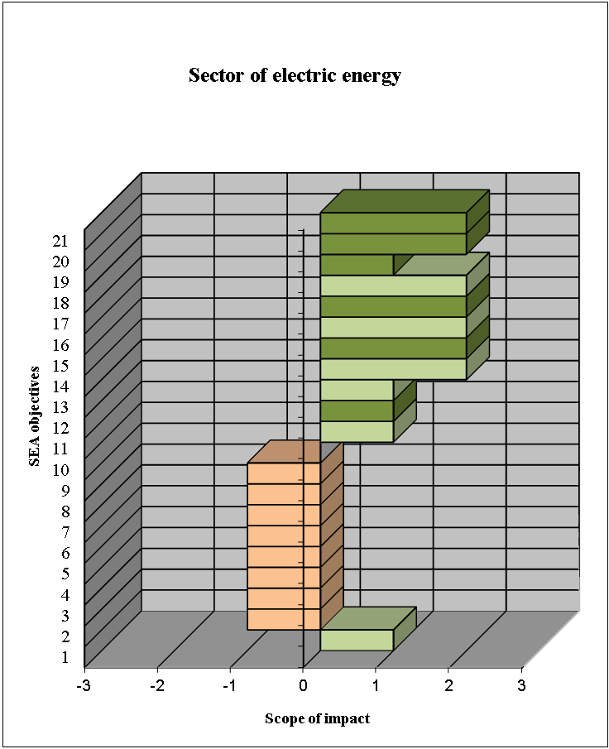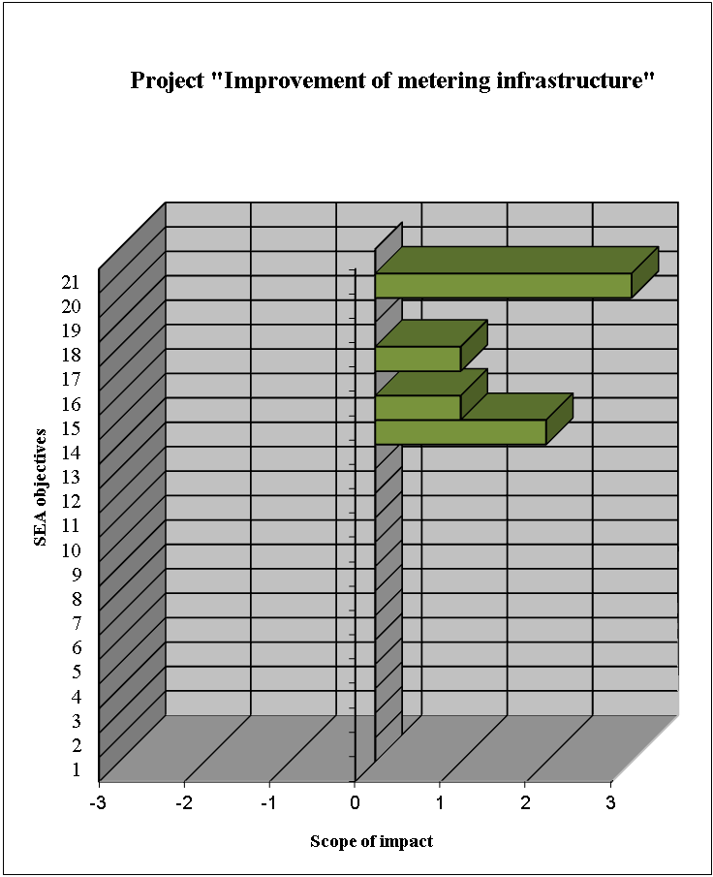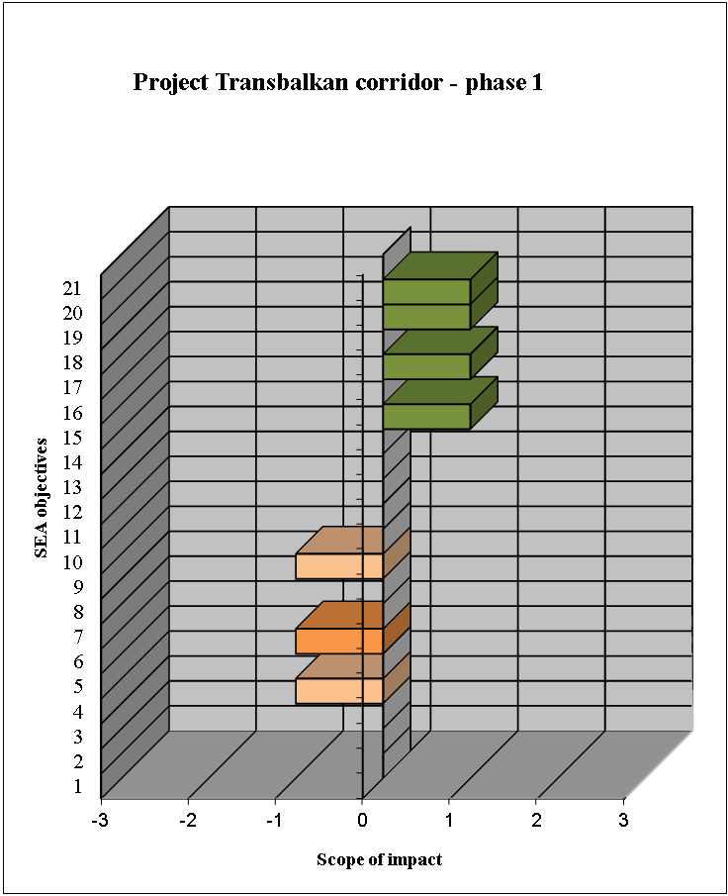

Designation (negative) | Impact significance | Designation (positive)
I | Transboundary | I
N | National | N
R | Regional | R
L | Local | L
SEA objectives
1. | Reducing the amount of particulate matter emissions in the air to the prescribed level | 8. | Biodiversity protection – avoiding irreversible losses | 15. | Encouraging economic development
2. | Reducing the amount of surface and groundwater pollution to the level which will not produce negative effects on water quality | 9. | Protection of cultural properties, preservation of cultural heritage and archeological sites | 16. | Promoting local employment
3. | Mitigating the negative effects of energy facilities on hydrological regimes | 10. | Improving waste usage, treatment and disposal | 17. | Reducing dependence on energy import
4. | Protection of forest and agricultural lands | 11. | Reducing effects of energy sector on human health | 18. | Reducing transboundary environmental impacts of energy facilities
5. | Reducing soil degradation and erosion | 12. | Better quality of life of people | 19. | Rational use of non-renewable energy sources and expand the use of renewable energy sources
6. | Landscape protection | 13. | Preservation of population density in rural areas | 20. | Improving energy efficiency
7. | Protection of natural values and areas | 14. | Improving the organizational unit for environmental protection, monitoring and control | 21. | Introducing clean technologies
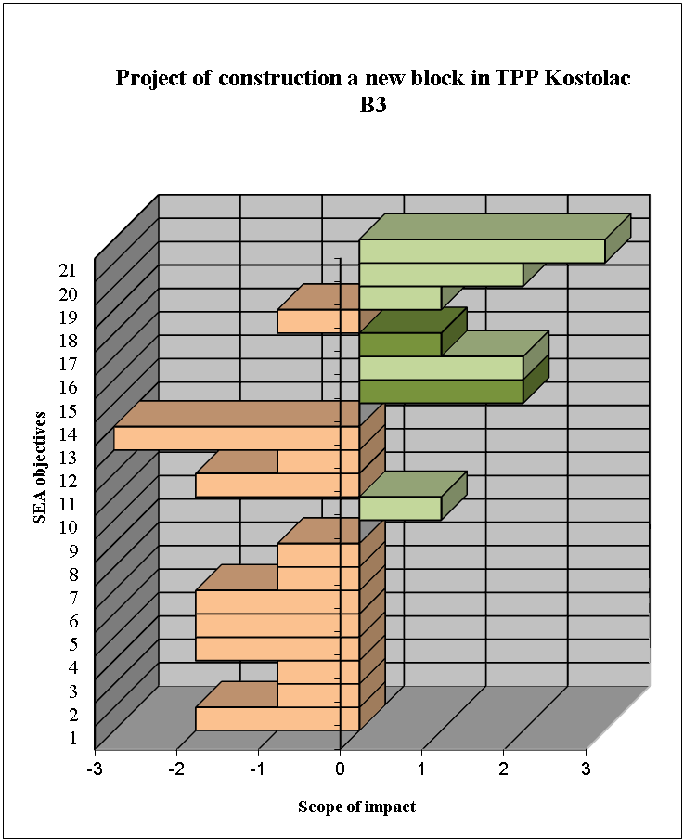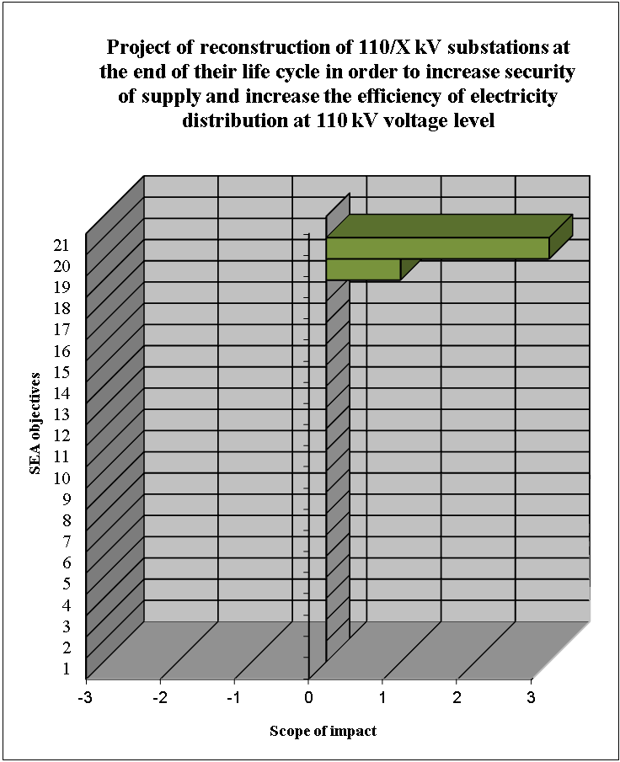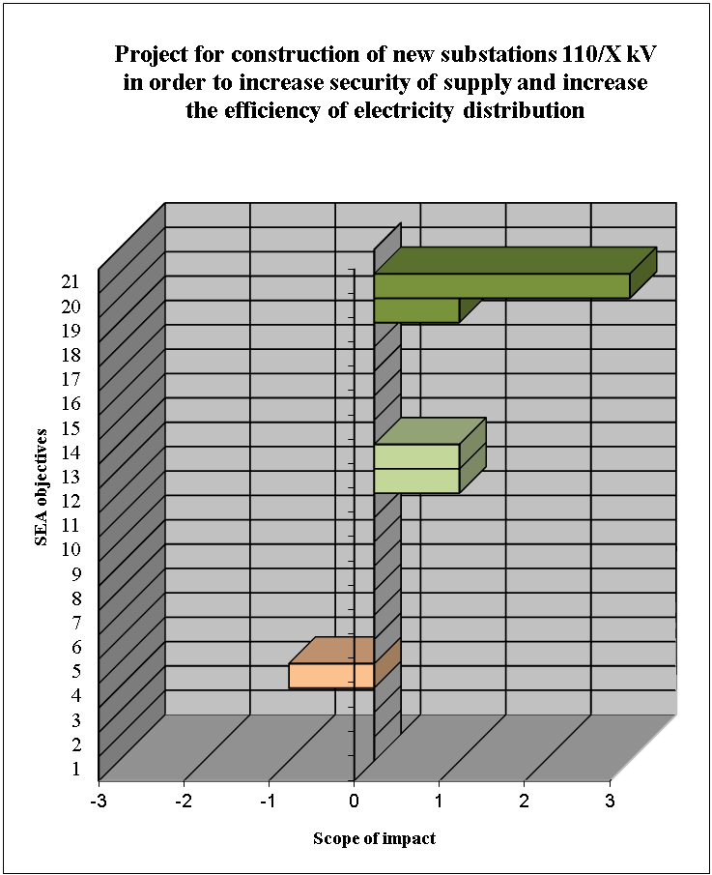

Designation (negative) | Impact significance | Designation (positive)
I | Transboundary | I
N | National | N
R | Regional | R
L | Local | L

SEA objectives

1. | Reducing the amount of particulate matter emissions in the air to the prescribed level | 8. | Biodiversity protection – avoiding irreversible losses | 15. | Encouraging economic development
2. | Reducing the amount of surface and groundwater pollution to the level which will not produce negative effects on water quality | 9. | Protection of cultural properties, preservation of cultural heritage and archeological sites | 16. | Promoting local employment
3. | Mitigating the negative effects of energy facilities on hydrological regimes | 10. | Improving waste usage, treatment and disposal | 17. | Reducing dependence on energy import
4. | Protection of forest and agricultural lands | 11. | Reducing effects of energy sector on human health | 18. | Reducing transboundary environmental impacts of energy facilities
5. | Reducing soil degradation and erosion | 12. | Better quality of life of people | 19. | Rational use of non-renewable energy sources and expand the use of renewable energy sources
6. | Landscape protection | 13. | Preservation of population density in rural areas | 20. | Improving energy efficiency
7. | Protection of natural values and areas | 14. | Improving the organizational unit for environmental protection, monitoring and control | 21. | Introducing clean technologies
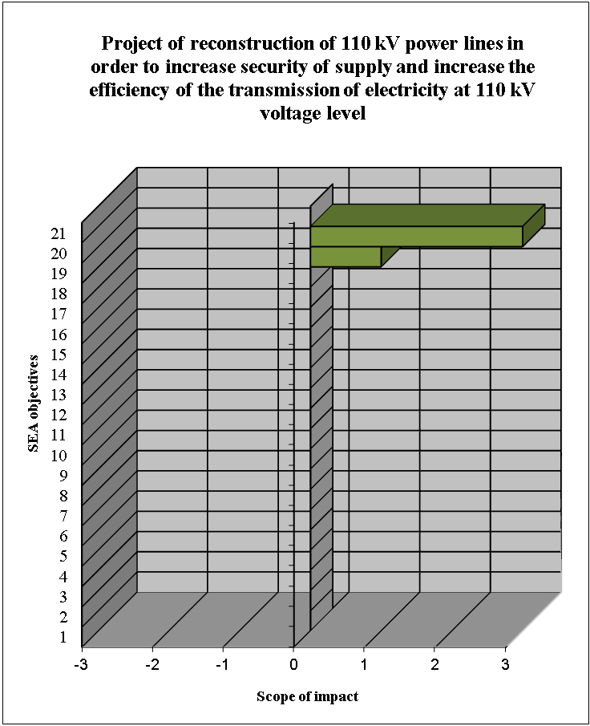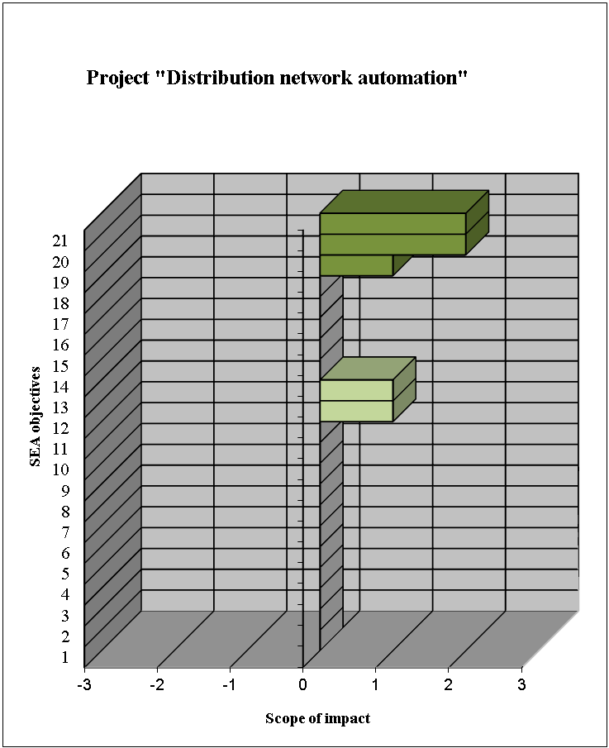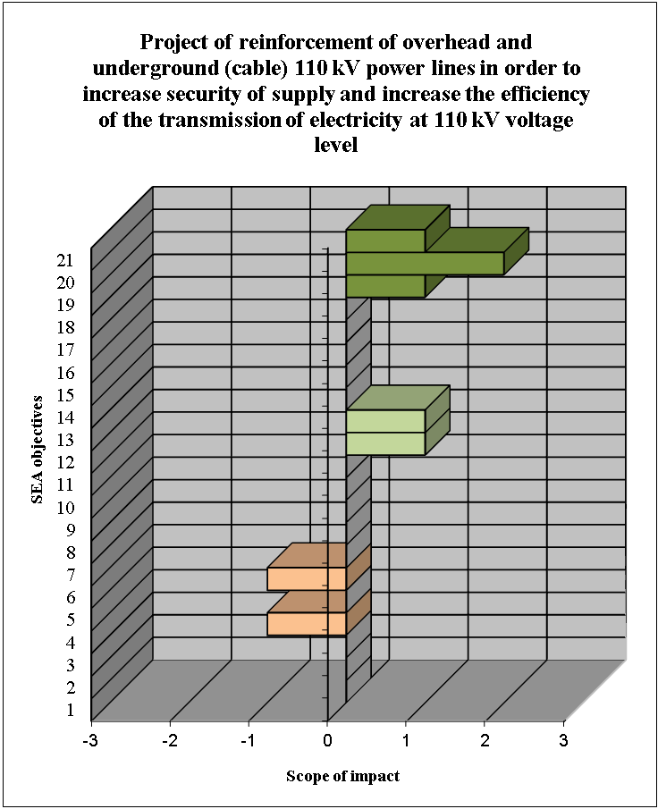

Designation (negative) | Impact significance | Designation (positive)
I | Transboundary | I
N | National | N
R | Regional | R
L | Local | L

SEA objectives

1. | Reducing the amount of particulate matter emissions in the air to the prescribed level | 8. | Biodiversity protection – avoiding irreversible losses | 15. | Encouraging economic development
2. | Reducing the amount of surface and groundwater pollution to the level which will not produce negative effects on water quality | 9. | Protection of cultural properties, preservation of cultural heritage and archeological sites | 16. | Promoting local employment
3. | Mitigating the negative effects of energy facilities on hydrological regimes | 10. | Improving waste usage, treatment and disposal | 17. | Reducing dependence on energy import
4. | Protection of forest and agricultural lands | 11. | Reducing effects of energy sector on human health | 18. | Reducing transboundary environmental impacts of energy facilities
5. | Reducing soil degradation and erosion | 12. | Better quality of life of people | 19. | Rational use of non-renewable energy sources and expand the use of renewable energy sources
6. | Landscape protection | 13. | Preservation of population density in rural areas | 20. | Improving energy efficiency
7. | Protection of natural values and areas | 14. | Improving the organizational unit for environmental protection, monitoring and control | 21. | Introducing clean technologies
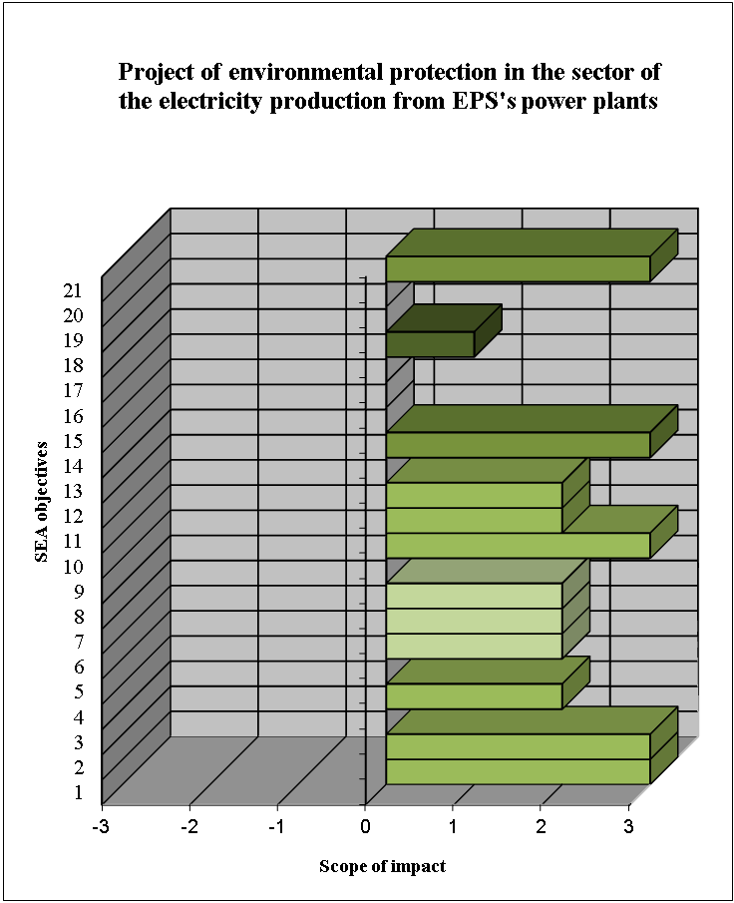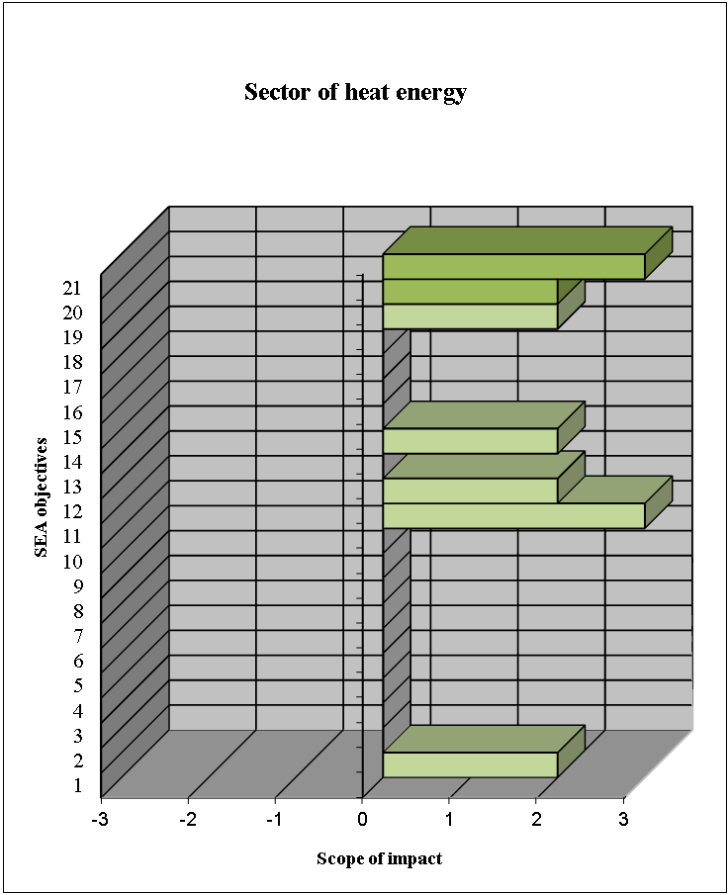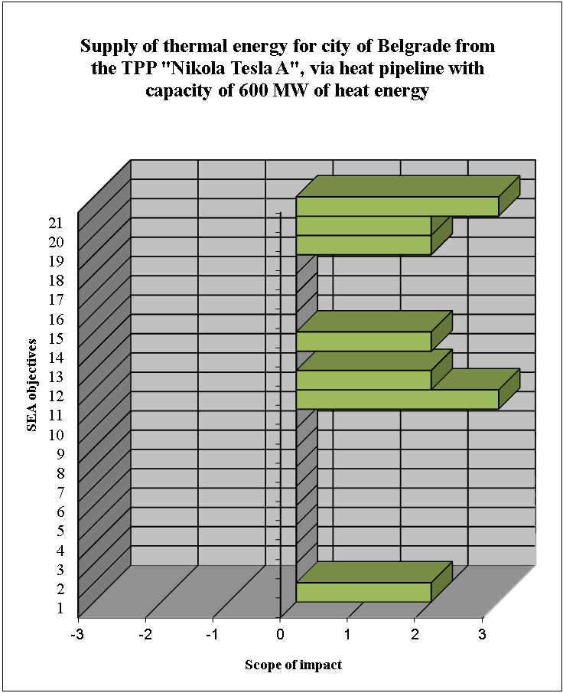

Designation (negative) | Impact significance | Designation (positive)
I | Transboundary | I
N | National | N
R | Regional | R
L | Local | L

SEA objectives

1. | Reducing the amount of particulate matter emissions in the air to the prescribed level | 8. | Biodiversity protection – avoiding irreversible losses | 15. | Encouraging economic development
2. | Reducing the amount of surface and groundwater pollution to the level which will not produce negative effects on water quality | 9. | Protection of cultural properties, preservation of cultural heritage and archeological sites | 16. | Promoting local employment
3. | Mitigating the negative effects of energy facilities on hydrological regimes | 10. | Improving waste usage, treatment and disposal | 17. | Reducing dependence on energy import
4. | Protection of forest and agricultural lands | 11. | Reducing effects of energy sector on human health | 18. | Reducing transboundary environmental impacts of energy facilities
5. | Reducing soil degradation and erosion | 12. | Better quality of life of people | 19. | Rational use of non-renewable energy sources and expand the use of renewable energy sources
6. | Landscape protection | 13. | Preservation of population density in rural areas | 20. | Improving energy efficiency
7. | Protection of natural values and areas | 14. | Improving the organizational unit for environmental protection, monitoring and control | 21. | Introducing clean technologies
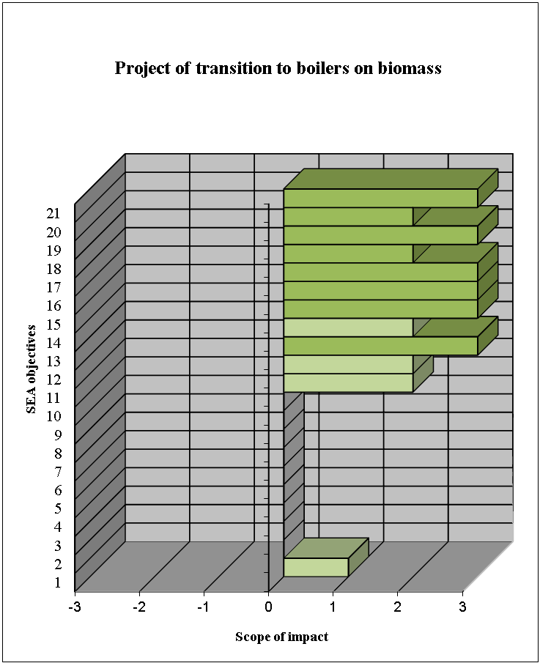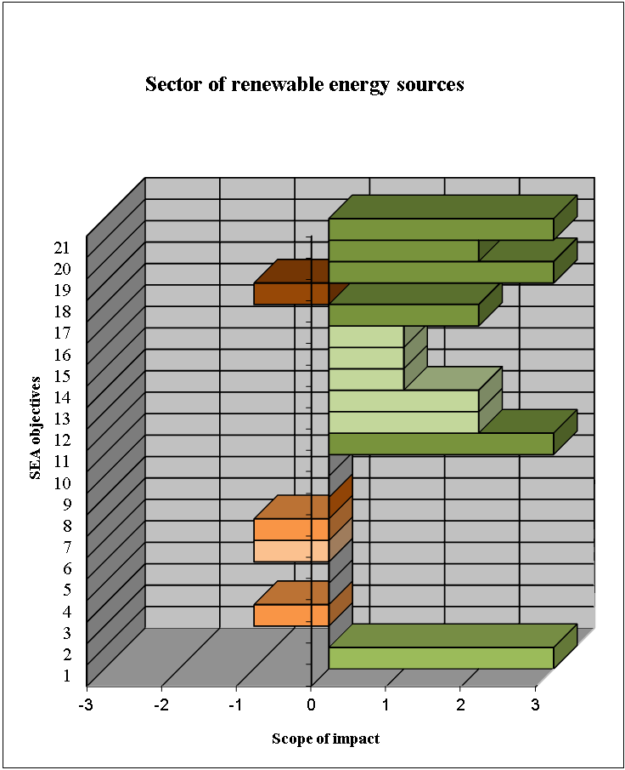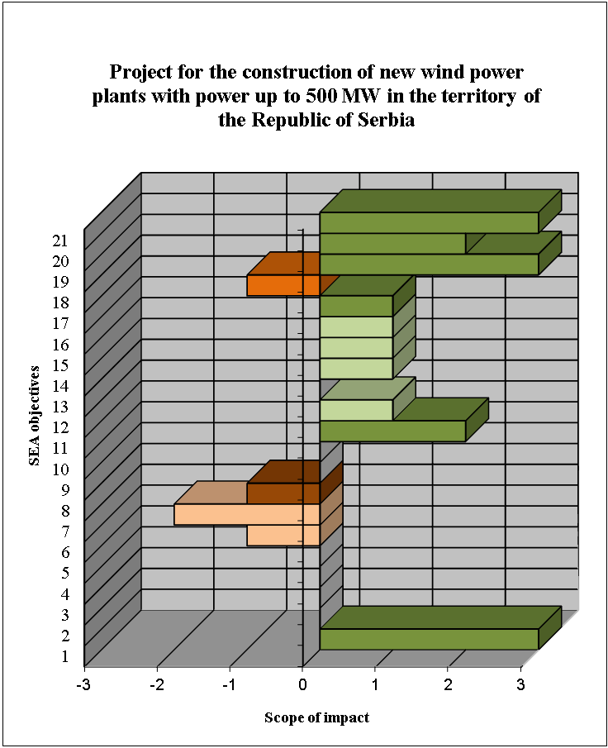

Designation (negative) | Impact significance | Designation (positive)
I | Transboundary | I
N | National | N
R | Regional | R
L | Local | L
SEA objectives

1. | Reducing the amount of particulate matter emissions in the air to the prescribed level | 8. | Biodiversity protection – avoiding irreversible losses | 15. | Encouraging economic development
2. | Reducing the amount of surface and groundwater pollution to the level which will not produce negative effects on water quality | 9. | Protection of cultural properties, preservation of cultural heritage and archeological sites | 16. | Promoting local employment
3. | Mitigating the negative effects of energy facilities on hydrological regimes | 10. | Improving waste usage, treatment and disposal | 17. | Reducing dependence on energy import
4. | Protection of forest and agricultural lands | 11. | Reducing effects of energy sector on human health | 18. | Reducing transboundary environmental impacts of energy facilities
5. | Reducing soil degradation and erosion | 12. | Better quality of life of people | 19. | Rational use of non-renewable energy sources and expand the use of renewable energy sources
6. | Landscape protection | 13. | Preservation of population density in rural areas | 20. | Improving energy efficiency
7. | Protection of natural values and areas | 14. | Improving the organizational unit for environmental protection, monitoring and control | 21. | Introducing clean technologies
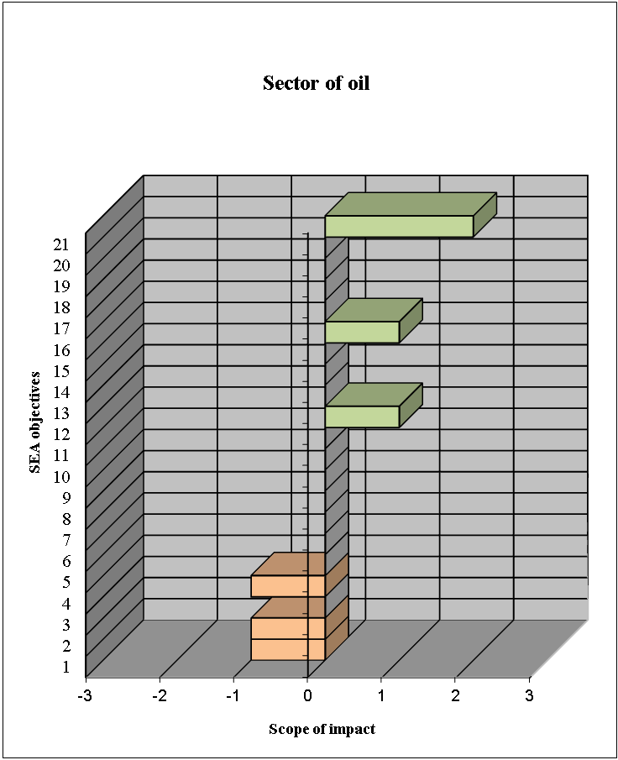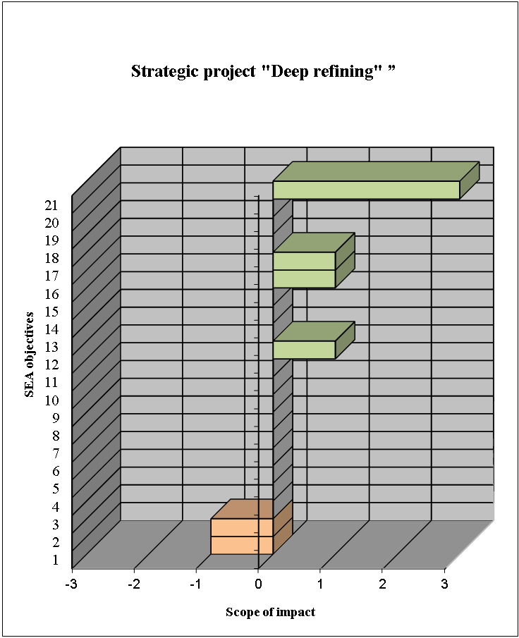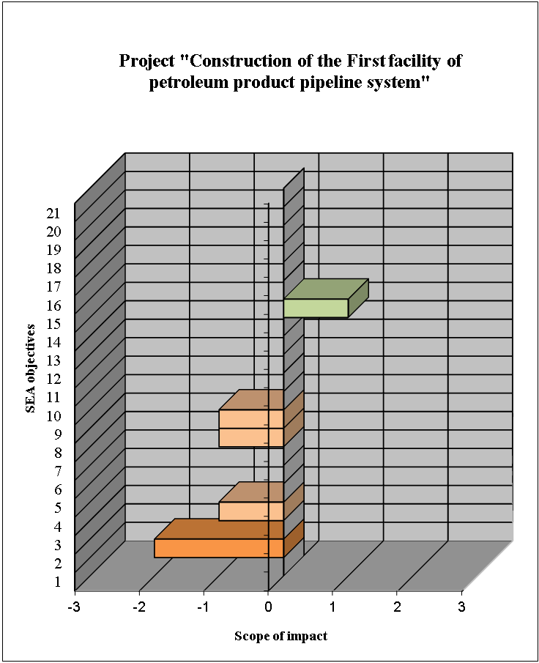

Designation (negative) | Impact significance | Designation (positive)
I | Transboundary | I
N | National | N
R | Regional | R
L | Local | L

SEA objectives

1. | Reducing the amount of particulate matter emissions in the air to the prescribed level | 8. | Biodiversity protection – avoiding irreversible losses | 15. | Encouraging economic development
2. | Reducing the amount of surface and groundwater pollution to the level which will not produce negative effects on water quality | 9. | Protection of cultural properties, preservation of cultural heritage and archeological sites | 16. | Promoting local employment
3. | Mitigating the negative effects of energy facilities on hydrological regimes | 10. | Improving waste usage, treatment and disposal | 17. | Reducing dependence on energy import
4. | Protection of forest and agricultural lands | 11. | Reducing effects of energy sector on human health | 18. | Reducing transboundary environmental impacts of energy facilities
5. | Reducing soil degradation and erosion | 12. | Better quality of life of people | 19. | Rational use of non-renewable energy sources and expand the use of renewable energy sources
6. | Landscape protection | 13. | Preservation of population density in rural areas | 20. | Improving energy efficiency
7. | Protection of natural values and areas | 14. | Improving the organizational unit for environmental protection, monitoring and control | 21. | Introducing clean technologies
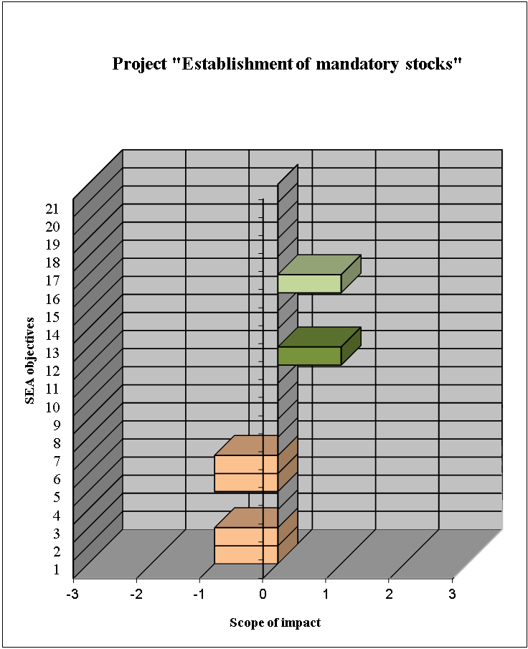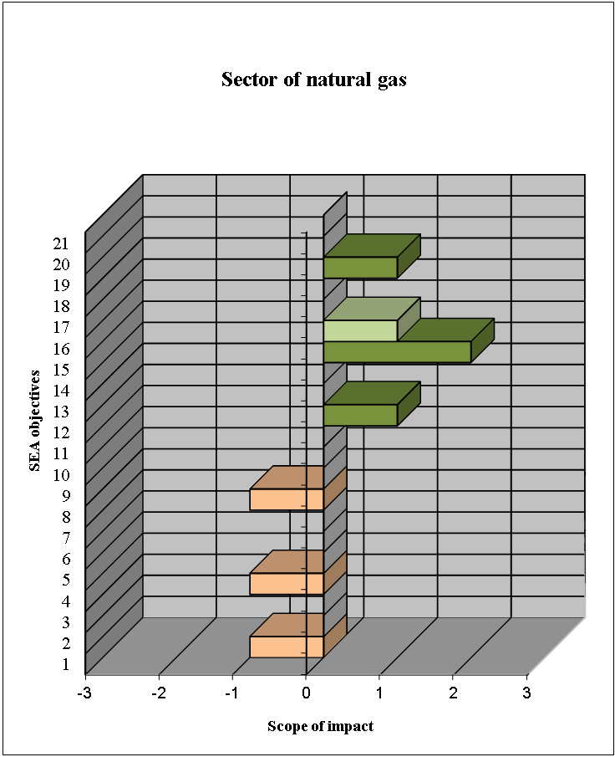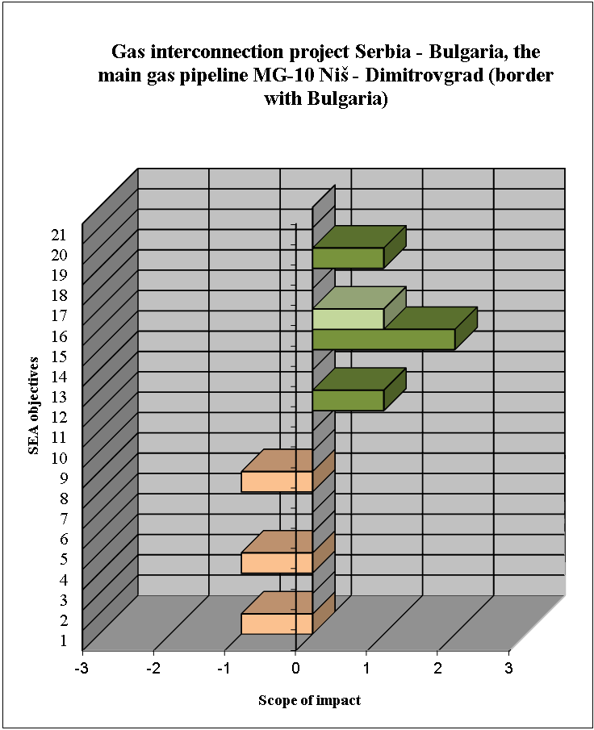

Designation (negative) | Impact significance | Designation (positive)
I | Transboundary | I
N | National | N
R | Regional | R
L | Local | L

SEA objectives

1. | Reducing the amount of particulate matter emissions in the air to the prescribed level | 8. | Biodiversity protection – avoiding irreversible losses | 15. | Encouraging economic development
2. | Reducing the amount of surface and groundwater pollution to the level which will not produce negative effects on water quality | 9. | Protection of cultural properties, preservation of cultural heritage and archeological sites | 16. | Promoting local employment
3. | Mitigating the negative effects of energy facilities on hydrological regimes | 10. | Improving waste usage, treatment and disposal | 17. | Reducing dependence on energy import
4. | Protection of forest and agricultural lands | 11. | Reducing effects of energy sector on human health | 18. | Reducing transboundary environmental impacts of energy facilities
5. | Reducing soil degradation and erosion | 12. | Better quality of life of people | 19. | Rational use of non-renewable energy sources and expand the use of renewable energy sources
6. | Landscape protection | 13. | Preservation of population density in rural areas | 20. | Improving energy efficiency
7. | Protection of natural values and areas | 14. | Improving the organizational unit for environmental protection, monitoring and control | 21. | Introducing clean technologies
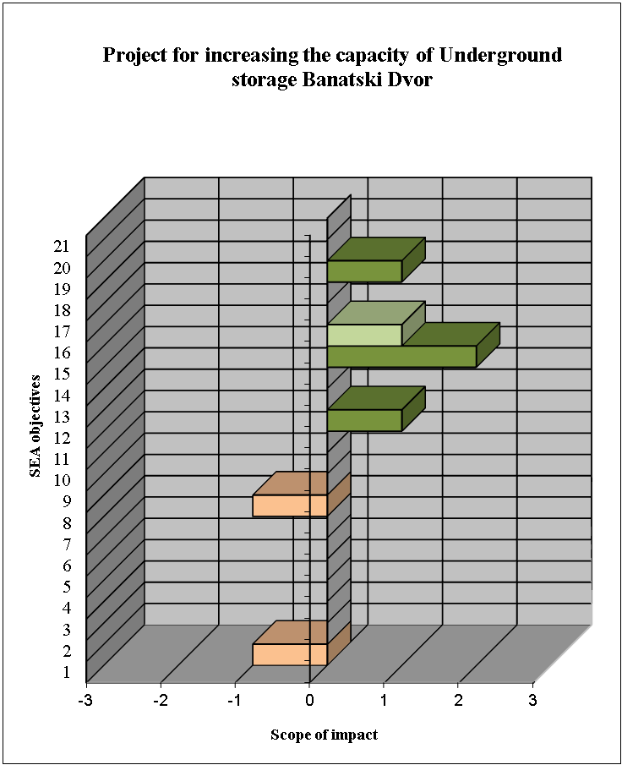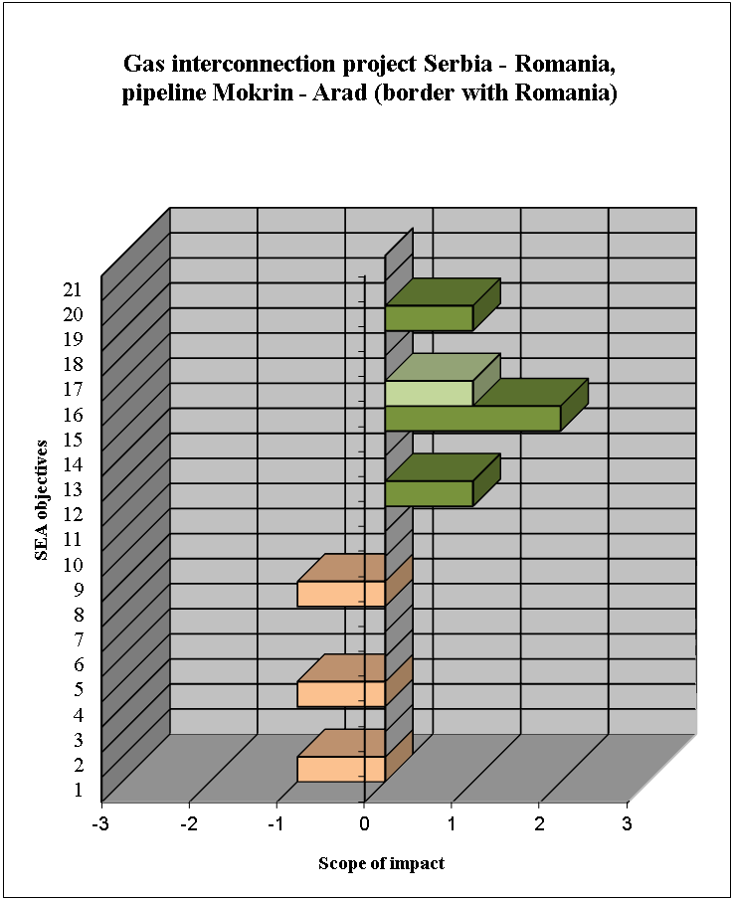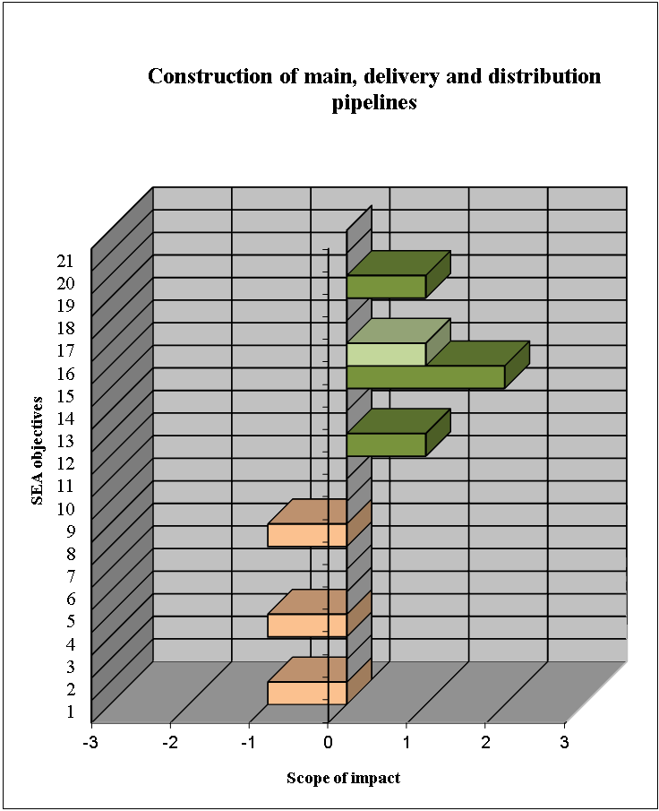

Designation (negative) | Impact significance | Designation (positive)
I | Transboundary | I
N | National | N
R | Regional | R
L | Local | L

SEA objectives

1. | Reducing the amount of particulate matter emissions in the air to the prescribed level | 8. | Biodiversity protection – avoiding irreversible losses | 15. | Encouraging economic development
2. | Reducing the amount of surface and groundwater pollution to the level which will not produce negative effects on water quality | 9. | Protection of cultural properties, preservation of cultural heritage and archeological sites | 16. | Promoting local employment
3. | Mitigating the negative effects of energy facilities on hydrological regimes | 10. | Improving waste usage, treatment and disposal | 17. | Reducing dependence on energy import
4. | Protection of forest and agricultural lands | 11. | Reducing effects of energy sector on human health | 18. | Reducing transboundary environmental impacts of energy facilities
5. | Reducing soil degradation and erosion | 12. | Better quality of life of people | 19. | Rational use of non-renewable energy sources and expand the use of renewable energy sources
6. | Landscape protection | 13. | Preservation of population density in rural areas | 20. | Improving energy efficiency
7. | Protection of natural values and areas | 14. | Improving the organizational unit for environmental protection, monitoring and control | 21. | Introducing clean technologies
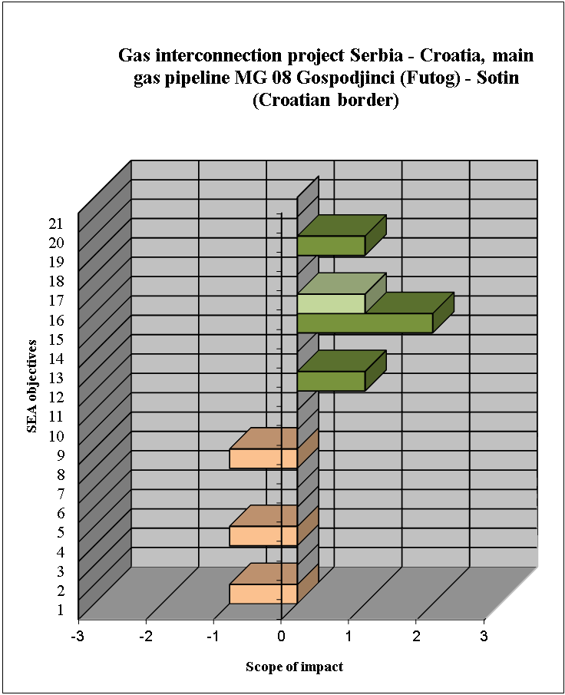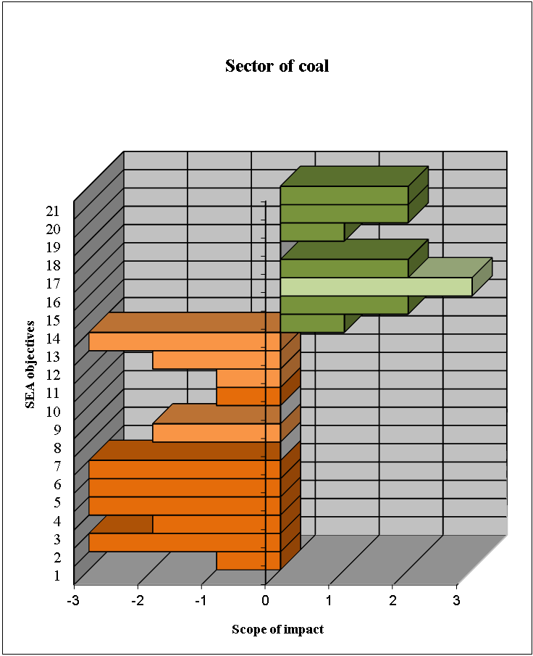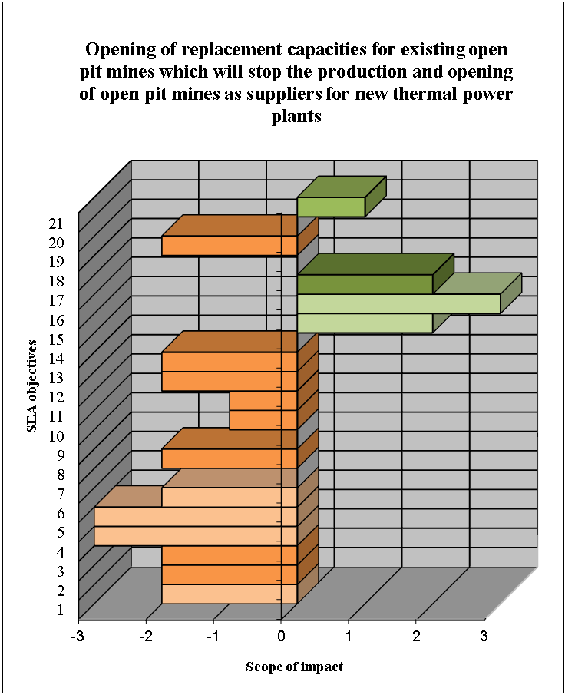

Designation (negative) | Impact significance | Designation (positive)
I | Transboundary | I
N | National | N
R | Regional | R
L | Local | L

SEA objectives

1. | Reducing the amount of particulate matter emissions in the air to the prescribed level | 8. | Biodiversity protection – avoiding irreversible losses | 15. | Encouraging economic development
2. | Reducing the amount of surface and groundwater pollution to the level which will not produce negative effects on water quality | 9. | Protection of cultural properties, preservation of cultural heritage and archeological sites | 16. | Promoting local employment
3. | Mitigating the negative effects of energy facilities on hydrological regimes | 10. | Improving waste usage, treatment and disposal | 17. | Reducing dependence on energy import
4. | Protection of forest and agricultural lands | 11. | Reducing effects of energy sector on human health | 18. | Reducing transboundary environmental impacts of energy facilities
5. | Reducing soil degradation and erosion | 12. | Better quality of life of people | 19. | Rational use of non-renewable energy sources and expand the use of renewable energy sources
6. | Landscape protection | 13. | Preservation of population density in rural areas | 20. | Improving energy efficiency
7. | Protection of natural values and areas | 14. | Improving the organizational unit for environmental protection, monitoring and control | 21. | Introducing clean technologies
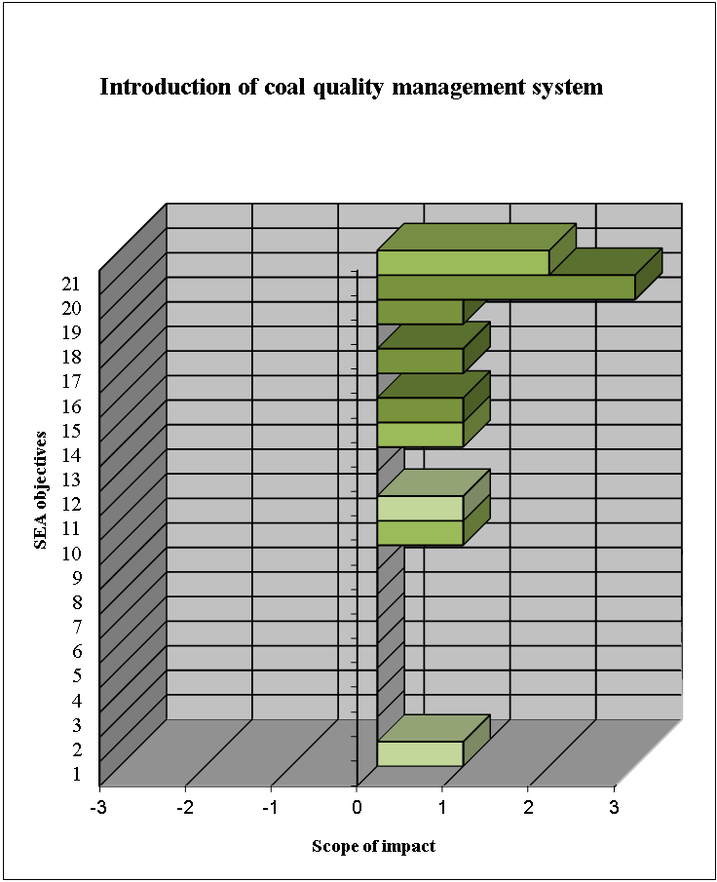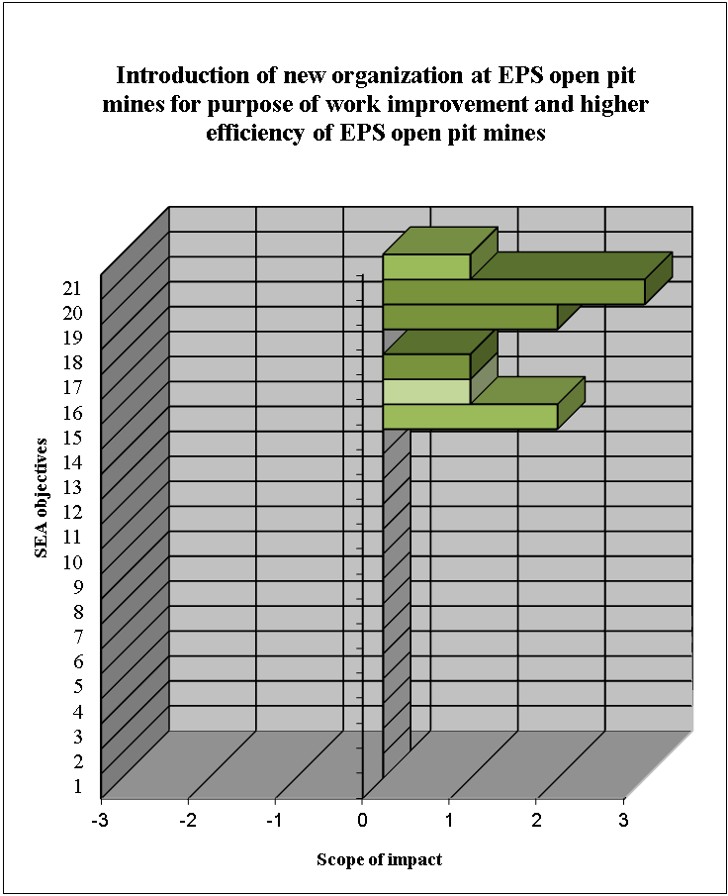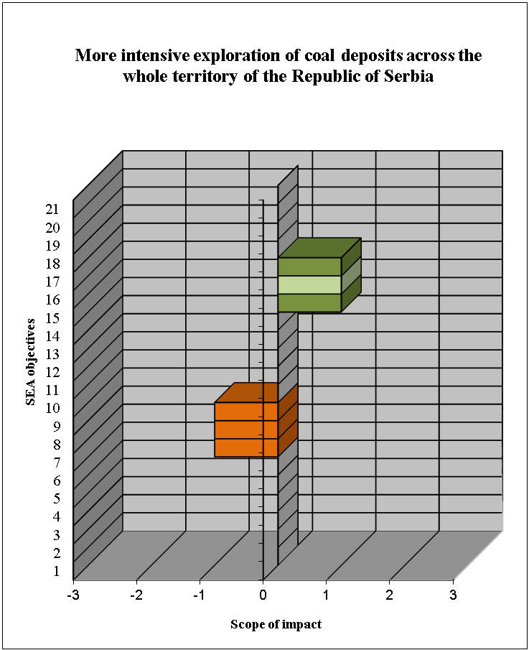

Designation (negative) | Impact significance | Designation (positive)
I | Transboundary | I
N | National | N
R | Regional | R
L | Local | L
SEA objectives
1. | Reducing the amount of particulate matter emissions in the air to the prescribed level | 8. | Biodiversity protection – avoiding irreversible losses | 15. | Encouraging economic development
2. | Reducing the amount of surface and groundwater pollution to the level which will not produce negative effects on water quality | 9. | Protection of cultural properties, preservation of cultural heritage and archeological sites | 16. | Promoting local employment
3. | Mitigating the negative effects of energy facilities on hydrological regimes | 10. | Improving waste usage, treatment and disposal | 17. | Reducing dependence on energy import
4. | Protection of forest and agricultural lands | 11. | Reducing effects of energy sector on human health | 18. | Reducing transboundary environmental impacts of energy facilities
5. | Reducing soil degradation and erosion | 12. | Better quality of life of people | 19. | Rational use of non-renewable energy sources and expand the use of renewable energy sources
6. | Landscape protection | 13. | Preservation of population density in rural areas | 20. | Improving energy efficiency
7. | Protection of natural values and areas | 14. | Improving the organizational unit for environmental protection, monitoring and control | 21. | Introducing clean technologies
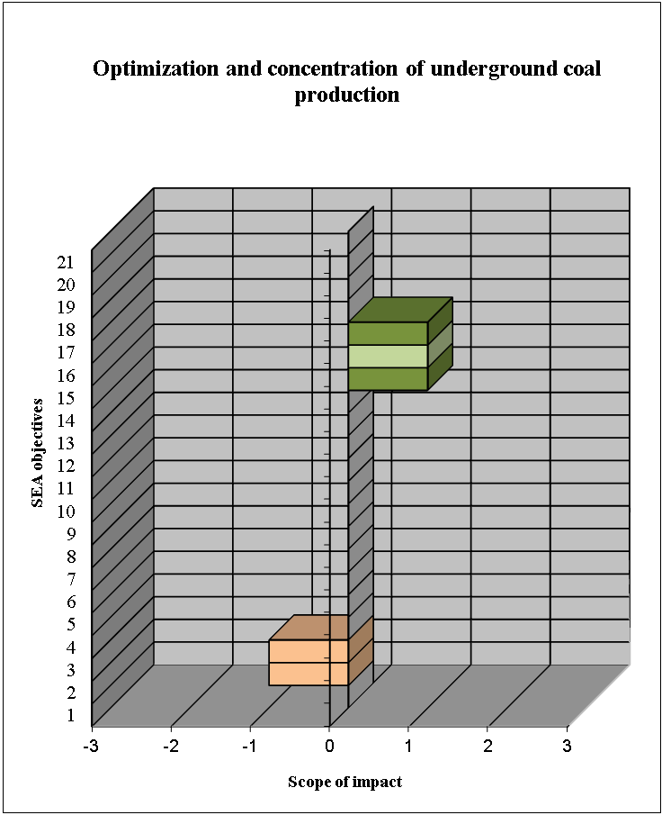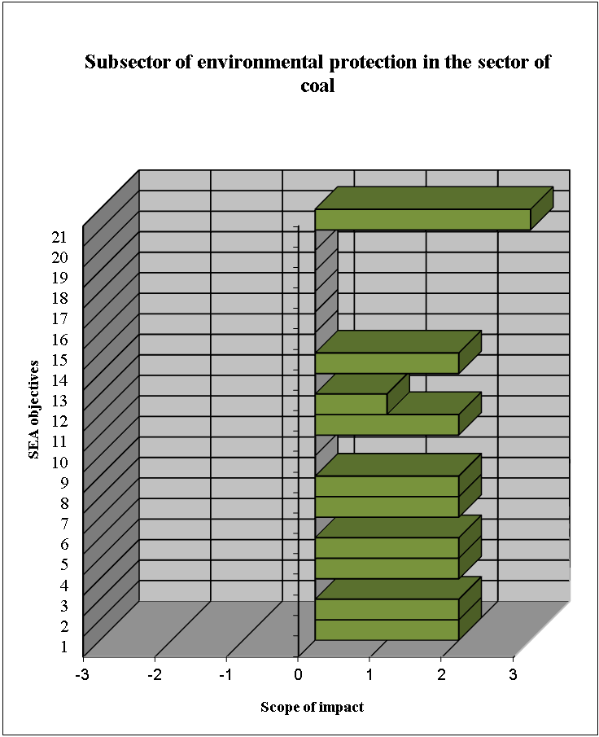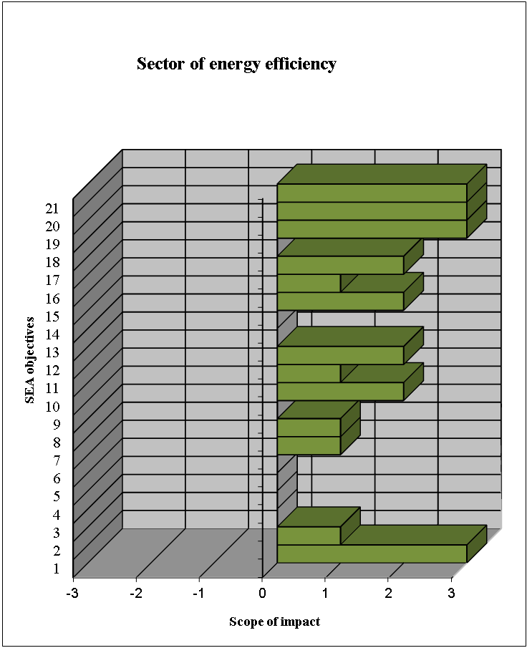

Designation (negative) | Impact significance | Designation (positive)
I | Transboundary | I
N | National | N
R | Regional | R
L | Local | L

SEA objectives
1. | Reducing the amount of particulate matter emissions in the air to the prescribed level | 8. | Biodiversity protection – avoiding irreversible losses | 15. | Encouraging economic development
2. | Reducing the amount of surface and groundwater pollution to the level which will not produce negative effects on water quality | 9. | Protection of cultural properties, preservation of cultural heritage and archeological sites | 16. | Promoting local employment
3. | Mitigating the negative effects of energy facilities on hydrological regimes | 10. | Improving waste usage, treatment and disposal | 17. | Reducing dependence on energy import
4. | Protection of forest and agricultural lands | 11. | Reducing effects of energy sector on human health | 18. | Reducing transboundary environmental impacts of energy facilities
5. | Reducing soil degradation and erosion | 12. | Better quality of life of people | 19. | Rational use of non-renewable energy sources and expand the use of renewable energy sources
6. | Landscape protection | 13. | Preservation of population density in rural areas | 20. | Improving energy efficiency
7. | Protection of natural values and areas | 14. | Improving the organizational unit for environmental protection, monitoring and control | 21. | Introducing clean technologies
Table 3.9. Identification and evaluation of strategically significant impacts of the Program

Program fields and priority projects | Identification and evaluation of significant impacts |  | Justification
Program fields and priority projects | SEA objective | Rank | Justification
Sector of electric power | 15 | +2/N/L/LT/Di | In the electric energy sector positive effects are expected on almost all SEA objectives, predominantly in the part regarding the encouragement of economic growth, increased energy efficiency and reduced losses in the network. Moreover, environmental protection projects in the sector of electricity production will contribute to reduction in the emission of harmful gases SО₂ and NOx, and their reduction to permissible limits and solving the problem of ash handling, waste storage and treatment of waste water at locations of certain generation facilities owned by EPS. These solutions will contribute to ensuring safe supply of electric power, the development of the electric energy market and the transition to sustainable energy sector. On the other hand, certain negative effects on the environment have been identified in connection of some projects in the electric energy sector. It particularly refers to the project of construction of new B3 block in TPP Kostolac B with the power of 350 MW, whose annual production will be 2,200 GWh, and expansion of open pit mine “Drmno”, with all negative implications regarding social factors. Although these effects have been assessed as large, they are also of the local character because their spatial distribution is expected in a limited space, and according to the defined criteria in Table 3.5. they are not assessed as strategically significant. Moreover, the construction of the new block will indirectly reduce the impact on the environment due to the fact that the new block will replace old production facilities whose work affected the environment negatively.
Sector of electric power | 17 | +2/N/P/LT/Di
Sector of electric power | 20 | +2/N/L/LT/Di
Sector of electric power | 21 | +2/N/S/LT/Di
Project of improvement of metering infrastructure | 14 | +2/N/S/LT/Id
Project of improvement of metering infrastructure | 20 | +3/N/P/LT/Id
Project of construction a new block in TPP Kostolac B3 | 15 | +2/N/L/LT/Di
Project for reconstruction of 110/X kV substations in order to increase security of work and supply and increase the efficiency of electricity distribution at 110 kV voltage level | 20 | +3/N/S/LT/Di
Project for construction of new substations 110/X kV in order to increase security of supply and increase the efficiency of electricity distribution | 20 | +3/N/S/LT/Di
Project for reconstruction of 110kV power lines in order to increase security of supply increase the efficiency of electricity distribution | 20 | +3/N/S/LT/Di
Project “Distribution network automation” | 20 | +2/N/P/LT/Id
Project “Distribution network automation” | 21 | +2/N/P/LT/Id
Project of reinforcement of overhead and underground (cable) 110 kV power lines in order to increase security of supply and increase the efficiency of the transmission of electricity at 110 kV voltage level | 20 | +2/N/S/LT/Di
Project of environmental protection in the sector of the electricity production from EPS’s power plants | 1 | +3/R/L/LT/Di
 | 2 | +3/R/L/LT/Id
 | 4 | +2/R/L/LT/Di
 | 10 | +3/R/S/LT/Di
 | 11 | +2/R/P/LT/Di
 | 12 | +2/R/P/LT/Id
 | 14 | +3/N/S/LT/Di
 | 21 | +2/N/S/LT/Di
Sector of heat energy | 20 | +2/R/L/LT/Di | The measures and projects in the sector of heat energy will contribute to reduced pollutants in the air directly – by introducing new technologies in the heating plants, and indirectly – by reducing the number of individual solid fuel burners by increasing the capacity of heating plants. The projected capacity of 600 MWth heating pipes provides heat for more than 50% of the consumption of thermal power plant New Belgrade. A complementary project is to connect the large and efficient heating plants (New Belgrade, Dunav, Konjarnik ...) into a single system for supplying consumers as well as installation of the system storage of thermal energy. DHS Belgrade will be potentially supplied with 600 MWth from units A3 to A6 in TENT-A, which will influence on the decrease of available power to TENT A of about 150 MWe. Moreover, several projects are being prepared to introduce biomass or geothermal in use as fuel in heating plants, with expected total power of 105 MW and an annual output of 21,000 toe. These objectives will be achieved through the activities within the project “Promotion of renewable energy sources – developing the biomass market", as well as through individual commercial projects. All this will contribute to the transition to sustainable energy sector.
Sector of heat energy | 21 | +3/R/L/LT/Di
Supply of thermal energy for city of Belgrade from the TPP “Nikola Tesla A”, via heat pipeline with capacity of 600 MW of heat energy | 1 | +2/R/S/LT/Di
 | 11 | +3/R/P/LT/Di
 | 12 | +2/R/L/LT/Id
 | 14 | +2/R/P/LT/Id
 | 19 | +2/R/S/LT/Di
 | 20 | +2/R/S/LT/Di
 | 21 | +3/R/S/LT/Id
Project of transition of boiler to biomass | 13  15  16  17  18  19 | +3/N/S/LT/Di +3/N/S/LT/Di +3/N/S/LT/Di +3/N/S/LT/Di +3/N/S/LT/Di +3/N/S/LT/Di
Project of transition of boiler to biomass | 20 | +2/N/L/LT/Di
Project of transition of boiler to biomass | 21 | +3/N/L/LT/Di
Sector of renewable energy sources | 1 | +3/N/S/LT/Id | Positive effects are expected on the reduced emissions of toxic matters and greenhouse gases (GHG) in the air by increased use of renewable energy sources, i.e. by introducing clean technologies in the process of electricity production. Strong positive effects are expected in relation to increased share of RES in the total energetic balance. Negative implications are possible as a consequence of certain projects on natural resources (reversible power plants and small power plants on water resources) and biodiversity (wind power farms on ornithological fauna and chiropters).
Sector of renewable energy sources | 11 | +3/N/L/LT/Id
Sector of renewable energy sources | 19  20 | +3/N/S/LT/Di  +3/N/S/LT/Di
Sector of renewable energy sources | 21 | +3/N/S/LT/Di
Project for the construction of new wind power plants of total power up to 500 MW in the territory of the Republic of Serbia | 1 | +3/N/S/LT/Id
 | 11 | +2/N/P/LT/Id
 | 19 | +3/N/S/LT/Di
 | 20 | +3/N/S/LT/Di
 | 21 | +3/N/S/LT/Di
Project "Construction of the First facility of petroleum product pipeline system" | 2 | -2/R/P/TO/Di | The construction of product pipelines poses a potential risk regarding the pollution of water resources during their installation, especially during potential accidents and oil derivative leaks into water resources. Other identified positive and negative effects have not been assessed as strategically significant, but they refer to careful planning, construction and control of the work of planned product pipelines.
Sector of natural gas | 15 | +2/N/L/LT/Di | The most important positive effect of projects in the sector of natural gas refers to the encouraged economic growth and insurance of sufficient quantities of natural gas. Other effects, positive or negative, have not been assessed as strategically significant. Negative effects refer to pollution as a consequence of potential accidents, while positive effects refer to the economic aspects of growth.
Gas interconnection project Serbia – Bulgaria, the main gas pipeline MG-10 Niš - Dimitrovgrad | 15 | +2/N/L/LT/Di
Project for increasing the capacity of Underground storage Banatski Dvor | 15 | +2/N/L/LT/Di
Gas interconnection project Serbia – Romania, the gas pipeline Mokrin – Arad (border with Romania) | 15 | +2/N/L/LT/Di
Construction of main, delivery and distribution pipelines | 15 | +2/N/L/LT/Di
Gas interconnection project Serbia – Croatia, main pipeline MG-08 Gospodjinci – Sotin | 15 | +2/N/L/LT/Di
Sector of coal | 2 | -3/N/P/LT/Di | Negative effects are possible on almost all environmental factors (pollution of air, soil and water, biodiversity, population, cultural heritage) as a consequence of increased/continued use of non-renewable resources. In this context the opening of replacement capacities for existing open pit mines is of greatest significance. On the other hand, there will certainly be some positive effects on reduced dependence on import energy sources, especially by applying modern technologies in coal exploitation, processing and use in thermal power plants by increasing the productivity of plants by 5 %, which means an increase in power production to 180 MW, reducing losses by 370 GWh, opportunities of low quality coal exploitation and environmental protection (preventing self-combustion of coal disposed in landfills). The implementation of this set of measures for efficient and profitable coal production will lead to a significant economic benefit.  The projects in the subsector of environmental protection in the sector of coal. In the sector of coal the project of installing a new drag/conveyor belt/tray system in Mining Basin Kolubara is underway. The project is aimed at ensuring reliable and continued coal delivery, rational management of natural resources while reducing the ambient air pollution in the surroundings of thermal power plants using coal from MB Kolubara. The project is significant from the aspect of reducing the effect of harmful substances on the environment and social development. Concerning protection from noise and from effects of suspended particles, all conditions have been fulfilled in line with the standards, regulations and Policy of the protection of the environment and EBRD social policy from 2008, which will have positive effects on the quality of the environment. Projects for recultivation of degraded areas have been made for all open pit mines and continued monitoring of water quality is envisaged.
Sector of coal | 3 | -2/N/L/LT/Di
Sector of coal | 4 | -3/N/L/LT/Di
Sector of coal | 5 | -3/N/L/LT/Di
Sector of coal | 6 | -3/N/S/LT/Di
Sector of coal | 8 | -2/R/S/LT/Di
Sector of coal | 12 | -2/R/S/LT/Di
Sector of coal | 13 | -3/R/S/LT/Di
Sector of coal | 15 | +2/N/S/LT/Id
Sector of coal | 17 | +2/N/S/LT/Di
Sector of coal | 20 | +2/N/L/LT/Id
Sector of coal | 21 | +2/N/S/LT/Di
Opening of replacement capacities for existing open pit mines which will stop the production and opening of open pit mines as suppliers for new thermal power plants | 1 | -2/R/L/LT/Di
 | 2 | -2/R/L/LT/Di
 | 3 | -2/R/L/LT/Di
 | 4 | -3/R/L/LT/Di
 | 5 | -3/R/S/LT/Di
 | 6 | -2/R/S/LT/Di
 | 8 | -2/R/S/LT/Di
 | 12 | -2/R/S/LT/Di
 | 13 | -2/R/S/LT/Di
 | 15 | +2/N/S/LT/Id
 | 17 | +2/N/S/LT/Di
 | 19 | -2/R/S/LT/Di
Introduction of coal quality management system | 20 | +3/N/L/LT/Di
Introduction of coal quality management system | 21 | +3/N/L/LT/Di
Introduction of new organization at EPS open pit mines for purpose of work improvement and higher efficiency of EPS open pit mines | 15 | +2/R/L/LT/Di
 | 19 | +2/N/L/LT/Di
 | 20 | +3/N/L/LT/Di
Subsector of environmental protection in the sector of coal | 1 | +2/N/S/LT/Di
Subsector of environmental protection in the sector of coal | 2 | +2/N/S/LT/Di
Subsector of environmental protection in the sector of coal | 4 | +2/N/P/LT/Di
Subsector of environmental protection in the sector of coal | 5 | +2/N/P/LT/Di
Subsector of environmental protection in the sector of coal | 7 | +2/N/P/LT/Di
Subsector of environmental protection in the sector of coal | 8 | +2/N/P/LT/Id
Subsector of environmental protection in the sector of coal | 11 | +2/N/P/LT/Di
Subsector of environmental protection in the sector of coal | 14 | +2/N/S/LT/Di
Subsector of environmental protection in the sector of coal | 21 | +3/N/S/LT/Di
Sector of energy efficiency | 1 | +3/N/S/LT/Id | Significant positive effects on the environment quality are expected through reduction of the final energy consumption, necessary energy resources etc. Reduced emission of greenhouse gases (GHG) is a particular contribution to the sector of energy efficiency. Measures in the sector of energy efficiency are integrated in all sectors defined by the Program.
Sector of energy efficiency | 10 | +2/N/S/LT/Di
Sector of energy efficiency | 12 | +2/N/S/LT/Di
Sector of energy efficiency | 15 | +2/N/S/LT/Di
Sector of energy efficiency | 17 | +2/N/S/LT/Di
Sector of energy efficiency | 19 | +3/N/S/LT/Di
Sector of energy efficiency | 20 | +3/ N/S/LT/Di
Sector of energy efficiency | 21 | +3/N/S/LT/Di

* - According to the criteria in Table 3.5.
3.2. Summary of significant Program impacts

On the basis of the evaluation of impact significance shown in Table 3.9, it can be concluded that the Program realization produces a significant number of strategically important, both positive and negative, in the space and environment.

Negative impacts are identified as an inexorable consequence of the development and natural potentials of the Republic of Serbia upon which future energy sector development should inevitably be based. This primarily implies: operations of the thermal power plants and, consequently, opening of new coal open-pit mines , which increases environmental pollution load to a great extent: pollution of the basic environment factors, effects on the population health, change in the view of landscape, biodiversity and geodiversity as well as social implications which manifest themselves in negative effects on the population health, on the one hand, and in displacement of settlements from areas in which opening and expanding of new coal open-pit mines is planned, on the other hand. Bearing the abovementioned in mind, it is necessary to pay special attention to the optimal development of the fields affected by the energy sectors. Certain negative implications are also expected due to inappropriately planned construction of reversible hydropower plants and small hydro-power plants, which would have negative effects on hydrological regime of watercourses on which their construction is planned, as well as on biodiversity and ichthyofauna, and will cause possible changes in the use of agricultural and forest lands etc.

As a signatory to the ESPOO Convention and Kiev Protocol, the Republic of Serbia has bound itself to inform other countries about proposed projects which may have transboundary impacts. In the Espoo Convention Environmental Impact Assessment, the transboundary impact is defined as “"any impact not exclusively of a global nature, within an area under the jurisdiction of a Party caused by a proposed activity the physical origin of which is situated wholly or in part within the area under the jurisdiction of another party”. The Espoo Convention requires that if the proposed activity is found to cause significant adverse transboundary impact, the Party, i.e. the Government of the Country undertaking the activity shall, for the purposes of ensuring adequate and effective intervention, notify any other party (other country) which it considers may be affected by the activity as early as possible and no later than when informing its own public about the proposed activity. In that respect, it may be stated that priority projects defined in the Program do not imply strategically significant effects, either positive or negative, but there are projects in the border zone with other states, whose manner of functioning may cause certain effects. In this context, special attention should be paid to transboundary cooperation when implementing the Project of constructing a new block in TPP Kostolac B3, which also refers to the implementation of projects regarding the use of RES which are planned near the borders with neighboring countries, for the following reasons:

- Wind farms – possible significant adverse impacts on internationally protected flying fauna (ornithological fauna and chiropters) on the Serbian-Romanian boundary), particularly on the Serbian-Romanian boundary;
- Reversible hydropower plants and small hydro-power plants planned on transboundary watercourses – possible adverse impacts on bentonic organisms and ornithological fauna on boundaries with Montenegro, B&H, Romania and Bulgaria.
- Coal-fired power plant projects – possible impacts on the air quality and international rivers.

On the other hand, a whole series of positive strategic impacts of the Program were identified, out of which the most significant ones include the following:

- Environmental quality: reduction in water, air and soil pollution and reduction of greenhouse gas emissions by increasing the use of renewable energy sources and the application of clean technologies in thermal power plants in accordance with Directive 2001/80/EC on the limitation of emissions of certain pollutants into the air from large combustion plants and Directive 2010/75/EU on industrial emissions (integrated pollution prevention and control) for new projects; implementation of a whole set of environmental protection measures in all individual fields of the Program; development of the transmission and distribution network which will substantially reduce losses, etc.

- Socio-economic development: energy sector development as a contributor to economic growth; ф the market-oriented formation of energy prices and prices for energy-generating products; strict implementation of energy-efficiency measures in final energy consumption; overall energy sector development, which will represent a long-term contribution to sustainable economic development and rational use of non-renewable energy sources, i.e. to increasing the share of energy from renewable resources in total consumption.

3.3. Cumulative and synergistic effects

In compliance with the Law on Strategic Environmental Impact Assessment (Article 15), the strategic assessment should also include an assessment of cumulative and synergistic effects on the environment. Significant effects can results from interactions of numerous smaller effects of the existing facilities and activities, as well as planned activities for the area covered by Plan. Cumulative effects arise when sectoral solutions each have insignificant effects while several individual effects а together may have a significant effect. Synergistic effects interact to produce a total effect greater than the sum of the individual effects.

Table 3.10. Identification of possible cumulative and synergistic effects of the Program

Field of the SEA
air AND CLIMATE CHANGE
Dust emissions are dominant in open-pit mines during excavation of coal and overburden. After the treatment, the emissions of air pollutants from thermal power plants do not exceed the GVI. Taking into consideration that on these locations there are also other sources of emissions (traffic, industrial plants and households) GVI can be exceeded during unfavorable weather conditions due to cumulative effects. Emissions of SO₂ and NOx from TPP, after the reconstruction which will be carried out in accordance with the Large Combustion Plants Directive, will not exceed the GVI. However, these pollutants coming from other sources are not purified, and so that GVI can be exceeded due to cumulative effects. Greenhouse gas emissions (CO₂, CH₄, N₂O, O₃ and halogen hydrocarbons) are released in all processes of converting fossil fuels into energy (thermal power plants, district heating plants, transportation). Considered cumulatively, the existing and new sources will cause an increase in greenhouse gas emissions, but levels at which GHG will be emitted will not be significant at the level of Serbia, and certainly not at the global level.
Positive cumulative effects which will help in reducing the exposure of people to air pollutants are achieved through reconstruction of TPPs, the use of RES, construction of combined heat and power plants using gas engines, as well as through gasification of settlements. An increase in depth of processing will have indirect effects, thereby the use of higher quality fuel for vehicles. A whole set of measures for environmental protection and energy efficiency will lead to the reduction in the greenhouse gas emissions (GHG).
WATER
The proposed development of mining activities will inevitably affect the hydrological regime in the open-pit mines and, cumulatively, in a wider surrounding area. Disturbed natural regime of water can have indirect effects on natural regime of ground and surface waters which serve for irrigation and water supply, as well as on the stability of the ground and buildings in settlements, while it can also affect negatively soil fertility and water supply for population. The construction of reversible hydropower plants and small hydro-power plants (especially if a greater number of small hydro-power plants is built on the same watercourse) will produce similar effects. Due to development of open-pit mines, a certain waterways will have to be diverted. Infiltration of pollutants into open pits and waste rock dumps is possible. Pollution of water due to potential incidents on the product lines is also possible.
Use of cutting edge technologies in thermal power plants will contribute to more efficient wastewater purification which will be supported by legislation and institutional organization harmonized with international obligations and EU regulations.
SOIL
Increasing amount of land used for surface mining (opening of new replacement open-pit mines) will reduce the amount of land needed for agriculture and forestry land.
Use of cutting edge technologies in thermal power plants and in the production of derivatives of oil, as well as the use of RES and the gasification system in Serbia, will contribute to the reduction of soil pollution because of smaller amounts of air pollutants which settle on the land. Recultivation of open-pit minds where exploitation is finished will partially compensate the damage arising from the opening of new replacement pits.
NATURAL VALUES
Mining activities, degradation of agricultural land and vegetation destruction in surface mining areas have cumulative effects causing loss of habitats of most of kinds of animals and their migration outside wider area of active open-pit mines. It is expected that the construction of hydroelectric power plants and wind farms will cause negative effects on landscape and biodiversity. Negative effects are expected on the landscape and biodiversity due to the construction of a larger number of hydro-power plants and wind farms.
/
WASTE
/
Use of cutting edge technologies in thermal power plants and defined environmental protection measures will contribute to an efficient waste treatment, with the support of legislation and institutional organization harmonized with international obligations and EU regulations and norms.
HUMAN HEALTH and sociO-ECONOMIC DEVELOPMENT
Negative effects limited to the surface mining areas and thermal power plants can combine with effects of other sources of air and noise pollution traffic, industry) within the boundaries of coal mining area and become significant, cumulative effects. Cumulative negative effects lead to changes in size and structure of population, as well as changes in characteristics of settlements, due to development of open-pit mines. short-term smaller negative effects on standard of living as a result of market corrections of electricity prices.
The mentioned priority activities in the energy sector will contribute to the population health by reducing pollutant emissions into the environment. Activities in the energy sector will contribute to socio-economic development from different aspects (economic growth, rising standard of living, growth of employment in the energy sector, etc.). Compared to adverse effects which are considered to be of short-term (initial) character, the Program implementation will have long-term positive effects on socio-economic development.

3.4. Description of guidelines for preventing and mitigating negative impacts and
maximizing positive impacts on the environment

On the basis of the results of multi-criteria analysis of priority activities envisaged in the Program, guidelines for environmental protection were established and given for the most significant facilities/projects envisaged in the Program, i.e. for those energy facilities/projects which are significant polluters by nature of their operation.
3.5.1. General guidelines

- It is mandatory to strictly obey the laws and regulations pertaining to environmental protection and implementation of internationally undertaken obligations related to the energy sector and environmental protection sector;
- It is mandatory to implement environmental protection guidelines set out in this SEA and to elaborate them in detail in the process of implementation of specific investment projects in the energy sector, production of planning, urbanistic and project-technical documentation for individual projects;
- It is mandatory to monitor the environmental quality in accordance with the relevant legislation and the Program for Environmental Monitoring set forth in this SEA;
- Apply measures for increasing energy efficiency in all energy sectors and in the realization of specific investment projects; detailed measures should be defined in the process of producing technical documentation;
- Give priority to the establishment of a cadastre of polluters in the energy sector and emission balances; add desulfurization and denitrification equipment to thermal power plants; install bag filters or reconstruct the existing ones in thermal power plants emitting the suspended particulate matters which exceed the GVI and which pose the greatest risks to the environment and human health;
- Make a greenhouse gas (GHG) inventory in the energy sector, introducing and implementing the ISO 14000 standards for environmental management in energy companies, and introducing the EMAЅ system;
- Households directly affected by activities related to energy facilities (surface mine development, activities in areas of coal transportation, construction of hydroelectric power plants, etc.), should be displaced to eco-friendly locations;
- If the displacement of residential buildings, auxiliary and other facilities is inevitable, the property owners must be compensated in accordance with relevant legal regulations;
- Establish the number of households or settlements to be displaced and the dynamics of their displacement on the basis of systematic research and analysis of the state of the environment and population health in the affected regions and regions which may be characterized as affected. The research should be carried out by independent professional organizations and the Program of settlement and/or household displacement should be made based on the obtained results, transparently and with the participation of all participants in the displacement process;
- Provide the environmental education and public participation in all stages of the implementation of projects in the energy sector;
- If the proposed activity is found to cause significant adverse transboundary impact, the Party, i.e. the Government of the Country undertaking the activity shall, for the purposes of ensuring appropriate and effective intervention, notify any other party (other Country’s Government) which it considers may be affected by the activity as early as possible and no later than when informing its own public about the proposed activity.

3.5.2. Guidelines for important projects envisaged in the Program

Open-pit mines

- Priority remediation of polluted mining and power plant sites, which includes: carrying out of decontamination and rehabilitation procedures in hot spots – contaminated sites; recultivation and rehabilitation of sites most affected by exploitation of raw mineral (Kolubara and Kostolac lignite basins); and rehabilitation of polluted waterways;
- Concerning the planned exploitation of raw minerals, coal in particular, it is mandatory to undertake complex and appropriate protection measures using the best available technologies (BAT);
- Introducing the systems for spraying water at the coal surface during excavation and conveyor belt transport;
- Tapping the coal loading/unloading points to prevent coal dust spreading into the coal mine area;
- Providing a selective disposal of coal overburden;
- Creating a green belt around open-pit mines before starting the exploitation of coal;
- Installing the “Mini jet” systems for spraying water at the coal face during transportation;
- Using the machinery with reduced emissions of harmful gases;
- Informing the public on environmental protection problems in the area and ensuring the public participation in decision-making on solving environmental protection problems, including all potentially affected and concerned parties;
- Reconstructing and improving the wastewater channeling and purification systems;
- Surface and groundwater monitoring system should be supplemented with measuring points in places susceptible from the aspect of pollution of sources of water supply;
- Creating an automated system for monitoring and control of surface and groundwater in the open-pit mining area and negative effects of water table lowering in areas under influence of open-pit mines;
- Making a plan for observing the land stability and stability of facilities in the area of open-pit mine expansion, as well as creating a system for observing the settling/moving of land by positioning trigonometric points and reference points for observing a wider area, thus enabling an appropriate response in case of damages to facilities;
- Providing selective disposal of waste rock before coal overburden excavation;
- Providing a successive recultivation of open-pit mining surfaces after the completion of mining works, adjusted to schedule of mining works;
- Making a directory of area-specific biodiversity as a basis for projects for biological recultivation of degraded areas and waterways;
- It is necessary to search for the data on possible archeological sites which might be affected by the planned expansion of open-pit mines;
- It is necessary to prepare sites for storage of all hazardous waste, as well as for building the mine waste storage unit, including fuel storage. Waste disposal must be strictly controlled;
- Using the methods for reducing the dust generation from unpaved roads and on surfaces covered by vegetation;
- Limiting the top speed of vehicles to reduce dust emissions generated during the execution of mining works.

Thermal Power Plants

- Mandatory implementation of the Directive 2001/80/EC on the limitation of emissions of certain pollutants into the air from large combustion plants;
- Mandatory implementation of the Directive 2010/75/EU on industrial emissions (integrated pollution prevention and control), Chapter III for new projects;
- Installing the carbon capture and storage (CCS) system in accordance with the EU CCS Directive. If this will not be possible for financial reasons, the coal-fired thermal power plant operators will be bound to make preparations for CCS retrofits in future ("CCS ready");
- Recycling the fly ash produced from coal combustion in coal-fired power plants in the production of cement, bricks and ceramics, road construction, label it as a side product and facilitate its further use;
- Wastewater originating from production processes must be purified to the prescribed level in accordance with relevant legislation;
- Machinery halls of thermal power plants should be insulated to minimize noise production from turbines, generators and transformers;
- Using the methods for reducing the dust origination from unpaved roads and on surfaces covered by vegetation;
- Limiting the top speed of vehicles to reduce dust emissions generated during the execution of works.

Hydroelectric power plants

- Hydro-technical facilities must be constructed to ensure a minimum flow rate in accordance with Article 8 of the Water Law (“Official Gazette of the Republic of Serbia”, No. 30/10), i.e. not to threaten survival and migration of fish and other aquatic organisms. Hydro-biologically acceptable minimum flow rate should be determined in the way prescribed by the Law on Waters;
- It is not allowed to block a waterway during execution of works or when using hydraulic structures;
- Derivation facilities are a significant intervention in space and that is why the below-listed protection measures must be taken into consideration when planning such facilities;
- Geodiversity, i.e. canyons and river valleys which are well-known for their ambient values must not be visually “polluted” and devastated by pipelines which in small hydropower plants are often fastened onto the rock formations in canyons or placed along the watercourse. If the solution with tunnel derivations and buried pipelines is impossible, such derivation solutions should be rejected.
- When routing canal derivation, attention must be paid to wild animals in order not to place a barrier on their migration routes. The slopes of canal derivations should be solved in such a manner as to enable wild animals to move freely (inclination of slopes, grinding of slopes at crossing points). Moreover, in appropriate places there should be forest protection corridors in the zone of new water basins and along canal derivations for the sake of protection of animals during their migrations, enabling them to reach watering places and for the sake of their safer movement over water obstacles.
- Since hydroelectric power plants are often built in the regions famous for typical architectural heritage, all facilities must be dispositional so as to fit in that urban and architectural harmony. Awkward buildings resembling “warehouses” should be avoided because they look dreadful in an urban environment. Due to small dimensions of small hydropower plants, they may be suitably conceived in line with traditional folk architecture, if necessary in the form of water mills or “rolling” mills frequently made on smaller rivers.
- Adequate routing and realization of overhead power lines is of special importance. Any passage through or in the immediate vicinity of protected zones should be avoided whenever it is possible. Cutting trees, bushes etc. in the course of making power lines should be performed in such a way as to prevent disturbing ambient values or intensifying the erosion process.
- The fishway should be designed in relation to water intake so that the amount of water will ensure an average minimum monthly flow rate to enable undisturbed passage of ichthyofauna and other aquatic organisms;
- If the fishway is comprised of a greater number of smaller basins, the height difference between them should not exceed 0.2 m;
- Turbulence of water through fishway should be at lower speed to enable the passage of migrating juvenile aquatic organisms /depending on the dominant species of ichthyofauna. In longer fishways it is necessary to make pools whose bottom is covered by natural substrates.
- Undisturbed functioning of the fishway must have a priority over the electricity generation, which means that in case of minimum flow rate the turbines must be stopped to ensure enough water for the fishway;
- The above mentioned water intake system and fishway must be appropriately ensured, including entrance and exit, to prevent unauthorized persons from accessing them, as well as to prevent any type of ichthyofauna catching devices to be placed in them;
- The fishway should be regularly cleaned by removing debris which can disturb movement of aquatic organisms;
- In case fishways are obstructed or in case of other accidents causing their dysfunction, the operation of hydroelectric power plant/small hydropower plant must be stopped until the causes are eliminated;
- It is necessary to separately plan cumulative impacts of a greater number of small hydropower plants if their construction is planned on the same waterway;
- Using the topographic features of the terrain and vegetation as visual barriers to prevent visual impacts.

Gas pipelines and product lines

- It is necessary to route gas pipelines and product lines at a safe distance from residential buildings;
- Undertaking all necessary protective technical measures in the event of accidents on gas pipelines or product lines in order to prevent pollution of water resources, air, soil and natural resources;
- If it is necessary for gas pipeline to pass through panoramic view locations, it is necessary to integrate underground facilities into the environment in order to mitigate visual impacts;
- Surface gas pipelines and product lines are sensitive facilities of technical infrastructure, particularly in relation to forests and landscape and, therefore, their routing and construction should ensure minimum forest and undergrowth clearing together with careful landscaping and autochthonous grass planting, and with mandatory renewal of vegetable cover;
- Concerning the archeological sites and cultural and historical structures, it is necessary to search for data on possible archeological sites to identify whether certain locations along the gas pipeline route might be affected;
- Carrying out an initial review of data on species and habitats in the planning area along the pipeline route;
- Using the methods for reducing the dust origination from unpaved roads and on surfaces covered by vegetation;
- Limiting the top speed of vehicles to reduce dust emissions generated during the execution of woks.

Development and strengthening of transmission and distribution infrastructure

- Surface facilities – overhead power transmission lines, convector power lines and substations are sensitive facilities of technical infrastructure, particularly in relation to forests and landscape and, therefore, their routing and construction should ensure minimum forest and undergrowth clearing along with careful landscaping and autochthonous grass planting, and with mandatory restoration of vegetable cover;
- Overhead power transmission lines and other surface facilities should be integrated into the environment. If it is necessary to construct them on panoramic view locations, the supporting structures should be positioned so far as possible, to mitigate visual impact;
- Searching the data on species and habitats on the planning area along the overhead power line routes;
- Mark the overhead electricity cables with visible markers, such as colored balls or flags, on key crossings or other areas where they pass over important habitats of birds;
- Using the methods for reducing the dust origination from unpaved roads and on surfaces covered by vegetation;
- Limiting the top speed of vehicles to reduce dust emissions generated during the execution of works.

Realization of projects using RES

- In locating wind farms, and for the purpose of protecting ornithological fauna and chiropters, special attention should be paid to detailed observations of flying fauna through monitoring of ornithological fauna and chiropters;
- In locating wind farms, special attention should be paid to required distances from environmentally sensitive areas to minimize possible adverse impacts on biodiversity;
- In locating wind farms, special attention should be paid to required distances from nearby settlements and residential buildings to minimize possible adverse impact of noise on people;
- In locating wind farms, special attention is to be paid to avoid potential shadow flicker, impacts on landscape characteristics and on agricultural production;
- Monitoring of ornithological fauna and chiropters should be carried out in the phase of project development, as well as the post-construction monitoring);
- Using the methods for reducing the dust origination from unpaved roads and on surfaces covered by vegetation;
- Limiting the top speed of vehicles to reduce dust emissions generated during the execution of works.
- Bag filters should be installed in biomass power plants which are designed to reduce emission of particles originating from stationary combustion plants;
- Biomass power plants can be insulated to minimize noise originating from turbines, generators, pumps, transformers, etc.;
- In locating biomass power plants, special attention should be paid to required distances from environmentally sensitive areas to minimize possible adverse impacts on biodiversity;
- The first priority is to use biomass for food production in order to avoid competition with energy production;
- In locating solar power plants, it is necessary to use devastated areas, namely, to avoid agricultural land and forest land, as well as other good quality land;
- Solar power plants and auxiliary facilities should be integrated into the surrounding environment to the maximum extent possible;
- It is necessary to choose appropriately colored materials for facilities, which will blend with landscape features;
- Mirrors in solar fields should operate and be distributed so as to avoid high intensity (reflection) of light which is reflected from solar receptors towards the ground, and, when this is inevitable, to install fences with appropriate slats or similar protective material;
- Lighting of facilities should be reduced to minimum for security purposes and should provide protection against light scattering (light pollution);
- Motion sensors with timers should be used whenever possible;
- In using the geothermal source, it is mandatory to implement all preventive measures to preserve volume and quality of hot water from geothermal source;
- In constructing the geothermal power plants, as well as during their operation, it is necessary to pay special attention to noise, shock and vibration reduction.
4. GUIDELINES FOR UNDERTAKING THE SEA AT LOWER
HIERARCHICAL LEVELS

Pursuant to Article 16. of the Law on Strategic Environmental Impact Assessment, the Strategic Environmental Assessment Report contains guidelines for plans or programs at lower hierarchical levels which suggest the need for carrying out the strategic assessment and environmental impact assessment, aspects of environmental protection and other issues of importance for environmental impact assessment for plans and programs at lower hierarchical levels.

For all planned capital energy facilities (reversible hydropower plants, thermal power plants, district heating plants, hydroelectric power plants), a greater number of energy facilities using RES which are grouped in the same area (this particularly refers to a greater number of hydroelectric power plants or smaller hydro-power plants to be constructed on the same watercourse), open pit mines, transmission and distribution networks, high capacity networks, storages, gas pipelines, etc.) whose spatial impact dispersion extends beyond local (micro-local) boundaries, it is necessary to make planning documentation for which a strategic environmental assessment is mandatory in order to assess potential environmental impacts in a wider context, cumulative and synergistic impacts, and define appropriate protection measures for limiting possible negative environmental impacts.

Pursuant to provisions of the Law on Strategic Environmental Assessment (“Official Gazette of the Republic of Serbia”, Nos. 135/04 and 36/09), ), the Study on Environmental Impact Assessment within the project and technical documentation can be required for individual energy facilities. In relation to the planned activities set forth in the Strategy, and in relation to the Ordinance on determining the List of projects for which an impact assessment is mandatory and the List of projects for which an impact assessment may be required (“Official Gazette of the Republic of Serbia'', No. 114/08), the environmental impact assessment study is mandatory for the following projects:

- Plants for processing of crude oil and natural gas and oil derivative production;
- Plants for gasification and liquefaction of coal or bituminous shale, heavy crude-oil residue;
- Industrial installations for the production of electricity, steam and hot water, process steam or heated gas, using all types of fuels, as well as installations for work machine operation (thermal power stations, district heating plants, gas turbines, installations with internal combustion engines and other combustion devices, including steam boilers) with installed capacity of 50 MW or more;
- Facilities for hazardous waste incineration and thermal, chemical and physical treatment;
- Facilities for non-hazardous waste incineration or chemical treatment with capacity of more than 70 tons per day;
- Extraction of crude oil and natural gas;
- Dams and other installations designed for the holding back or permanent storage of water, where a new or additional amount of water held back or stored exceeds 10 million cubic meters;
- Pipelines for the transport of gas, liquid gas, crude oil and oil derivatives or chemicals with a diameter of more than 800 mm and a length of more than 40 km;
- Quarries and open-pit mining where the surface area of the site exceeds 10 hectares, or peat extraction, where the surface area of the site exceeds 100 hectares;
- Building the overhead electrical power lines with a voltage of 220 kV or more and a length of more than 15 km;
- Installations for storage of crude oil, underground natural gas, flammable and combustive liquids or chemical products with the capacity of 100,000 tons or more;
- Activities and installations for which an integrated permit shall be granted pursuant to the Decree on Types of Activities and Installations for Which an Integrated Permit Shall be Granted (“Official Gazette of the Republic of Serbia”, No. 84/05);
- Projects implemented in protected natural resources and environments close to immovable cultural heritage, as well as in other special-purpose areas.

If any amendmends are made to the legal regulations, this list of projects should be harmonized with the specific amendments to the regulations.

For other energy facilities of smaller capacities, the Project Promoter is, pursuant to Art.8 of the Law on Environmental Impact Assessment, obliged to submit to the authority responsible for issues related to environmental protection the Request for Determining the need for Making the Environmental Impact Assessment Study, pursuant to the Law on Environmental Protection (“Official Gazette of the Republic of Serbia”, Nos. 135/04, 36/09, 72/09 – 43/11 – Constitutional Court and 14/2016), Law on Environment Impact Assessment (“Official Gazette of the Republic of Serbia'', Nos. 135/04 and 36/09), Rules on the Contents of the Environmental Impact Assessment Study (“Official Gazette of the Republic of Serbia'', No. 69/2005), and Ordinance on Determining the List of Projects for Which an Impact Assessment is Mandatory and the List of Projects for which an Impact Assessment May be Required (“Official Gazette of the Republic of Serbia'', No. 114/08).

5. PROGRAM FOR ENVIRONMENTAL MONITORING DURING THE
IMPLEMENTATION OF THE PLAN

The precondition for achieving environmental protection objectives, i.e. the SEA objectives, is to establish an efficient monitoring program as one of the main priorities in the Program implementation. Pursuant to the Law on Environmental Protection, the Government shall adopt a monitoring program pursuant to special laws for the period of two years for the entire territory of the Republic of Serbia, while local self-government units shall adopt environmental monitoring programs for their territories, which must be harmonized with the mentioned program of the Government.

The Law on Strategic Environmental Impact Assessment sets forth an obligation of defining the environmental monitoring program during the implementation of plans or programs for which the SEA is undertaken. The Law also specifies the contents of the monitoring program which shall include the following in particular:

1) Description of objectives of plans and programs;
2) Environmental monitoring indicators;
3) Rights and obligations of competent authorities, etc.

Therefore, this program can also be an integral part of the existing monitoring program provided by the competent environmental protection authority. Furthermore, monitoring should provide information on the quality of the existing report, which could be useful in making the future report on the state of the environment.

A continual monitoring in areas of exploitation of mineral raw materials, open-pit mines and power plants (particularly thermal power plants) is of special importance.

5.1. Description of the Program objectives

Description of the Program objectives is given in more detail in Chapter 1 of the SEA. Therefore, a greater attention will be dedicated to the objectives of the Environmental Monitoring Program.

The main objective in creating a monitoring system is to provide, amongst other things, a timely response to and warning of possible negative processes and accident situations, as well as a complete insight into the status of elements of the environment and an identification of the need to undertake protection measures depending on threats from pollution and its forms.

It is necessary to provide a continuous tracking of the state of the environment and activities, in this specific case for the entire territory of the Republic of Serbia (especially on sites of the existing or planned power plants), thus opening the possibility for rational environmental management.

In correlation with the above mentioned objectives, the key fields of monitoring are: water, air, soil, air pollutant emissions, noise and natural values (through biodiversity, geoheritage, landscape, forests).

5.2. Indicators for environmental monitoring

The environmental monitoring is carried out through the systematic measurement, identification and evaluation of environmental and pollution indicators, including the monitoring of natural factors, i.e. environmental changes and characteristics.

According to the Law on Environmental Protection, “environment quality” is defined as a set of natural and created values whose complex mutual relations make up the environment, i.e. space and conditions for life, whereas the state of the environment is expressed by physical, chemical, biological, aesthetic and other indicators. In Serbia the most common indicators are taken to be the data referring to the quality of air, water and soil. However, the modern approach of the European Environmental Agency (ЕЕА) is based on a more complex driving force-pressure-state-impact-response (DPSIR) concept which takes into consideration all the phenomena in the cause-and-effect chain, including reactions to unsatisfactory states. This concept involves an active attitude to changes in the environment, also including socio-economic aspects which are often the driving force of changes. In this manner purely “ecological indicators” are included in the system of sustainable development indicators. This concept is essentially used ion the stage of setting forth the objectives of the strategic environmental assessment and indicators, as well as instruments for monitoring progress in achieving objectives of the Program and the Strategic Assessment. Accordingly, the indicators shown in Table 5.1 will be used in combination with the indicators in Table 2.1 for monitoring the achievement of strategic assessment objectives.

Table 5.1. Environmental monitoring indicators

Field |  | Indicators
Air quality protection | Frequency of exceeding daily limit values for СО₂, SО_{2,} NО_{2,} PM₁₀ and О₃*
Air quality protection | Emission of primary suspended particles and secondary precursors of suspended particles: PM₁₀, NO_{x}, NH₃ and SO₂*
Air quality protection | Altered emission of greenhouse gasses, primarily CO2, N2O, CH4, SF6, HFC, PFC (%)
Sustainable water use | Water Exploitation Index (WEI) *
Sustainable water use | BOC and COC in the watercourses exposed to the impact of energy facilities and activities
Sustainable water use | Use of water in households*
Sustainable water use | Water losses*
Sustainable water use | Re-used and recycled water*
Preservation of groundwater and surface water regimes | Lowered level of groundwaters (m)
Preservation of groundwater and surface water regimes | Minimum and average flows in watercourses (m³/s)
Improvement of groundwater and surface water quality | Serbian Water Quality Index (SWQI) *
Improvement of groundwater and surface water quality | Emissions of pollutants from point sources into water bodies*
Improvement of groundwater and surface water quality | Change in the watercourse quality class (%)
Improvement of groundwater and surface water quality | Polluted (unpurified) waste waters*
Improvement of groundwater and surface water quality | Purification facilities for waste water from public sewer system *
Improvement of groundwater and surface water quality | Inhabitants connected to public sewer system (%)*
Preservation of arable agricultural land | Change in the arable land area (%)
Preservation of arable agricultural land | Consumption of mineral fertilizers and plant protection substances*
Increased surface area of forest land | Area, stands of trees and types of forests: changing trend in the forest-covered areas*
Increased surface area of forest land | Area, stands of trees and types of forests: percentage of forest area in comparison to the total area*
Increased surface area of forest land | Area, stands of trees and types of forests: forest areas for commercial use*
Increased surface area of forest land | Damage in forests*
Biodiversity protection | Endangered and protected species*
Biodiversity protection | Forest: dead wood*
Biodiversity protection | Diversity of species*
Landscape preservation and enhancement | Management of contaminated locations*
Preservation of important protected and unprotected natural resources | Protected regions*
Preservation of important protected and unprotected cultural property | Number and importance of endangered immovable cultural property
Mitigation of negative effects of development on demography | Change in number of inhabitants (%)
Mitigation of negative effects of development on demography | Number of households to be relocated
Protection and enhancement of the population health | Drinking water quality*
Protection and enhancement of the population health | Expected lifespan of the newly-born
Protection and enhancement of the population health | Frequency of respiratory diseases (%)
Protection and enhancement of the population health | % of inhabitants exposed to increased air pollution
Reduction of impacts on settlements and facilities | Number of facilities to be destroyed (%)
Reduction of impacts on settlements and facilities | Number of facilities to be relocated (%)
Encouragement of economic growth and employment | % of inhabitants with income above the Republic average
Encouragement of economic growth and employment | Number of employees (%)
Improvement of water supply | % of inhabitants connected to public water supply*
Improvement of water supply | Number of hours without water per month
Improvement of waste treatment and disposal | Total amount of generated waste*
Improvement of waste treatment and disposal | Waste production (municipal, industrial, dangerous) *
Improvement of waste treatment and disposal | Amount of separated, collected, reused and disposed waste*
Improvement of waste treatment and disposal | Waste dumps*
Improvement of the monitoring and ecomanagement system | Environment protection management system*
Improvement of the monitoring and ecomanagement system | Successful implementation of legal regulations*
Improvement of the monitoring and ecomanagement system | Budget expenses*
Improvement of the monitoring and ecomanagement system | Investments and current expenses*
Improvement of the monitoring and ecomanagement system | Number of measuring points in monitoring systems

* The definition and description of this indicator, including the calculation methodology, are given in the Annex of the Regulation on the National List of Environmental Indicators (2011).

All abovementioned parameters should be monitored in relation to indicators given according to environmental receptors which are shown in Table 5.1, the Regulation on the National List of Environmental Indicators, as well as pursuant to laws and by-laws for certain environmental aspects mentioned in points 5.2.1–5.2.6.

In addition to the above, monitoring of the implementation of protection measures defined within the SEA is also of particular importance.

Water Quality Monitoring System

The Annual Water Quality Monitoring Program is the main document for water quality management. Pursuant to Art.108 and 109 of the Law on Waters (“Official Gazette of the Republic of Serbia”, No. 30/10), as established by the decree of the Government at the beginning of each calendar year for the current year. The Program is implemented by the Republic Hydrometeorological Service and the Serbian Environmental Protection Agency. The monitoring includes: for surface water – volume, water levels and flow rates up to the level of importance for ecological and chemical status and ecological potential, as well as parameters of ecological and chemical status and ecological potential; for groundwater – levels and control of chemical and quantitative status. Through the implementation of the Plan, it is necessary to establish the obligation of extending the network of observation points and determine competencies for implementing additional obligations of water quality monitoring.

The monitoring of hydraulic structures from which water is used for water supply is carried out by institutions for health protection having territorial competence (at the level of local self-management unit, where there is one), while the extent and type of the monitoring are adapted to the schedule of the realization of planning solutions related to water supply.

Continuous measurements of water volume and testing of water quality are carried out for water bodies from which more than 100 m³ of water can be taken per day and which are earmarked by the Water Management Plan for drinking water supply and sanitary and hygiene needs.

Measurements and testing are carried out by the republic organization responsible for hydrometeorological activities, and according to annual plans adopted by the Ministry of Agriculture, Forestry and Water Management (on the basis of Article 78 of the Law on Waters).

On the basis of Article 74 of the Law on Waters, the public company or other legal entity involved in water supply services is obliged to install devices for permanent and systematic water measuring and quality control at water intakes and undertake measures for ensuring safety of drinking water and maintenance of hygiene in facilities, as well as to undertake adequate technical measures to keep devices in good working order.

Ambient Air Quality Monitoring System

The assessment and monitoring of air quality are aimed at controlling and identifying levels of air pollution, as well as at analyzing air pollution trends, in order to take a prompt action to reduce air pollution to the level that will not significantly affect the environmental quality.

The Law on Environmental Protection (“Official Gazette of the Republic of Serbia”, Nos. 135/04, 36/09, 72/09 – 43/11 – Constitutional Court and 14/2016), Law on Ministries (“Official Gazette of the Republic of Serbia”, Nos. 72/12 and 76/13), Law on Air Protection (“Official Gazette of the Republic of Serbia”, No. 36/09) and the Ordinance on Monitoring Conditions and Air Quality Requirements (“Official Gazette of the Republic of Serbia”, Nos. 11/2010 and 75/2010) provide a legal foundation for ambient air monitoring. Standards and methods for air monitoring are prescribed by the Decree on conditions for monitoring and requirements for air quality (“Official Gazette of the Republic of Serbia”, Nos. 11/2010 and 75/2010), which was adopted pursuant to the Law on Air Protection.

The systematic measurements include inorganic particulate matter (sulfur dioxide, soot, suspended particulates, nitrogen dioxide, ground-level ozone, carbon monoxide, hydrogen chloride, hydrogen fluoride, ammonia, and hydrogen sulfide), settleable particles, heavy metals in suspended particulates (cadmium, manganese, lead, mercury, copper), volatile organic compounds (carbon disulfide, acrolein, etc.), and carcinogenic particulate matter (arsenic, benzene, nickel and vinyl chloride).

Furthermore, the Decree also prescribes matters and episode pollution for which ambient air quality warning is issued, frequency of sampling, as well as limit values for air pollutants. Pursuant to the Law, the Government establishes two-year ambient air monitoring programs. According to the Program, systematic measurements of air quality are carried out on the given location and within a local network of air monitoring stations. Taking into consideration the type and character of planning solutions and anthropogenic and natural features in the planning area, as well as assessed small or negligible effects of these solutions on the air quality, it is considered that occasional or seasonal measurements of ambient air quality for larger settlements and settlements along main roads will be satisfactory. The programs will be implemented by the Serbian Environmental Protection Agency and competent district institutes for health protection.

Soil Quality Monitoring System

The soil-quality monitoring intended for agricultural production is specified by the Law on Agricultural Land (“Official Gazette of the Republic of Serbia”, Nos. 62/06 and 65/08). It includes soil quality testing to determine the concentration of harmful and hazardous matter in soil for agricultural uses and irrigation water. It is carried out according to the program which is adopted by the Minister responsible for agricultural affairs. The soil quality testing can be carried out by qualified legal entities (enterprises, companies, etc.).

The Minister also prescribes allowable concentration of hazardous and harmful matter in soil, as well as testing methods. The time frame for adopting bylaws is two years following the adoption of the above mentioned law. Until then, the Decree on program for systematic monitoring of soil quality, risk assessment indicators of soil degradation and methodology for preparation of remedial programs (“Official Gazette of the Republic of Serbia”, No. 88/2010) will apply.

Fertility control of agricultural land and amount of applied mineral fertilizes and pesticides is carried out if necessary, but at least once in five years. The control can be carried out by registered, authorized and qualified legal entities, while costs shall be borne by users or owners of agricultural land. The soil test report contains mandatory recommendations for the type of fertilizers to use and best methods for improving chemical and biological soil properties. The protection of agricultural land, as well as agricultural land quality monitoring, is a mandatory element of the agricultural base, whose content, method and adoption is governed by Articles 5–14 of the Law on Agricultural Land. The same Law also envisages the strategic environmental assessment of the agricultural base.

Monitoring of soil erosion, particularly washouts and accumulation of materials by action of water, is an important instrument for a successful protection both of agricultural land and of forestland and other types of land, which was included in the Law on Agricultural Land and Law on Forests as an implicit obligation, while in the Law on Environmental Protection as a general obligation. The provisions of Articles 61 and 62 of the Law on Waters also envisage the protection against harmful effects of erosion and flash floods.

Emissions monitoring

The Law on Integrated Environmental Pollution and Control (“Official Gazette of the Republic of Serbia”, Nos. 135/04 and 36/09) sets forth an obligation of monitoring the emissions/effects in their source as an integral part of documentation for obtaining an integrated permit for the plants and activities which have negative effects on the environment and human health. This is regulated by enactments of the Government (Regulation On Types of Activities and Installations for which Integrated Permit is to be Issued - “Official Gazette of the Republic of Serbia”, No. 84/05), Decree on Content of the Program of Measures for Adapting the Existing Installation and Activities to the Prescribed Conditions (“Official Gazette of the Republic of Serbia”, No. 84/05), Decree on the Criteria for Determining the Best Available Techniques for Implementation of Quality Standards and for Determining Emission Limit Values in an Integrated Permit (“Official Gazette of the Republic of Serbia”, No. 84/05), or the act of Minister responsible for environmental protection (Regulation on the Content and Methods for Keeping the Register of Issued Integrated Permits - “Official Gazette of the Republic of Serbia”, No. 69/05). The integrated permit, which is issued by the authority responsible for environmental protection (at the national, provincial or municipal level – depending on which authority grants a building permit) also contains a monitoring plan to be implemented by the operator (legal or physical entity which operates or controls the plant, etc.).

Noise Monitoring

The noise monitoring is carried out through the systematic measurement, evaluation or calculation of certain noise indicators, pursuant to the Law on Environmental Noise Protection (“Official Gazette of the Republic of Serbia”, Nos. 36/09 and 88/10) and other bylaws:

- Decree on Noise Indicators, Limit Values, Method for Assessment of Noise Indicators, Disturbance and Harmful Environmental Impact of Noise (“Official Gazette of the Republic of Serbia”, No. 75/10);
- Rulebook on Acoustic Zone Methodology (“Official Gazette of the Republic of Serbia”, No. 72/10),
- Regulation on the Methods for Noise Measurement, Content and Scope of the Noise Test Report (“Official Gazette of the Republic of Serbia”, No. 72/10),
- The questionnaire of the Regulation which must be filled in by an organization qualified for noise measurement, as well as documentation accompanying the request for obtaining noise measurement authorization (“Official Gazette of the Republic of Serbia”, No. 72/10),
- Rulebook on Contents and Methods Governing the Preparation of Strategic Noise Maps and Method of their Presentation to the Public (“Official Gazette of the Republic of Serbia”, No. 80/10),

The noise monitoring data are an integral part of the uniform information system pursuant to the law governing environmental protection.

Natural resource monitoring

The main objective is to establish a biodiversity monitoring system, i.e. to monitor natural habitats and the population of wild flora and fauna, primarily vulnerable habitats and rare, endangered species, but also the condition of landscape features and the state of geoheritage objects and their changes. The mentioned monitoring is a direct responsibility of the Institute for Nature Conservation of Serbia and the Provincial Institute for Nature Protection in Novi Sad respectively, which is carried in accordance with medium-term and annual programs for natural resources protection.

The general monitoring of natural values must be carried out at least once a year, while individual biodiversity monitoring activities are organized if necessary, i.e. in cases of unexpected changes which can have significant negative effects. Monitoring is carried out pursuant to the Law on Nature Protection (“Official Gazette of the Republic of Serbia”, Nos. 36/09 and 88/10 and correction 91/10) and related bylaws.

5.3. Rights and Obligations of Competent Authorities

The rights and obligations of competent authorities related to environmental monitoring stem from the Law on Environmental Protection, i.e. Articles 69–78 of the Law. Pursuant to the mentioned articles of the Law, the rights and obligations of competent authorities are the following:

- The Government shall adopt monitoring programs for the period of two years;
- Local self-government units shall adopt monitoring programs for their territories which must be in accordance with the program of the Government;
- The Republic and local self-government units respectively shall provide financial resources for monitoring,
- The Government shall establish criteria for determining the number and distribution of measurements points, network of measuring points, scope and frequency of measurements, classification of monitored phenomena, methods of work and indicators of environmental pollution and monitoring, data delivery time frame and methods;
- Monitoring can be carried out only by authorized organizations. The Ministry shall set detailed requirements which authorized organizations must meet, as well as designate authorized organizations upon prior consent of the Minister responsible for the specific field.
- The Government shall specify the types of air emissions and other phenomena which shall be subject to pollution monitoring, as well as methods of measurement, sampling and recording, and data delivery time frame and methods;
- Organs of state, organizations and local self-government units, authorized organizations and the polluters, shall be obliged to submit data arising from monitoring to the Serbian Environmental Protection Agency in a prescribed way;
- The Government shall set contents and method of maintaining the information system, the methods, structure, common databases, categories and levels of data collection, as well as contents of information which shall be regularly and mandatory provided to the public;
- Information system shall be maintained by the Serbian Environmental Protection Agency;
- Minister shall set methodology for integrated cadastre of polluters, as well as the type, methods, classification and time frame of data delivery;
- The Government shall submit annual environmental reports to the National Assembly;
- Competent local self-government authorities shall submit environment reports for their territories to the assembly once in two years;
- Environmental reports shall be published in official gazettes of the Republic of Serbia and local self-government units respectively.

Pursuant to the Law on Environmental Protection and other regulations, the state organs, local self-government units, authorized and other organizations are obliged to timely, completely and objectively inform the public about the current state of the environment, i.e. phenomena which are subject to ambient air quality monitoring, as well as about warning measures or pollution which may pose threat to the life and health of people. Furthermore, pursuant to the same Law, the public has the right to access to prescribed registries or records containing associated information and data.

6. OVERVIEW OF THE USED METHODOLGY

The purpose of the SEA is to facilitate a timely and systematic consideration of possible environmental impacts at the level of strategic decision-making for plans and programs, taking into account the principle of sustainable development. The SEA has gained in its importance after the adoption of the EU Directive 2001/42/EC on the effects of certain plans and programs on the environment, while in Serbia, after the adoption of the Law on Strategic Environmental Impact Assessment. Considering that experiences in the SEA implementation have been insufficient so far, there are plenty of problems to be solved. In the strategic environmental assessment of plans and program, the following two approaches are currently in use:

(1) Technical approach: represents an extension of methodology for environmental assessment impact also to the plans and programs of small spatial coverage where there is no a complex interaction between planning solutions and concepts in which principles of SEA can be used; and

(2) Approach to strategic planning: requires an essentially different methodology for the following reasons:

- Plans are much more complex than projects. They address strategic issues and have less detailed information on the environment and processes and projects which will be implemented in the planning area. Due to this, it is difficult to assess impacts that will occur in the process of planning documents at lower hierarchical level of planning;
- Plans are based on the concept of sustainable development and, in addition to environmental issues, they also address social and economic issues to a greater extent;
- Sophisticated mathematical methods of simulation are not applicable due to the complexity of facilities and processes, as well as cumulative and synergistic effects in the planning area;
- Parties concerned, the public in particular, have greater degree of influence over decision making, thus the used methods and assessment results should be more understandable to the participants in the environmental assessment process, as well as presented in a clear and simple way.

For the mentioned reasons, expert methods are most frequently used in the practice of strategic environmental assessment, such as: control lists and questionnaires, matrices, multi-criteria analysis, spatial analysis, SWOT analysis, Delphi method, evaluation of ecological carrying capacity, cause-and-effect analysis, environmental vulnerability assessment, risk assessment, etc. Graphs and/or matrices are created to show results of each the methods used. They are used to explore environmental changes which could be caused by the implementation of plans/programs and selected alternatives. Graphs and/or matrices are created by establishing the relationships between objectives of the plan, planning solutions and SEA objectives, to which associated indicators are assigned. Specificities of environmental conditions related to the subject assessment are reflected in the fact that the assessment has been carried out as a SEA with the aim of assessing the achievement of objectives defined in the Program and identifying characteristics of possible impacts, as well as set guidelines for reducing environmental negative impacts to the level of acceptability. The content of strategic environmental assessment and, to some extent, also the basic methodological approach are specified by the Law on Strategic Environmental Impact Assessment and the Law on Environmental Protection.
The methodology used in the subject SEA has been developed and supplemented over the last 15 years in Serbia. It is based on recent approaches to and instructions for carrying out the SEA used in the European Union. The evaluation methodology and the method developed within a scientific project under title of „Methods for strategic environmental assessment in planning spatial development of lignite basins" were used. The project was made by the Institute of Architecture and Urban & Spatial Planning of Serbia from Belgrade and financed in the period between 2005 and 2007 by the Ministry of Science and Environmental Protection of the Republic of Serbia. Methods whose values have been confirmed in European countries were taken as a basis for developing the abovementioned method. The used methodology is based on multi-criteria for quantitative evaluation of the environmental, social and economic aspects of the development in the Program area, immediate and wider environment, as a basis for the valorization of the area for further sustainable development. In the context of general principles of the methodology, the SEA was carried out based on previously defined initial elements of the program (content and objectives of the Strategy), initial basis and current state of the environment. A significant part in the analysis was dedicated to: the assessment of the current state of the environment, on the basis of which environmental planning guidelines can be given; qualitative analysis of possible effects of planned activities on the basic environmental factors which also served as basic indicators; the analysis of strategic determinants on the basis of which environmental guidelines for the implementation of the Program, i.e. for determining the scope of the environmental evaluation of the area for further development, are defined.

The value of the used approach has been confirmed in over forty SEAs that have been carried out in the country and aboard for different hierarchical levels of planning. Some of the results are presented in highest-ranking international scientific journals (Renewable Energy Journal, Environmental Engineering and Management Journal, etc.).

Figure 6.1. Procedural and methodological framework for carrying out the SEA

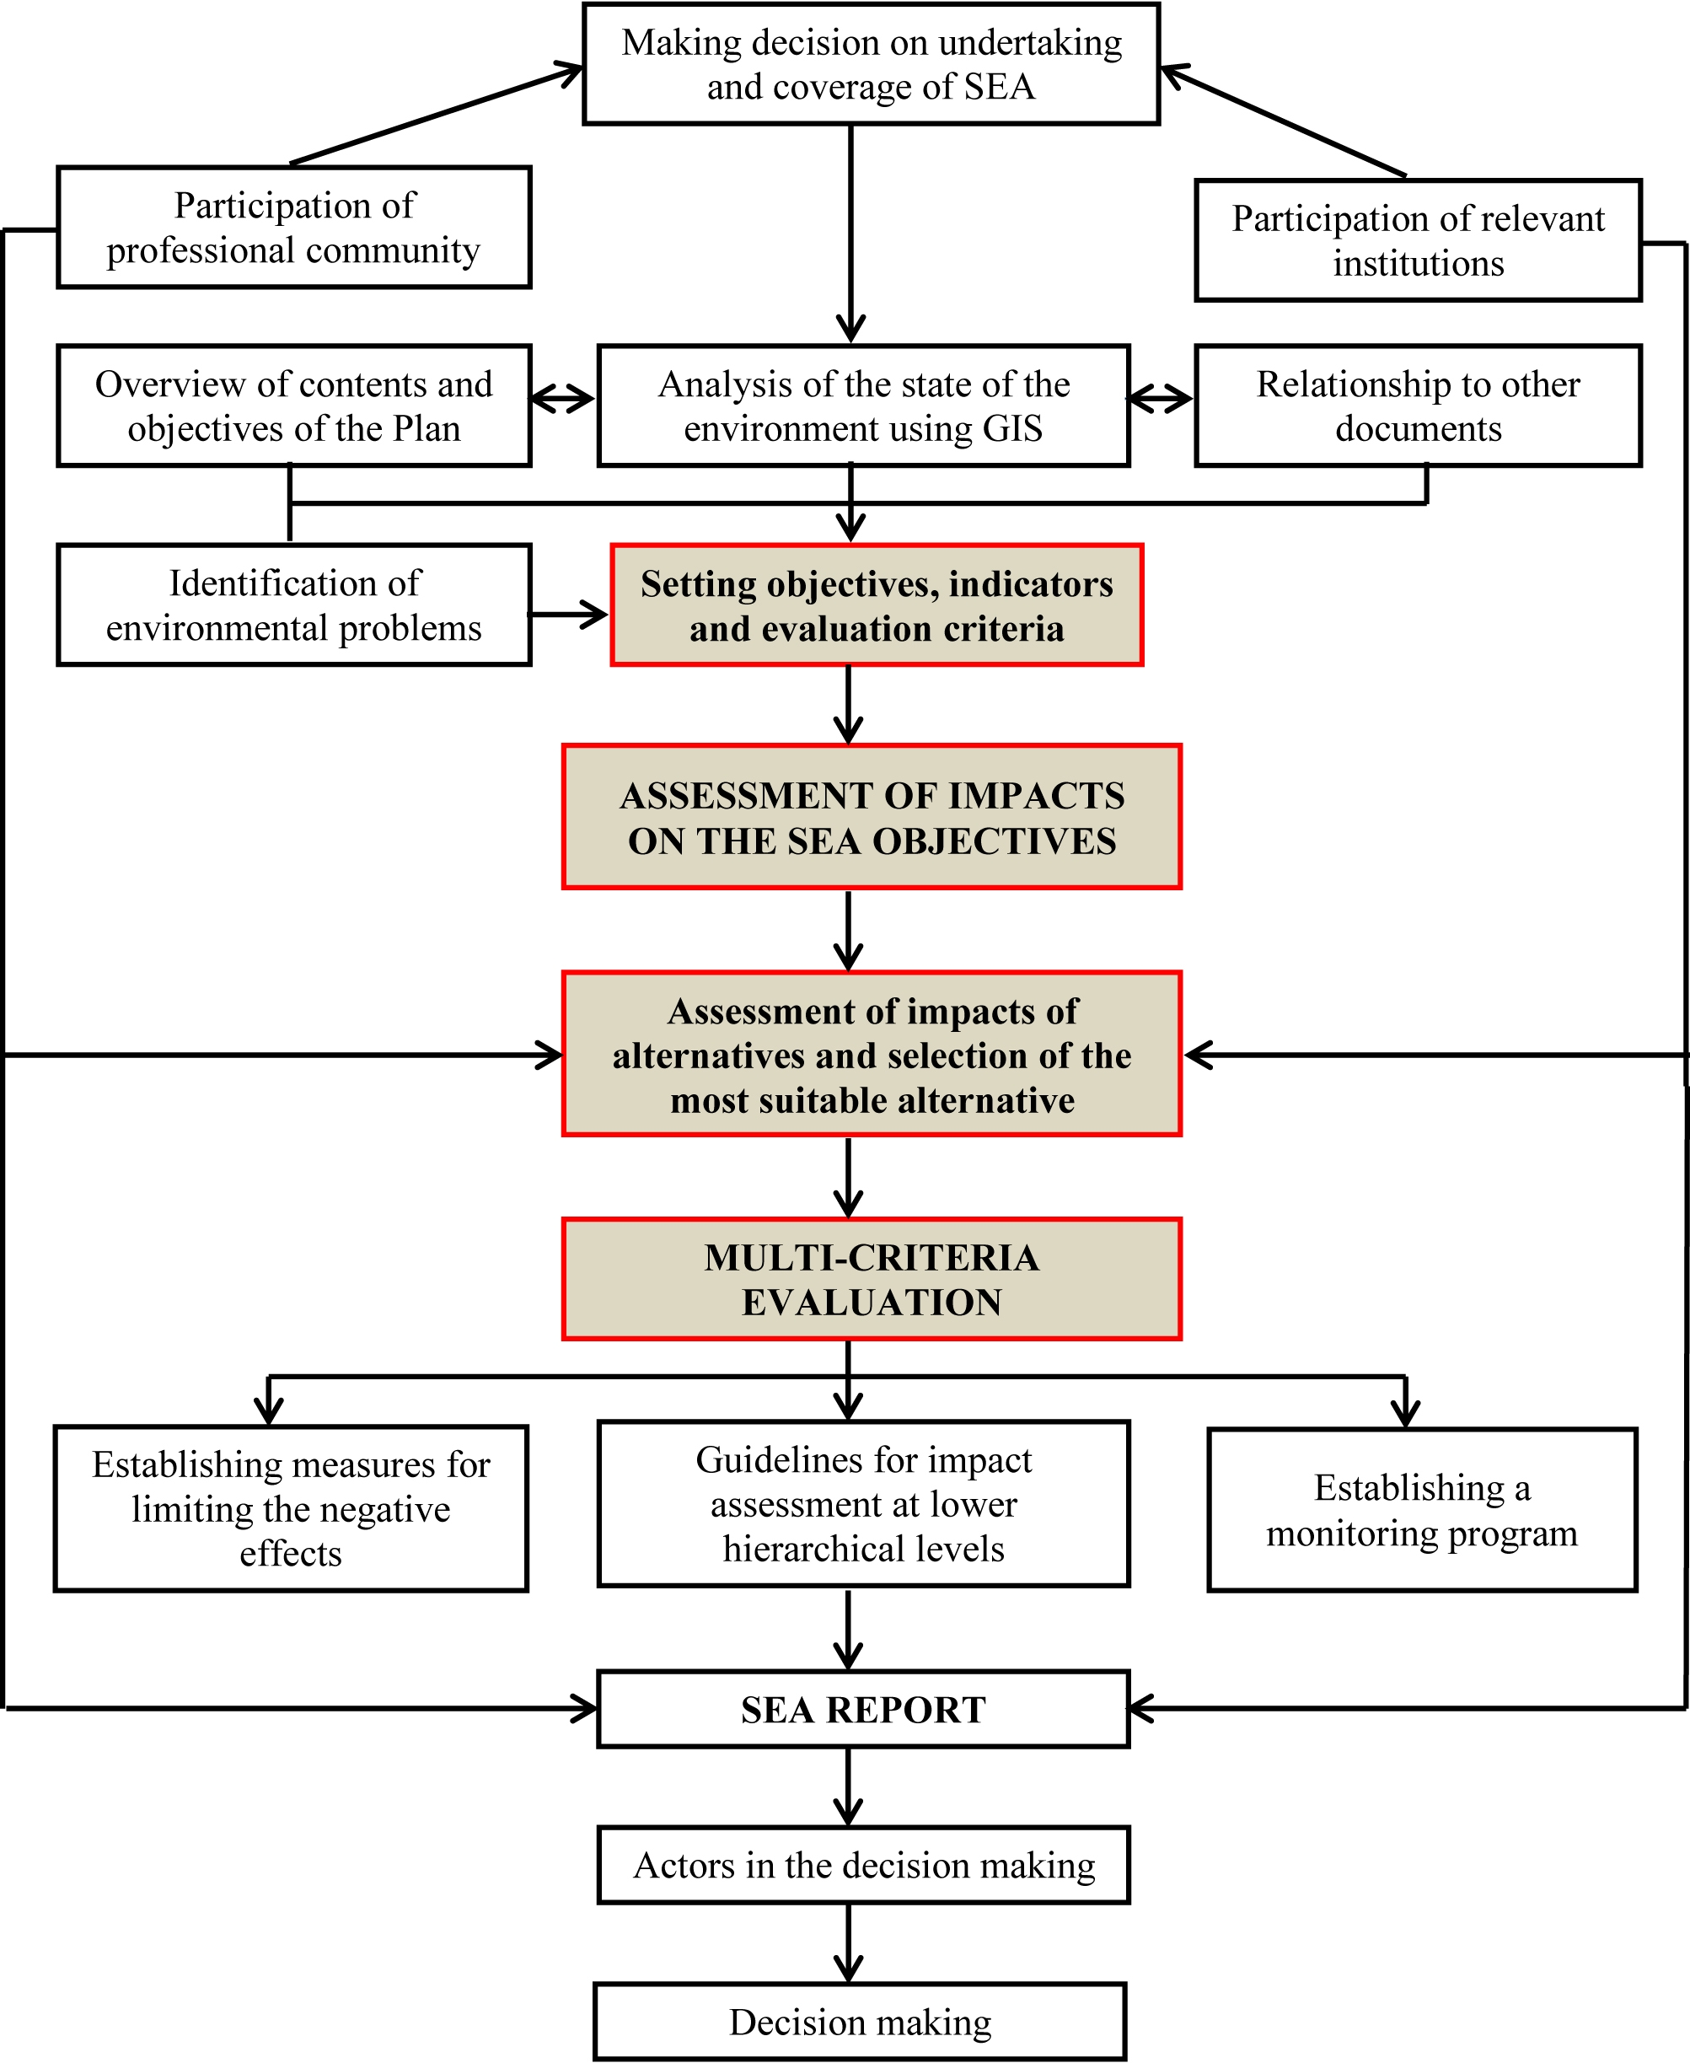
7. DECISION-MAKING METHODS

Adequate and transparent inclusion of parties concerned (investors, competent organs of state, local administration, non-government organizations, and population) in the decision-making process related to environmental protection issues at higher levels in relation to the current practice of formal organization of public debates on the proposed Program is of special importance due to importance of possible negative and positive effects of the proposed Program on the environment, human health, social and economic status of local communities

The Law on Strategic Environmental Impact Assessment (Article 18) provides for the participation of authorities and organizations concerned which can submit their opinion within 30 days from the date of the receipt of the request for opinion.

The authority competent for preparation of plans/programs shall provide for the public participation in the strategic assessment report consideration prior to submission of request for granting the approval for the strategic assessment report (Article 19). The authority competent for the preparation of plans/programs shall inform the public about the method and deadlines for insight into the content of the report and submission of opinions, as well as about the time and venue of public debate organized in accordance with the Law regulating the procedure for adoption of plans and programs.

Competent authorities and organizations shall be provided for the participation through written forms and through presentations in all stages of considering and carrying out the strategic assessment. The participation of the public concerned and non-government organizations shall be provided through public media and public presentations.

The authority competent for the preparation of plans/programs, in this specific case the Ministry of Mining and Energy, shall make the Report on the Participation of Interested Authorities and Organizations and the Public Concerned which shall contain all opinions on the SEA, as well as opinions submitted during the public insight and public debate.

The Strategic Assessment Report shall be submitted together with the report on professional opinions and public debate to the authority competent for environmental protection for evaluation. The evaluation shall be carried out according to criteria specified in Annex II of the Law. On the basis of the evaluation, the authority competent for environmental protection shall approve the strategic environmental assessment report within 30 days from the receipt of the request for evaluation.

After collecting and processing all opinions, the authority competent for the preparation of plans/programs shall submit the draft Program together with strategic assessment report to the authority competent for decision-making.

8. OVERVIEW OF CONCLUSIONS OF THE STRATEGIC ENVIRONMENTAL
ASSESSMENT REPORT

The Report on Strategic Environmental Assessment of the Program included an analysis of the current state of the environment with special insight into the areas affected by activities in the field of energy, importance and characteristics of the Program, characteristics of effects of planned priority activities by the Program fields, as well as other environmental protection issues and problems, according to criteria for identifying possible significant environmental impacts. In this process, a predominant planning approach which was used was the one which considered trends which can result from activities in the field of energy sector, as well as scenarios of energy sector development.

The following key problems in the fields affected by the energy sector have been identified in the analysis of the state of the environment:

- Due to intensive activities in the energy sector there is pollution of basic environmental factors;
- Surface waters and groundwaters are exposed to intensive negative impacts of pollution sources, as well as impacts of the wider environment, so that they do not meet fully water quality standards; due to impacts of mining works, the sources of water supply are endangered, and the level of groundwaters has been lowered;
- The soil in the vicinity of mines and landfills is contaminated;
- There is an increased noise level in the zone of open-pit mines and on coal transportation routes;
- The health of the people has been affected in settlements in the endangered environment, i.e. in the impact zone of mining and energy-related activities;
- The flora and fauna are endangered – biodiversity and geodiversity, as well as the habitats in the region of active mines;
- Industrial waste management is not at a satisfactory level, either concerning the collection system or waste disposal.

The methodological approach applied in the production of the SEA was based on defining objectives and indicators of sustainable development and multi-criteria qualitative expert evaluation (semi-quantitative method) of planned priority projects by the Program fields in relation to defined SEA objectives and pertaining indicators.

Within the SEA, 21 objectives of sustainable development and 34 indicators for evaluating the Program sustainability were defined. The selection of objectives and indicators supports the approach applied in the production of the Report on the Energy Sector Development Strategy of the Republic of Serbia (“Official Gazette of the Republic of Serbia”, No. 101/15), since it was approved by the relevant Ministry and having in mind that this document is actually its elaboration. In that context, the indicators were selected from the UN set of indicators of sustainable development and tailored to the need of making the subject document. This set of indicators was based on the Principle of Cause and Effect and on identification of response which allowed for the minimization of environmental problems, as well as in line with the Instruction issued by the Ministry of Science and Environmental Protection in February 2007 and the Regulation on the National List of Environmental Indicators (“Official Gazette of the Republic of Serbia”, No. 37/2011).

In the processes of multi-criteria evaluation, 33 priority solutions were included for individual Program fields, 12 of which were separately evaluated taking into consideration all the projects (and not only the priority ones) which were set forth for these Program fields. The mentioned fields and priority activities of the Program were evaluated according to the following groups of criteria:

- Impact magnitude;
- Spatial extent of possible impacts;
- Impact probability;
- Impact duration (temporary/occasional and long-term); and
- Impact type (direct and indirect).

The matrices were formed in which multi-criteria evaluation of defined priority activities (29) was carried out in relation to established criteria/indicators (21/34) and environmental impact assessment criteria (18). The matrix results were shown in graphs for each field and activity of the Program. The results obtained in this way were shown in a simple and understandable way. This was followed by the assessment of cumulative and synergistic effects of priority activities in relation to the fields of strategic environmental assessment.

The results of the evaluation indicated the fact that the Program implementation would have a considerable number of strategically significant both positive and negative environmental impacts.

Negative environmental impacts are identified as an unavoidable consequence of development and the use of natural potentials of the Republic of Serbia upon which future energy sector development should inevitably be based. This primarily implies: operations of the thermal power plants and, consequently, opening of new coal open-pit mines , which increases environmental pollution load to a great extent: pollution of the basic environment factors, effects on the population health, change in the view of landscape, biodiversity and geodiversity as well as social implications which manifest themselves in negative effects on the population health, on the one hand, and in displacement of settlements from areas in which opening and expanding of new coal open-pit mines is planned, on the other hand. Bearing the abovementioned in mind, it is necessary to pay special attention to the optimal development of the fields affected by the energy sectors. Certain negative implications are also expected due to inappropriately planned construction of reversible hydropower plants and small hydro-power plants, which would have negative effects on hydrological regime of watercourses on which their construction is planned, as well as on biodiversity and ichthyofauna, and will cause possible changes in the use of agricultural and forest lands etc.

As a signatory to the ESPOO Convention and Kiev Protocol, the Republic of Serbia has bound itself to inform other countries about proposed projects which may have transboundary impacts. In the Espoo Convention Environmental Impact Assessment , the transboundary impact is defined as “any impact not exclusively of a global nature, within an area under the jurisdiction of a Party caused by a proposed activity the physical origin of which is situated wholly or in part within the area under the jurisdiction of another party”. The Espoo Convention requires that if the proposed activity is found to cause significant adverse transboundary impact, the Party, i.e. the Government of the Country undertaking the activity shall, for the purposes of ensuring adequate and effective intervention, notify any other party (other country) which it considers may be affected by the activity as early as possible and no later than when informing its own public about the proposed activity. In that respect, it may be stated that priority projects defined in the Program do not imply strategically significant effects, either positive or negative, but there are projects in the border zone with other states, whose manner of functioning may cause certain effects. In this context, special attention should be paid to transboundary cooperation when implementing the Project of constructing a new block in TPP Kostolac B3, which also refers to the implementation of projects regarding the use of RES which are planned near the borders with neighboring countries, for the following reasons:

- Wind farms – possible significant adverse impacts on internationally protected flying fauna (ornithological fauna and chiropters) on the Serbian-Romanian boundary), particularly on the Serbian-Romanian boundary;
- Reversible hydropower plants and small hydro-power plants planned on transboundary watercourses – possible adverse impacts on bentonic organisms and ornithological fauna on boundaries with Montenegro, B&H, Romania and Bulgaria.
- Thermal power plant projects – possible impacts on the air quality and international rivers.

On the other hand, a whole series of positive strategic impacts of the Program were identified, out of which the most significant ones include the following:

- Environmental quality: reduction in water, air and soil pollution and reduction of greenhouse gas emissions by increasing the use of renewable energy sources and the application of clean technologies in thermal power plants in accordance with Directive 2001/80/EC on the limitation of emissions of certain pollutants into the air from large combustion plants and Directive 2010/75/EU on industrial emissions (integrated pollution prevention and control) for new projects; implementation of a whole set of environmental protection measures in all individual fields of the Program; development of the transmission and distribution network which will substantially reduce losses, etc.

- Socio-economic development: energy sector development as a contributor to economic growth; the market-oriented formation of energy prices and prices for energy-generating products; strict implementation of energy-efficiency measures in final energy consumption; overall energy sector development, which will represent a long-term contribution to sustainable economic development and rational use of non-renewable energy sources, i.e. to increasing the share of energy from renewable resources in total consumption.

The construction of a greater number of hydroelectric power plants or smaller hydro-power plants on the same watercourse is identified as an especially important issue in the context of possible cumulative impacts on the environment. In the Chapter 4 of the SEA, which refers to guidelines for lower hierarchical levels of planning, the preparation of specific planning documents and carrying out of the SEA are envisaged for such interventions in space so as to comprehensively consider in a wider context the negative effects of these interventions on the environment.

Other identified adverse transboundary impacts were not evaluated as strategically significant because they would not significantly increase environmental pollution load.

Environmental protection guidelines were established in the SEA which should be implemented to prevent and limit the negative effects of the Program on the environment in order to maintain positive effects of planning within frameworks which will not increase environmental load, and which will and minimize and/or prevent possible negative effects of the Program. A monitoring system was established as an instrument for monitoring the implementation of planned activities, the state of the environment and the status of each environmental factor separately.

Starting from the objectives and criteria of environmental protection defined in the protection policies and strategies in the adopted documents while taking into account the inherited state of the environment, and using the projections of the economic and spatial development, it is necessary to apply complex spatial, technical-technological, urbanistic-ecological, organizational and other protection measures in the Program implementation. When programming and planning activities for the Program implementation it is mandatory to apply a preventive approach to preserving the population health, natural resources and environment protection, while observing generally accepted criteria, legal norms and standards of protecting the environment and human health.

Summarizing all above mentioned, it may be concluded that the Program constitutes the framework for the sustainable energy sector development in the Republic of Serbia and that, except inevitable consequences accompanying the use of available and currently unavoidable mineral resources, almost all fields of the Program will have a substantial influence on improving the environment in comparison to the current state and current trends in the space and environment. In that context, in the regions functioning in the conditions of specific and special purpose in the field of energy, it is necessary to conduct consistently defined environmental protection measures and energy efficiency measures defined for separate fields o the Program, as well as the propositions of the subject Report on the SAE, whereas the Program may be considered as fully acceptable in such conditions.

The following data were used for the analysis and presentation of data on environmental quality: data obtained from the Serbian Environmental Protection Agency; documentation basis of the Spatial Plan of the Republic of Serbia; other available documentation from spatial plans and studies dealing with areas containing the most significant energy facilities and activities.
Climate Change Aspects of Energy Sector Development in Serbia. Part 1 (of 4): Summary, Introduction and Policy Assessment. Final Report, May 21, 2012
Decree on limit values of pollutants in surface and ground waters and sediments, and the deadlines for their achievement (“Official Gazette of the Republic of Serbia” No. 50/2012)
The samples at the reference station for this water body are taken on the right bank (state frontier goes along the Danube) and in the middle of the course as usual for other vioewed profiles.
The measurements in the period 2007/12 at 140 profiles located in 66 water courses, 26 accumulations and 5 lakes, as well as the results of other explorations, particularly biological parameters.
All mentioned projects necessitate making the associated planning document together with the Strategic Environmental Assessment Report in accordance with conclusions given in Paragraph 2 of Chapter 4 of the subject SEA.
EEA, Technical Report No25, Environmental Indicators: Typology and overview, Copenhagen, 1999.

