NOTIFICATION CONCERNING THE INTENTION TO REALISE THE PROJECT
„ Romania – Turkey High Voltage Direct Current (HVDC) Interconnection Link”
TO OBTAIN THE ENVIRONMENTAL AGREEMENT
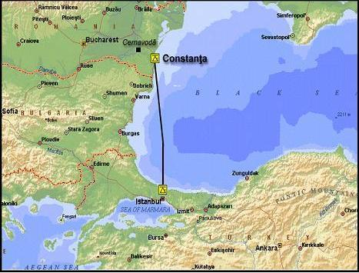

Constanţa/România

Client: C.N.T.E.E. TRANSELECTRICA S.A.

DECEMBER 2011
NOTIFICATION TO AN AFFECTED PARTY OF A PROPOSED ACTIVITY
UNDER ARTICLE 3 OF THE CONVENTION

Abbreviation List
AC = Alternative current
DC = Direct current
EIA = Environmental Impact Assessment
EMF = Electromagnetic fields
EU = European Union
HVDC = High Voltage Direct Current
OHTL = Overhead Transmission Line

1. INFORMATION ON THE PROPOSED ACTIVITY
(i) Information on the nature of the proposed activity
Type of activity proposed: | Romania – Turkey High Voltage Direct Current (HVDC) Interconnection Link.
Is the proposed activity listed in Appendix I to the Convention? | The proposed activity is NOT listed in Appendix I to the Convention.
Scope of proposed activity  (e.g. main activity and any/all peripheral activities requiring assessment) | The project consists of a transmission link connecting the grid system in Romania at Constanta Nord substation, with that in Turkey at the Alibeyköy substation.
Scale of proposed activity  (e.g. size, production capacity, etc.) | The connection point of the cable to the Romanian power system will be the Constanta Nord 400 kV substation. The connection point to the Turkish power system will be the Alibeyköy 380 kV substation to the north-west of Istanbul. The approximate transmission length is 400 km.
Description of proposed activity  (e.g. technology used): | Due to the distance involved, the only technology feasible is a High Voltage Direct Current (HVDC) link.  The selection of a DC link reduces the need for costly and complicated coordination of the frequencies of the two large grids, as the conversion to AC on either side is independent of the AC frequency on the other side.
Description of purpose of proposed activity: | The project aims to strengthen the transmission capacity and improve the power exchange in the south-east Europe region, thereby enabling improved supply security, quantity and quality. With the link, Romania, and Europe will have an alternative facility to import power from the Turkish power grid, and to export from the eastern European grid. Sources of generation in Romania include nuclear, hydropower and modern thermal power and in the future also wind power. Sources of generation in Turkey include hydropower, wind and thermal power (based on coal and gas). The HVDC link will also be able to support the 400 kV AC interconnections between Turkey and Bulgaria as well as Greece, also reduce and e.g. interact on oscillations on the 400 kV AC interconnections.
Rationale for proposed activity (e.g. socio-economic, physical geographic basis) | The Project is in line with the EU strategy on internal EU energy market and EU 1229/2003/EC and EU 96/391/EC and with the EU’s and ENTSO-E intentions and ambitions for the internal electricity market, e.g. to increase the number of interconnections between its member states in order to increase security of supply.
Additional information/comments | The idea to make a direct interconnection via a submarine cable from Romania to Turkey was launched a few years ago and recently the governments in both countries decided to evaluate the feasibility for this link, among other bilateral energy projects.
(ii) Information on the spatial and temporal boundaries of the proposed activity
Location: | Romania, Bulgaria (Black Sea) and Turkey.
Description of the location  (e.g. physical-geographic, socio-economic characteristics); | The proposed cable landing point on the Romanian site is located to the south of the city of Constanta. Constanta is the oldest city in Romania, the administrative center of the county, and the largest city in the region. The city is situated on the Black Sea coast, having a coast length of 13 km. The Port of Constanta is the largest Romanian port on the Sea, and one of the largest ports in Europe. Constanta is also important for its recreational area Mamaia. The resort is located on a narrow stretch of fine-sand beach between the Black Sea and Lake Siutghiol, north of Constanta.  The proposed cable landing point on the Turkish side is in a rural, sparsely populated area near Yeniköy village, about 35 km from the Alibeyköy substation. The coastal area has traditionally been used for coal mining.
Rationale for location of proposed activity  (e.g. socio-economic, physical-geographic basis): | The Project also brings an important contribution and stability to the regional electricity market in South-East Europe.
Time-frame for proposed activity (e.g.: start and duration of construction and operation) | Start and duration of construction  Time 1 year: Start of manufacturing of cable  Time 1,5 years: Converter Station: Order placement for converter transformers  Time 2,5 years: Start of civil works  Time 2,25 – 2,75 years: Laying of the first cable sections  Time 3,25 years: First converter transformer goes into production  Time 3,25 and 4,25 years: Laying the remaining cable sections  Time 4 years: Equipment on site  Time 4,75 years: Equipment installed – Commissioning tests and trail operation can start  Time 5,25 years: Tests completed  Duration of operation: 30 years .
Maps and other pictorial documents connected with the information on the proposed activity | Please see:  - Figure 1 - Aerial view of cable route for link connecting Romania - Turkey  - Figure 2 - Scheme of transmission link connecting Romania - Turkey
Additional information/comments
(iii) Information on expected environmental impacts and proposed mitigation measures
Scope of assessment  (e.g. consideration of: cumulative impacts, sustainable development issues, impact of peripheral activities, etc.): | Potential pollution effects during the period of objective functioning  Heat dissipation  Heat produced by the buried cable can potentially have an impact on bottom ecology. The level of heat dissipation from the cable to the surrounding sediments and water depends on the cable’s heat loss, the ambient temperature and the thermal resistivity of the material (sediments) surrounding the cable, but will be approximately 20 W/m.  The potential rise in temperature in the seawater is smaller than the natural fluctuations, no impact is therefore expected on water quality or aquatic flora and fauna. A temperature increase of one to a few degrees C will stimulate macroinvertebrate and in fauna (fauna within the bottom substratum) productivity along the cable. It is not expected to have any impact on fish or aquatic mammals.  Electromagnetic fields  Electromagnetic fields (EMF)s are invisible lines of force that surrounds any electrical device carrying electrical current (e.g. power lines and electrical equipment). They consist of electric and magnetic components. One of the main characteristics that defines an electromagnetic field (EMF) is its frequency or its corresponding wavelength. If the frequency is zero the field is denoted “static” or “DC”, otherwise it is denoted “time-varying” or “AC”.  These two types of fields differ by their physical characteristics and cause different effect on the environment.  Both AC and DC electric and magnetic fields will be generated by different parts of project components.  The Romanian -Turkey HVDC link will comprise a HVDC submarine part, a HVDC overhead transmission line part (depending on the chosen alternative) and a HVAC overhead transmission line part.  Submarine part  Electric field  In mid-point earthed symmetric monopolar schemes, no current is ejected via the electrodes. Electric field in submarine HVDC cables is shielded since cables are isolated. Therefore there will be no electric field in the sea. The R-T HVDC transmission system is planned to operate in mid-point earthed symmetric monopolar scheme with no current in the earth.  Other environmental issues associated with non-synmetrical monopolar submarine HVDC systems such as: electrolyses products, corrosion of buried pipes and metallic structures, moisture level reduction in soil close to the land electrode site are not relevant for this project as there will not be any return current through the earth or sea.  Magnetic field  The submarine cable project will generate a static magnetic fields spanning along the route of the cables. Each of the cables will generate a field, which interacts with the field from the other cable, as well as the Earth geomagnetic field. Cables close to each other with opposite current directions will reduce the resulting magnetic field. The extent and strength of the resulting field depends on the distance between the cables and the direction of the cables relative the magnetic north direction. In case of R-T HVDC cable link two cables with opposite current direction will be bounded and placed in one trench. Since cables will be placed close to each other, the total magnetic field will be significantly reduced.  On-land part  Different alternatives of the landing sites and location of necessary installations suggest three options of connection between the landing site and the substations:  - AC OHTL  - DC OHTL  - DC Underground cable  Below each of the above-mentioned connections are examine in respect with electromagnetic fields they will generate.
Expected environmental impacts of proposed activity  (e.g. types, locations, magnitudes): | Taken in consideration the diminution measures of the impact over the environmental factors, as the control, alarm, monitoring systems, with which the project is foreseen in the projection phase, the appearance probability of some events that could generate a negative impact over the environmental factors is very small.  The nature of the proposed activities does not create the possibility of the appearance of an irreversible impact.
Inputs  (e.g. raw material, power sources, etc.) | Alternative current
Outputs  (e.g. amounts and types of: discharges in air, discharges into the water system, solid waste) | Alternative current
Transboundary impacts (e.g. types, locations, magnitudes): | - Cable laying in the Black Sea  - At the deeper waters, cable will be layed by gravity. These waters are characterised by the presence of a well-defined anoxic zone. Presuming that bottom sediment from the anoxic layer will not be mixed with oxygen-rich waters from the oxic layer during cable laying, the impact on aquatic ecosystem will be minimal.  - Construction of the overhead transmission lines (OHTL) connecting converter stations to existing substations.  - Connections between landing points and converter stations by cable or OHTL  - Construction of the converter stations and transition stations in Turkey and Romania
Proposed mitigation measures  (e.g. if known, mitigation measures to prevent, eliminate, minimize, compensate for environmental effects): | Proposed mitigation measures are mentioned in the EIA documentation.
Additional information/comments | -
(iv) Proponent/developer:
Name, address, telephone and fax numbers | C.N.T.E.E. Transelectrica S.A.
(v) EIA documentation
Is the EIA documentation (e.g. EIA report or EIS) included in the notification? | No, the EIA documentation is not included in the notification.
If no/partially, description of additional documentation to be forwarded and (approximate) date(s) when documentation will be available | EIA documentation will be forwarded if Bulgaria will participate in the procedure.
Additional information/comments | -
2. POINTS OF CONTACT
(i)Point of contact for the possible affected Party:
Authority responsible for coordinating activities relating to the EIA (refer to decision I/3, appendix):  Name, address, tel and fax numbers | Ministry of Environment and Water  22 Maria Louisa Blvd. 1000 Sofia  Telephone: +359 2 988 25 77  Fax: +359 2 986 25 33  Ms. Jacquelina METODIEVA  Head of EIA/EAD Department  Telephone: +359 2 940 60 32  E-mail: metodieva@moew.government.bg  Ms. Detelina PEICHEVA  State Expert, International Cooperation Department  Telephone: +359 2 940 62 15  Fax: +359 2 987 38 67  E-mail: dpeycheva@moew.government.bg
List of affected parties to which notification is being sent | Bulgaria
(ii) Points of contact for the Party of origin
Authority responsible for coordinating activities relating to the EIA ( refer to Decision I/3, appendix)  Name, address, tel and fax numbers | Ministry of Environment and Forests  Head of EIA office: Ms.Daniela Pineta  Blvd. Libertatii nr 12, sect. 5, Bucharest, Romania  Tel 021 408 95 48; 021 408 95 37  Fax 021 316 04 21  e-mail: daniela.pineta@mmediu.ro
Decision making authority if different than authority responsible for coordination activities relating to the EIA  Name, address, tel and fax numbers | EPA Constanţa
3. INFORMATION ON THE EIA PROCESS IN THE COUNTRY WHERE THE PROPOSED ACTIVITY IS LOCATED
(i) Information on the EIA process that will be applied to the proposed activity:
Time schedule: | Approximately 6 months
Opportunities for the affected party/parties to be involved in the EIA process | The affected party may participate within the procedure as it follows:  - Based on the notification and the accompanying Project Presentation Report, the affected party decides on the implication in the procedure and may send comments and issues to be treated in the EIA documentation;  - After receiving the EIA documentation, the affected party is invited to send comments/opinions on it;  - The Romanian Ministry of Environment and Forests, EPA Constanţa and the developer of the project may participate, at the invitation of the affected party, in any public hearing proposed on the territory of the affected country.  If needed, consultation with the authorities of the affected party, based on art.5 of the Espoo Convention will be agreed later in the procedure.
Opportunities for the affected party/parties to review and comment on the notification and the EIA documentation | Comments on the notification are expected to accompany the Bulgarian answer to the present notification.  Comments on EIA documentation are expected during the procedure.
Nature and timing of the possible decision: | The possible decision is the issuing of environmental agreement for this project and issuing the construction authorization in 2012.
Process for approval of the proposed activity | The proposed activity will be approved by construction authorization after the environmental agreement (final EIA decision) is issued by the environmental competent authorities.
Additional information/comments | -
4. INFORMATION ON THE PUBLIC PARTICIPATION PROCESS IN THE COUNTRY OF ORIGIN
Public participation procedures | In accordance with Romanian legislation, public participation during the procedure: public hearing with minimum 20 working days access to the EIA documentation and an opportunity for submitting comments in writing before and during public debate.
Expected start and duration of public consultation | Minimum 20 working days for public debate on EIA report.  The public consultation for the project will be agreed with the environmental authorities in Bulgaria, after confirmation of their involvement in the procedure.
Additional information/comments | -
5. DEADLINE FOR RESPONSE
Date | 30th of January 2012

Figure 1 –- Aerial view of cable route for link connecting Romania - Turkey
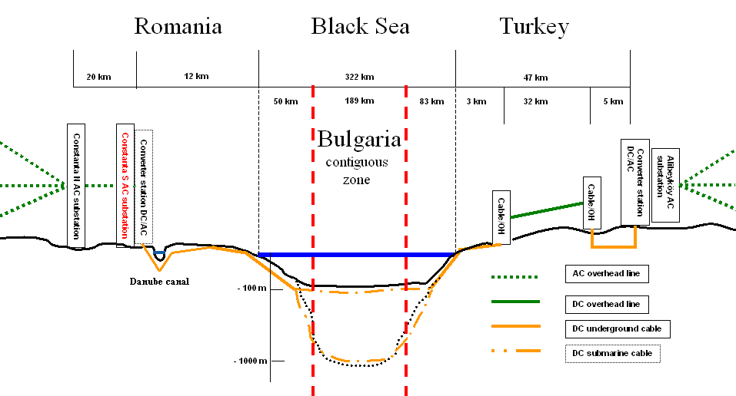

Figure 2 - Scheme of transmission link connecting Romania - Turkey

