III. Partner search information
Contact information
Admir Mesic Organization: Emisoft AS
Address: Bønesskogen 124,O PB 51 Bergen, N-5849 Norway E – Mail
Telephone: 0047 908 39 758 Web page: www.emisoft.com and www.teamsglobal.com

Programme(s) and call (s) of interest (please check as appropriate):
BG02 Integrated marine and inland water management | BG03 Biodiversity and ecosystem services
1. Call 1: More integrated management of marine and inland water resources (Launch: June 2014) | 1. Small grant scheme SGS1: Development of a nation-wide education and awareness campaign through volunteer action and supporting activities (Launch: June 2014)
2. Call 2: Improved monitoring of marine waters (Launch: June 2014) | 2. Call 1: Invasive alien species networking for information exchange and capacity building (Launch: June 2014)
3. Call 3: Increased capacity for assessing and predicting environmental status in marine and inland waters (Launch: June 2014) | 3. Call 2: Ecosystem services mapping and assessment (Launch: fourth quarter of 2014)
 | 4. Call 3: Sectoral policies for the systematic use of ecosystem services (Launch: June 2014)

Preferred themes of projects and profile of partner
- Brief description on participant’s Organization
Emisoft offers reporting and monitoring systems in the areas of climate change, environment, sustainability and corporate social accountability as well as related consulting services. The reporting system is based on our leading software TEAMS Sustainability Reporting. Through our customers, TEAMS is today used by our customers in more than 100 countries.
The company was established in 1992. From the start our consultants has been working with leading and demanding customers within environmental management and performance.
2. Sector of activities of participant’s Organization
1. Delivery, implementation and follow up of reporting and monitoring systems
2. Delivery of reporting and monitoring systems customized to desired frameworks such as: GRI, E-PRTR, CDP, WFD, MSFD or other frameworks.
3. Environmental Consulting on various areas. Today Emisoft has environmental consultants working for Shell and Statoil among others. We can offer highly experienced experts. We have especially one consultant who has a PhD specialized on water and rivers, he has also international project background that might be of interest in Bulgaria.
3. Established contacts to potential partners from Bulgaria (select as appropriate)
I have/ I have not established contact with Bulgarian organizations
If yes, please specify:
4. Description of preferable project partner’s profile
Either Executive Environment Agency Bulgaria (ExEA), or the environmental ministry, or perhaps a company related to reporting and monitoring of marine waters.

5. Please describe what you expect from the potential project partner from Bulgaria
Interest in improving the reporting and monitoring status both internally as well as on a national level. Open-minded with clear ambitions. We are also open to the idea of implementing such a system together with a local partner with experience on awareness raising, competence and capacity building.

6. Please describe what you can offer to potential project partner from Bulgaria
Emisoft has over 20 years of experience with delivery of reporting and monitoring systems for several different industries and fields of environment such as water, air pollution, wastewater, waste management, chemicals, soil, biodiversity, as well as economic and social parameters.
Our system TEAMS is based on customers own organizational structure and complexity. TEAMS can collect, monitor and report on multiple frameworks at the same time. Emission factors and other background data is easily managed for each framework. We also provide Business Intelligence features that allow users of TEAMS to efficiently analyze and monitor the data on daily basis.
We have recently completed a successful project in Serbia by implementing a fully E-PRTR compliant system combined with national framework for SEPA, Serbian Environmental Protection Agency. Today more than 7000 companies report directly into TEAMS. With our experience from Serbia, and the process and oil and gas industry In Norway, we believe we could share and use this experience in Bulgaria, making an improvement of monitoring of marine waters. We also strongly believe that we could also learn a lot from Bulgarian best practices.

7. The information given in this registration form can be given to the participants from Bulgaria for developing partnership
Yes No

Annex 2
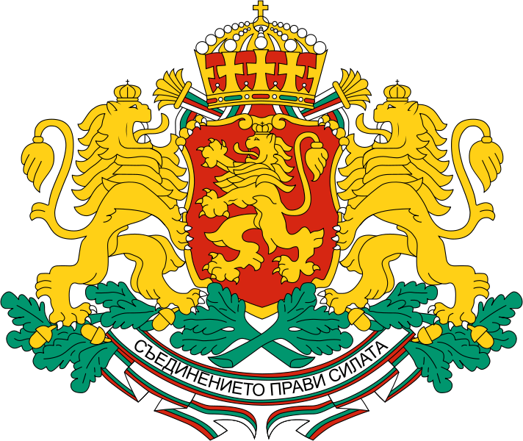

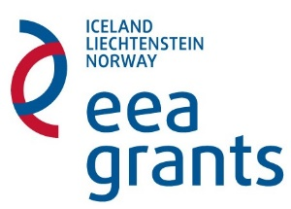
Report and reimbursement claim
for bilateral funding - programmes BG02 Integrated marine and inland water management and BG03 Biodiversity and ecosystem services
Organization
Grant approval date
Programme
Type of funding granted | Measure (a) Measure (b)

Person(s) performing the bilateral activities:

Purpose of the visit:

Description of the implemented activities (describe in details the initiatives, activities, participants, date and location):

Outcome of activities:

Financial report and requested amount (double-click to edit; add rows as necessary and describe): 1
Reimbursement details:
IBAN: BIC:
Bank name, branch: Account holder:

Attachments (add rows as needed)
    - …………………………………………..
    - …………………………………………..
    - …………………………………………..
Please attach all expenditure documents – verified “true to original” and provided with translation into English if the document’s language is other than Bulgarian or English.
Please attach copies of all results from the bilateral cooperation activities.
Declarations
The undersigned ……………………. (name, position) of ……………………… (organisation name) hereby declare:
      - That the information provided in the payment request and the attached documents is complete and accurate
      - That the costs incurred can be considered eligible in accordance with Chapter 7 of the Regulation on the implementation of the EEA FM and the Bilateral cooperation support guide for programmes BG02 Integrated marine and inland water management and BG03 Biodiversity and ecosystem services.
      - That the activities reported herein are not funded by another source
      - That the activities reported herein were implemented under observation of the EU and national law

Official representative of the institution: /signature, stamp/

