III. Partner search information
Contact information
First name, last name Organization
Address: NMBU POB 8146 DEP., N-0033 Oslo Norway E – Mail: vidar.berg@nmbu.no
Telephone +47 901 88 462 Web page: http://www.umb.no

Programme(s) and call (s) of interest (please check as appropriate):
BG02 Integrated marine and inland water management | BG03 Biodiversity and ecosystem services
1Call 1: More integrated management of marine and inland water resources (Launch: June 2014) | 1. Small grant scheme SGS1: Development of a nation-wide education and awareness campaign through volunteer action and supporting activities (Launch: June 2014)
2. Call 2: Improved monitoring of marine waters (Launch: June 2014) | 2. Call 1: Invasive alien species networking for information exchange and capacity building (Launch: June 2014)
- 3. Call 3: Increased capacity for assessing and predicting environmental status in marine and inland waters (Launch: June 2014) | 3. Call 2: Ecosystem services mapping and assessment (Launch: fourth quarter of 2014)
 | 4. Call 3: Sectoral policies for the systematic use of ecosystem services (Launch: June 2014)

Preferred themes of projects and profile of partner
- Brief description on participant’s Organization
University of life science
2. Sector of activities of participant’s Organization
Research
3. Established contacts to potential partners from Bulgaria (select as appropriate)
I have not established contact with Bulgarian organizations
If yes, please specify:
4. Description of preferable project partner’s profile
Environmental chemistry biology ecotoxicology

5. Please describe what you expect from the potential project partner from Bulgaria
A cooperation aiming at research and environmental monitoring and evaluation of human impact on environment

6. Please describe what you can offer to potential project partner from Bulgaria
We have a laboratory with extensive experience in analysis of pollutants, and a history of a large number of publications in respected international journals

7. The information given in this registration form can be given to the participants from Bulgaria for developing partnership
- Yes
Annex 2
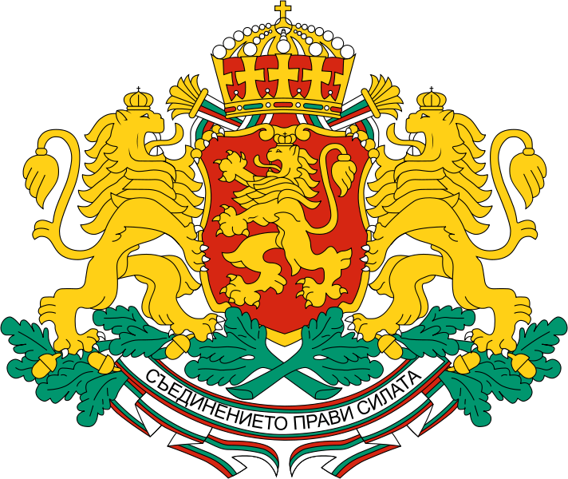

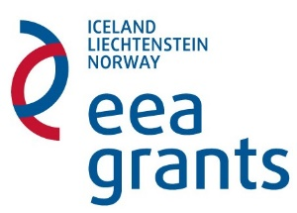
Report and reimbursement claim
for bilateral funding - programmes BG02 Integrated marine and inland water management and BG03 Biodiversity and ecosystem services
Organization
Grant approval date
Programme
Type of funding granted | Measure (a)

Person(s) performing the bilateral activities:

Purpose of the visit: Conference and matchmaking event, EEA Grants

Description of the implemented activities (describe in details the initiatives, activities, participants, date and location):

Outcome of activities:

Financial report and requested amount (double-click to edit; add rows as necessary and describe): 1
Reimbursement details:
IBAN: BIC:
Bank name, branch: Account holder:

Attachments (add rows as needed)
    - …………………………………………..
    - …………………………………………..
    - …………………………………………..
Please attach all expenditure documents – verified “true to original” and provided with translation into English if the document’s language is other than Bulgarian or English.
Please attach copies of all results from the bilateral cooperation activities.
Declarations
The undersigned ……………………. (name, position) of ……………………… (organisation name) hereby declare:
      - That the information provided in the payment request and the attached documents is complete and accurate
      - That the costs incurred can be considered eligible in accordance with Chapter 7 of the Regulation on the implementation of the EEA FM and the Bilateral cooperation support guide for programmes BG02 Integrated marine and inland water management and BG03 Biodiversity and ecosystem services.
      - That the activities reported herein are not funded by another source
      - That the activities reported herein were implemented under observation of the EU and national law

Official representative of the institution: /signature, stamp/

