Convention on the Conservation of European Wildlife and Natural Habitats
Recommendation No. 110 (2004) on minimising adverse effects of above-ground electricity transmission facilities (power lines) on birds
(Adopted by the Standing Committee on 3 December 2004)
The Standing Committee of the Convention on the Conservation of European Wildlife and Natural Habitats, acting under the terms of Article 14 of the Convention,
Having regard to the aims of the Convention to conserve wild fauna and its natural habitats;
Recalling that Article 2 of the Convention requires Parties to take requisite measures to maintain the population of wild fauna at a level which corresponds in particular to ecological, scientific and cultural requirements, while taking account of economic requirements;
Recalling that Article 3.2 of the Convention requires each Contracting Party to undertake, in its planning and development policies and in its measures against pollution, to have regard to the conservation of wild fauna.
Recalling also the Convention on the Conservation of Migratory Species of Wild Animals (CMS) Resolution 7.4 on Electrocution of Migratory Birds adopted by the 7th meeting of the Conference of the Parties (2002) and recognising the intention of the CMS to increase cooperation with the Bern Convention;
Recognising the importance of maintaining energy supplies and for actions taken to protect birds to be proportionate in terms of cost and to avoid reduction in overall level of safety of transmission lines or in stability of supply;
Recognising the importance of maintaining a stable energy supply and avoiding a reduction in the overall level of safety of transmission lines;
Recognising also that actions taken to protect birds should be proportionate in terms of cost,
Referring to the information presented in the report T-PVS/Inf (2003) 15 Protecting birds from powerlines: a practical guide to minimising the risks to birds from electricity transmission facilities, prepared by BirdLife International for the Council of Europe, informing of the negative impact on many species of wild bird (including migratory species) across Europe and the world, from overhead electricity transmission lines, conductors and towers (including those associated with railway infrastructure) through increased mortality due to electrocution, collision and also through reduction of suitability of staging, wintering and breeding areas, especially when powerlines cross open landscapes;
Concerned that a significant number of bird species suffering from electricity transmission facilities are listed in Annex II to the Convention, and that the threat is increasing due to the continuing construction of dangerous electricity transmission facilities;
Concerned particularly that, without action to minimize threats to birds from electricity transmission facilities, many populations and potentially species, including globally threatened species such as Aquila adalberti may be severely affected;
Recognising that, especially in arid zones, electrocution of birds on transmission lines can cause disastrous forest fires affecting both wildlife and people and for which electric utility companies can expect to be made liable;
Aware that technical solutions are available to eliminate or reduce transmission line electrocution and collision risk posed to birds and that such solutions which are safer for birds also correspond to a better energy supply and therefore are an advantage to supplying companies; most existing facilities do not incorporate such solutions
Desiring to raise awareness among the public, developers and decision-makers of the serious, widespread risks posed to birds by powerlines and that these can readily be minimised;
Recommends that Contracting Parties to the Convention:
1. take appropriate cost-effective measures to reduce bird mortality from electric transmission facilities taking into account Resolution 7.4 of the Seventh meeting of the Parties of the Convention on Migratory Species of Wild Animals (Appendix 2), applying those cautions to cases where non-migratory species may be affected;
2. apply as far as possible the measures for bird safety suggested in the report mentioned in the consideranda above, and in particular those suggested in the enclosed Appendix 1, taking into account that, to ensure appropriately located and safe constructions, the following measures need to be considered:
To avoid electrocution
a) banning of the most dangerous types of pole
b) use of state-of-the-art recommended technical standards for bird safety for new and retrofitted facilities
To avoid collisions and reduction of habitat availability, while improving air safety
c) encouraging underground location of cables where possible in technical and financial terms; or
d) in locations of particular importance to birds, and where birds may be vulnerable to collision, consents should be conditional upon examination of different routing alternatives prior to and during the planning phase, involving a minimum of one year of ornithological investigations including of bird movements during both day and night ;
e) constructions should obstruct only a minimum of air space in a vertical direction i.e. single-level arrangement of conductor cables with no neutral cable above or clearly visible black-and-white markers should be attached to high-risk cables;
3. consider replacing underground overhead powerlines in areas of exceptional high interest for birds, particularly in protected areas and in areas designated for the Natura 2000 and Emerald Networks for their bird interest.
4. systematically collect information with respect to collisions and electrocutions on electricity transmission lines;
5. communicate to the Standing Committee the relevant steps that have been adopted or envisaged concerning the implementation of this recommendation as well as information on the outcome of measures adopted;
Invites observer states to take note of this recommendation and implement it as appropriate.
APPENDIX 1
Examples of measures that may be considered as appropriate for minimising the negative impacts on birds of electricity transmission facilities are listed for implementation by Contracting Parties. Additional standards, including stricter standards, may be adopted by Contrating Parties. The design and route of electricity transmission lines is critically important to avoiding deleterious impacts on birds.
In considering these examples of possible bird mitigation measures, it is recognised that the electricity industries in Contracting Parties will necessarily have to work at actions that might be taken to protect birds in a wider context. This includes cost, stability of supply and overall safety of transmission lines
A. Criteria for Environmental Assessment
(a) Thorough environmental assessment (Footnote : For example, as set out in Directive 2001/42/EC of the European Parliament and of the Council Assessment of certain public and private projects on the environment (EIA Directive) as amended by Directive 97/11/EC) should be undertaken for all electricity transmission lines that have the potential for damaging effects on wild birds or in areas where there is uncertainty as to the potential effects. .
(b) The use of standard methods is essential to ensure comparability, adopting the Before-After Control-Impact (BACI) approach with consistent application of these methods before, during and after construction in the vicinity of the power line and a reference area for comparison
(c) There is a need for best practice guidance on standard study methods, to inform the EIA process.
(d) In case of lacking knowledge and in areas of particular importance to birds, a minimum one-year baseline field study should be undertaken to determine the use of the study-area by birds.
(e) Post-construction monitoring needs to enable short- and long-term effects and impacts to be distinguished and satisfactorily addressed.
The following list of bird families are indicative of those that should tend to be focal species for environmental assessments where they are at risk as they are considered to be particularly sensitive, or potentially so, to power lines (electrocution, collision, displacement including barrier to movement). Key: 0 - no casualties reported or likely; I - casualties reported, but no apparent threat to the bird population; II - regionally or locally high casualties; but with no significant impact on the overall species population; III - casualties are a major mortality factor; threatening a species with extinction, regionally or on a larger scale.
B. Precautions for route selection for electricity transmission lines
(a) There should be precautionary avoidance of locating power lines farms in designated or qualifying sites for nature conservation, including Important Bird Areas (IBAs).
(b) As part of effective regional planning, there is a need to identify species and areas of concern, to map potential and potentially sensitive locations for electricity transmission lines based on nature conservation concerns, for example avoidance of migratory corridors and other large concentrations of birds.
C. Technical Standards to protect birds from electrocution
Newly erected power poles and technical hardware should be constructed to exclude the possibility of bird electrocution. Crossarms, insulators and other parts of medium voltage (1KV – 60 KV) powerlines should be constructed so that birds are not able to perch near energized powerlines that might be hazardous.
Mitigating measures should be undertaken on existing power poles and technical hardware in the medium voltage range in locations of particular importance for birds
Power poles for medium voltage (1KV – 60 KV) should reflect the state-of-the-art in design for bird safety and should follow the detailed design guidelines and criteria described in the catalogue „Vogelschutz an Freileitungen“, VDEW-Verlag, 2nd edition, 1991 (Comments on Section 8.10 Bird Protection of German Industry Norm VDE 0210/12.85).
The following describes the most widely used types of power poles worldwide, their potential risk and steps towards mitigation. Recommendations are made for power poles made of concrete, steel, composite steel and wood. This report is based on standards set up by the Vereinigung Deutscher Elektrizitätswerke (1991) as well as studies carried out by the NABU National Working Group on Electrocution (2002).
The safety of the installations depends primarily on
• how insulators are attached to the poles and
• the actual space between the power cables and other energized and grounded parts.
A) POWER POLES WITH UPRIGHT INSULATORS
Power poles, constructed on pre-stressed concrete or metal with upright insulators, are widely used and rank as the most dangerous of all types. The gap between the cables and the crossarm is small.
B) POWER POLES WITH SUSPENDED INSULATORS
C) STRAIN POLES
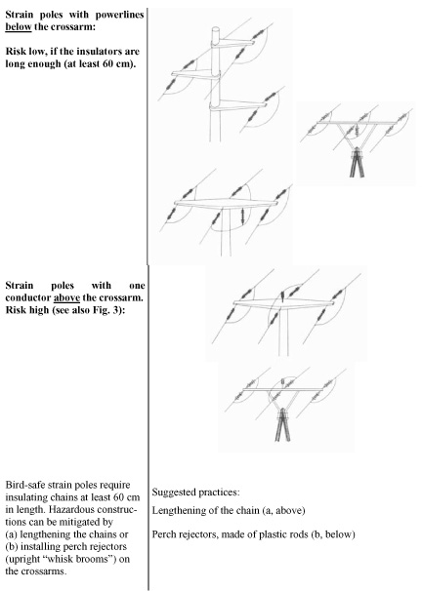
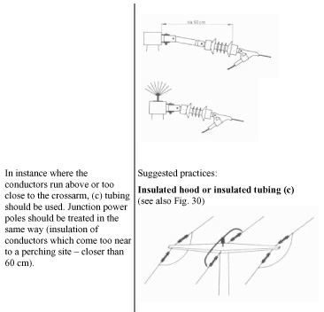
D) TERMINAL POLES AND TOWER STATIONS
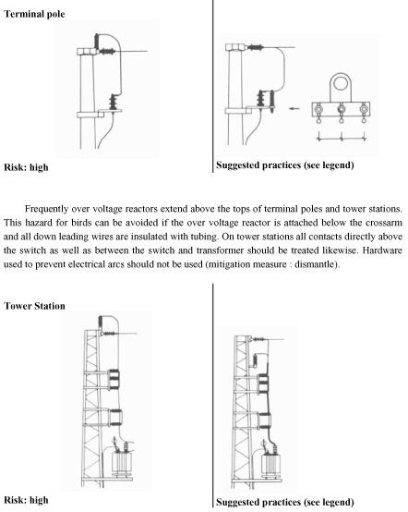
E) SWITCH TOWERS
The safest switch towers have their switches attached below the crossarm. Otherwise, mitigation measures are more complicated and do not provide the same high degree of safety for birds. As hooding is usually not possible, various techniques have been tested.
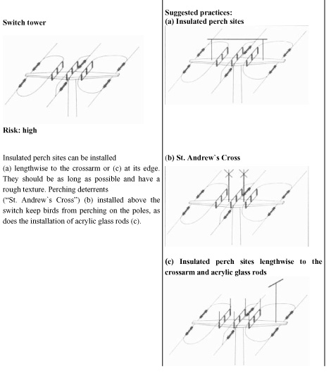
In the case of medium-voltage railway powerlines , similar modifications or new constructions must become mandatory: they reduce bird losses and improve railway safety. In Germany, railway engineers, conservationists and government representatives are in the process of elaborating detailed technical standards and design guidelines, which take into consideration bird safety. Fig. 16 illustrates that bird safety can be introduced without large technical effort.
D. Priorities for research to enable impacts of electricity transmission lines to be minimized
(a) Research and monitoring should be implemented by national governments and the energy utility companies, in consultation with relevant experts, to improve our understanding of the impacts of electricity transmission installations. This will be an iterative process that will inform decision-making, appropriate route selection and design of installations. The results of research should be published in international scientific journals, including a summary, preferably in English, to ensure wider dissemination including to electro-engineering periodicals.
(b) Research and monitoring requirements should encompass the following:
i. effects and potential population level impacts on birds of electrocution, collision and displacement from habitats and barriers to movement;
ii. effectiveness of different designs of installation at minimising bird mortality, while taking account of their cost effectiveness, including durability.
(c) There need to be incentives to ongoing technological development of electricity transmission installations which minimise impacts on birds eg while being durable and removing neutral cables which are at different heights from other cables.
(d) A useful subject for further study is to look in detail at individual case studies to evaluate examples of conflict resolution, case law, or trends in casework throughout the Council of Europe area.

APPENDIX 2 - Convention on the Conservation of Migratory Species of Wild Animals
RESOLUTION 7.4 (* The original draft of this resolution, considered by the Conference of the Parties, was numbered 7.12.) - ELECTROCUTION OF MIGRATORY BIRDS
Adopted by the Conference of the Parties at its Seventh Meeting (Bonn, 18-24 September 2002)
Recognising that, under Article II of the Convention, Range States agree to take action for the conservation of migratory species whenever possible and appropriate, paying special attention to migratory species the conservation status of which is unfavourable, and taking individually or in cooperation appropriate and necessary steps to conserve such species and their habitats;
Recognising that Article II of the Convention requires all Parties to take action to avoid any migratory species becoming endangered and, in particular, to endeavour to provide immediate protection for migratory species listed in Appendix I to the Convention;
Recognising that Article III (4) (b) of the Convention requires Parties to endeavour inter alia to prevent, remove, compensate for or minimise, as appropriate, the adverse effects of activities or obstacles that seriously impede or prevent the migration of migratory species;
Concerned by the information presented in document UNEP/CMS/Inf.7.21 to the Seventh Meeting of the Conference of the Parties concerning the worldwide and increasing impact of electricity transmission lines, conductors and towers in causing injury and death by electrocution to species of large birds, including migratory species;
Noting that a significant number of migratory bird species that are significantly exposed to electrocution danger are listed in the Appendices to the Convention;
Concerned that such species are increasingly threatened by continuing construction of medium voltage overhead transmission lines;
Concerned particularly that, without action to reduce or mitigate threats of electrocution, many populations and potentially species, including Aquila adalberti and Hieraaetus fasciatus, may be severely affected;
Recognising that, especially in arid zones, electrocution of birds on transmission lines can cause disastrous forest fires affecting both wildlife and people;
Desiring to raise awareness among the public, developers and decision makers of the serious, widespread electrocution risk posed to birds;
Aware that technical solutions are available to eliminate or minimise transmission line electrocution risk posed to birds;
Recognising that power lines that are considered safer for birds also correspond to a better energy supply and therefore are an advantage to supplying companies;
Bearing in mind that collision with power lines is also a problem for birds, and that preventive measures should also be applied to mitigate its effects; and
Bearing in mind that electrocution on electricity transmission lines of railway infrastructure may also be a problem, and preventive measures should be envisaged;
The Conference of the Parties to the Convention on the Conservation of Migratory Species of Wild Animals
1. Calls on all Parties and non-Parties to curb the increasing electrocution risk from medium-voltage transmission lines to migratory birds and to minimise this risk in the long term;
2. Calls on all Parties and non-Parties to include appropriate measures in legislation and other provisions for planning and consenting medium-voltage electricity transmission lines and associated towers, to secure safe constructions and thus minimise electrocution impacts on birds;
3. Encourages constructors and operators of new medium voltage transmission lines and associated towers to incorporate appropriate measures aimed at protecting migrating birds against electrocution;
4. Calls on Parties and non-Parties to appropriately neutralise existing towers and parts of medium voltage transmission lines to ensure that migratory birds are protected against electrocution;
5. Invites all concerned to apply as far as possible the catalogue of measures contained in document UNEP/CMS/Inf.7.21, which are based on the principle that birds should not be allowed to sit on parts that are dangerously close to the transmission parts under voltage;
6. Encourages constructors and operators to cooperate with ornithologists, conservation organizations, competent authorities and appropriate financial bodies in order to reduce the electrocution risk posed to birds from transmission lines; and
7. Requests the Secretariat to collect more information with respect to collisions and electrocutions on electricity transmission lines of railway infrastructure and other related issues.
* * *

